RY2021 Medicare Performance Adjustment (MPA) Attribution FAQ
This guide is intended as a resource help explain the attribution used in the year 2 Medicare Performance Adjustment. It is not final and is subject to change. Additional questions or edits may be added as they are received.
Contents
Overview of Y2 MPA Attribution Algorithm 2
1. Beneficiary attribution hierarchy 3
1a. MDPCP-actual beneficiary attribution details 4
1b. ACO-like beneficiary attribution details 4
1c. PCP-like beneficiary attribution details 5
2. Provider to hospital linkage 5
2a. MDPCP provider to Hospital-affiliated CTO linkage details 7
2b. ACO Provider to Hospital-affiliated ACO linkage details 7
2c. Employed Provider to Hospital linkage details 7
2d. Referral Pattern linkage detalis 7
3. Geographic Attribution (Primary Service Area-Plus) 8
Frequently Asked Questions 9
What about MDPCP practices that do not participate with a hospital-based CTO? 9
Why is a provider assigned beneficiaries under multiple approaches? 9
Why does my employed provider only show up as an MDPCP or ACO-like provider? 9
Can a provider be assigned beneficiaries to multiple hospitals? 9
Why are providers in the same practice assigned to different hospitals? 9
Why are some providers “missing”? 9
How do we address instances when a greater portion of a provider’s beneficiaries use a different hospital other than the one to which they are attributed? 10
Why would providers have attributed costs and zero beneficiaries? 10
How would sharing providers between hospitals work? 10
Are the beneficiaries attributed under ACO-like the same ones as my ACO beneficiaries? 10
Attribution Examples 11
What if the beneficiary sees providers in more than 1 ACO? 11
What if the beneficiary also sees providers not in an ACO? 11
What happens to beneficiaries attributed to a non-ACO group? 12

Policy decisions may be revisited for Y3 of the MPA, and interested parties are welcome to email hscrc.tcoc@maryland.gov with specific scenarios and policy suggestions.

Overview of Y2 MPA Attribution Algorithm
Medicare Fee for Service beneficiaries are first attributed to a provider, and then providers (and their attributed beneficiaries) are linked with hospitals. Beneficiaries are attributed to providers based on primary care use, and are not attributed to more than one provider. Providers with attributed beneficiaries are linked to hospitals based on existing provider-hospital relationships, regardless of how a beneficiary is attributed to that provider. Beneficiaries that cannot be attributed to a provider are attributed directly to a hospital based on geography (that is, where the beneficiary resides).
1.Beneficiary Attribution

Goal: Attribute beneficiaries to providers based on provision of primary care services.
Approach: A beneficiary is attributed to a single provider, even if that beneficiary sees more than one provider for care. Once a beneficiary is attributed to a provider, no further steps in the beneficiary attribution are needed. This step utilizes a hierarchy that broadens the definition of primary care provider to include certain specialists in order to minimize the number of beneficiaries attributed based on geography. Providers may be attributed beneficiaries under all of the attribution approaches listed in the hierarchy below.
Hierachy: 1a) Maryland Primary Care Program (MDPCP), 1b) Accountable Care Organization (ACO)- like, 1c) Primary Care Provider (PCP)-like.
2.Provider-to-Hospital Linkage

Goal: Link providers and their attributed beneficiaries to a hospital
Approach: Utilize existing relationships between providers and hospitals, with the tightest care coordination relationships taking precedence. Once a provider is linked with a hospital, no further linkage steps are needed, all of that provider’s beneficiaries are linked to the same hospital. A provider will be linked with only one hospital.
Hierarchy: 2a) MDPCP providers participating with Hospital-affiliated Care Transformation Organization (CTO), 2b) providers participating in a hospital-affiliated ACO, 2c) employment, 2d) referral-pattern.
3. Remaining Beneficiary Geographic Attribution

Geographic: Any beneficiaries not attributed through the MDPCP, ACO-like or referral pattern components are attributed using the primary service areas listed in each hospital’s global budget revenue agreement, and as well as additional zip codes not claimed in any hospital’s PSA based on plurality of hospital utilization and drive time.

1. Beneficiary attribution hierarchy
A beneficiary is attributed to a single provider, even if that beneficiary sees more than one provider for care. Once a beneficiary is attributed to a provider, no further steps in the beneficiary attribution are needed. This step utilizes a hierarchy that broadens the definition of primary care provider to including certain specialists in ordert to minimize the number of beneficiaries attributed based on geography (these non-PCP providers treated as PCP’s will be referred to as “Non-Traditional PCPs”. Providers may be attributed beneficiaries under multiple steps in the hierarchy below.
Beneficiaries are attributed to providers based on a hierarchy of:
- MDPCP-actual: Beneficiaries are attributed based on primary care use of clinicians participating in Maryland Primary Care Program (MDPCP).
- ACO-like: Beneficiaries not attributed through MDPCP are attributed based on primary care use of clinicians in hospital-based Accountable Care Organization (ACO).
- PCP-like: Beneficiaries not attributed in the MDPCP or ACO-like approach are attributed to PCPs based on plurality of primary care use.

It is important to note that per stakeholder request, the MPA algorithm attributes to specific providers, not just groups. This is an additional step that is not part of MDPCP or actual ACO programs.

MDPCP-actual
Beneficiary
ACO-like component
PSA Plus component
PCP-like component
Beneficiaries attributed to ACO
Beneficiaries attributed to PCP
Figure 1. Overview of MPA Beneficiary Attribution Algorithm
1
2
3
Non-MDPCP or ACO-like beneficiaries
Non-MDPCP, ACO-like, or PCP-like beneficiaries
Non-MDPCP beneficiaries
Beneficiaries attributed to MDPCP practice
PCP
MDPCP practice
ACO
Beneficiaries attributed to specific PCP
Beneficiaries attributed to specific PCP
PCP stands for primary care provider. A PCP for this purpose includes traditional and Non-Traditional PCPs.

1a. MDPCP-actual beneficiary attribution details
Beneficiaries attributed to MDPCP practices in the actual MDPCP program are attributed to MDPCP practices for the purposes of the MPA. Once beneficiaries are attributed to a practice under MDPCP, beneficiaries are attributed to PCPs based on plurality of visits among the MDPCP practice providers. Even if a beneficiary was attributed to a MDPCP practice based on their use of ten different PCPs, the beneficiary will only be listed under one MDPCP provider. Again, this specific beneficiary-to-provider link does NOT determine whether the beneficiary is attributed to the MDPCP practice.

1b. ACO-like beneficiary attribution details
Under the ACO-like approach, each of the Maryland hospital-based ACOs are considered their own collection of providers, and any providers not in those collections are considered a “non-ACO” collection. Non-hospital based ACOs are considered non-ACOs for the purposes of the MPA Algorithm.

Beneficiary has at least 1 visit/any PC services with Traditional PCPs?
Are the Plurality of PC services are with ACO PCP(s)?
No
No
Beneficiary moves to PCP-like attribution
Beneficiary attributed to corresponding ACO
Figure 2. Beneficiary to ACO-like diagram
Beneficiary has any PC services with Non-Traditional PCPs?
Yes
Yes
No
Yes

Each beneficiary is attributed under ACO-like based on the plurality of allowed primary care services charges among providers in each ACO collection (or no ACO). If the plurality of primary care service charges is with a specific ACO’s collection of ACO NPIs (with eligible specialties), the beneficiary is attributed to that ACO under ACO-like. If the plurality of charges is with the non-ACO NPI collection, the beneficiary is not attributed under ACO-like, even if there are some services with ACO providers. If attributed to a non-ACO collection, the beneficiary moves to the PCP-like part of the algorithm. The algorithm checks first for primary care services with Traditional PCPs, then checks for primary care services with Non-Traditional PCPs.
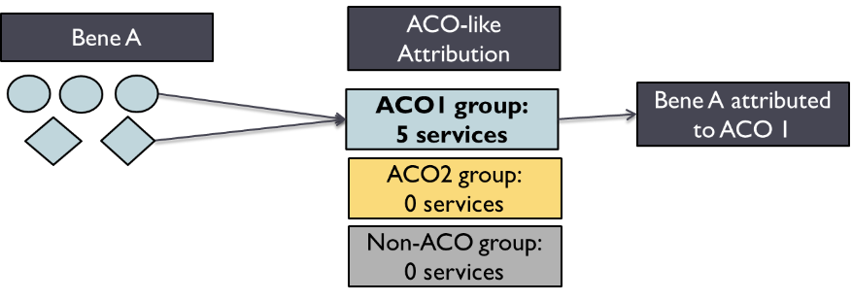
EXAMPLE: BENEFICIARY TO ACO ATTRIBUTION
Beneficiary A had 5 primary care services with Dr. Circle and 5 with Dr. Diamond. Both Dr. Circle and Dr. Diamond are participating with ACO 1.

Attribution: Under the ACO-like attribution, the beneficiary had 10 services with ACO1, and the beneficiary is attributed to ACO1.

Once beneficiaries are attributed under ACO-like, beneficiaries are attributed to PCPs based on plurality of visits among the ACO providers. Even if a beneficiary was attributed to an ACO based on their use of multiple different PCPs, the beneficiary will only be listed under one ACO provider. Again, this specific beneficiary-to-provider link does NOT determine whether the beneficiary is attributed to the ACO.

1c. PCP-like beneficiary attribution details
Only beneficiaries not attributed under ACO-like or MDPCP actual approaches are eligible for PCP-like attribution. If the beneficiary has any office visits with a traditional PCP, the beneficiary is attributed to the PCP with the plurality of that bene’s visits. If the beneficiary doesn’t have any visits with a traditional PCP, the attribution checks for any visits with a Non-Traditional PCP. If neither of those is met, the beneficiary moves to the PSA+ geography approach.

2. Provider to hospital linkage
Summary: For Year 2 of the MPA, eligible provider-to-hospital relationships begin with MDPCP provider participation with a hospital-affiliated Care Transformation Organization (CTO), followed by ACO provider participation with an ACO-affiliated hospital. If the provider does not participate with a hospital in these programs, providers may be linked with hospitals based on employment. All remaining providers with attributed beneficiaries will be linked to hospitals based on the referral patterns of their attributed beneficiaries, as described below.
If a provider is on multiple lists, the linkage higher in the hierarchy takes precendence. For example, if a provider is participating in MDPCP with Hospital A’s CTO, and is also an employed provider with Hospital A, the provider will show up on the MDPCP linkage.
d
All beneficiaries attributed to provider from beneficiary algorithm
All beneficiaries attributed to provider from beneficiary algorithm
All beneficiaries attributed to provider from beneficiary algorithm
MDPCP-provider participating with hospital CTO
Provider with Attributed Beneficiaires
Provider participating with hospital-based ACO
Referral Pattern
Provider employed by hospital
Figure 4. Overview of MPA Provider to Hospital Linkage
a
b
c
Non MDPCP/hosp CTO or hosp ACO providers
Non MDPCP/hosp CTO. Hospital ACO or employed provider
nonMDPCP/hosp CTO providers
All beneficiaries attributed to provider from beneficiary algorithm
Hospital

2a. MDPCP provider to Hospital-affiliated CTO linkage details
MDPCP practices participating with a hospital-affiliated care transformation organization (CTO) will be linked with the corresponding hospital, and all attributed beneficiaries for that practice will be attributed to that hospital. If multiple hospitals are part of a hospital-affiliated CTO, the hospital system indicated specific provider to hospital linkages. All remaining providers and practices will be assessed for linkage under ACO-like approach.

2b. ACO Provider to Hospital-affiliated ACO linkage details
Providers not linked under the MDPCP-CTO linkage who are participating with a hospital-based ACO will be linked with the corresponding hospital and all attributed beneficiaries for that provider (regardless of beneficiary attribution method) will be attributed to a hospital. If multiple hospitals are part of a hospital-affiliated ACO, the hospital system indicated specific provider to hospital linkages.

2c. Employed Provider to Hospital linkage details
Any providers not linked to hospitals through the CTO or ACO linkages may be linked to hospitals based on voluntary hospital-submitted employment lists. If multiple hospitals are part of a hospital employment system, the hospital system indicated specific provider to hospital linkages.

2d. Referral Pattern linkage detalis
Remaining providers will be assigned to the hospital from which that provider’s attributed beneficiaries receive the plurality of their care, as in the Y1 MPA policy. Once beneficiaries are attributed to PCPs, all of the IP and OP visits by that PCP’s attributed beneficiaries are summed. Whichever hospital represents the greatest count of IP and OP visits by all those beneficiaries is attributed all of the PCP’s beneficiaries attributed under referral-pattern.
EXAMPLE: PCP BENEFICIARY TO HOSPITAL ATTRIBUTION
Two providers have 100 beneficiaries attributed to them and neither is participating in MDPCP with a hospital-based CTO, hospital-based ACO, or is on a hospital’s employment list. Both hospitals have a count of 10 visits to hospital A for all of their beneficiaries, but Dr. Triangle’s beneficiaries also have 20 visits to Hospital B.
Provider | # of beneficiaries | Hospital A | Hospital B | Attribution to:
Dr. Rectangle | 100 beneficiaries | 10 visits | 0 visits | All 100 beneficiaries attributed to Hospital A
Dr. Triangle | 100 beneficiaries | 10 visits | 20 visits | All 100 beneficiaries attributed to Hospital B
Attribution: All 100 of Dr. Rectangle’s patients are attributed to Hospital A, and all 100 of Dr. Triangle’s patients are attributed to Hospital B

3. Geographic Attribution (Primary Service Area-Plus)
If beneficiaries are not attributed through the ACO-like or MDPCP-like approaches, beneficiaries and TCOC are attributed through the geographic approach. The beneficiaries and costs not attributed through ACO-like or MDPCP like are grouped into the beneficiary zip codes of residence. If the zip code is in only one hospital’s primary service area (PSA) as indicated in their Global budget agreements, all the remaining patients are attributed to that hospital. If the zip code is in more than 1 hospital’s PSA, costs will be allocated according to utilization share in that zip code. If the zip code is not in any hospital’s PSA, it falls into the plus part of the PSA plus component. The zip code is assigned to hospitals based on share of Medicare ECMADs and drive time.

Beneficiaries residing in Zip Code
Beneficiaries on multiple hospital lists but costs allocated according to ECMAD in that Zip Code
Zip Code in one hospital’s PSA
Attributed to Hospital
Zip code not in any hospital’s PSA
Zip Code in more than one hospital’s PSA
Those Zip Codes assigned to hospitals (PSA-Plus) based on ECMADs and drive time (<30 minutes)
ECMAD stands for equivalent case-mix adjusted discharge. It is the number of (a) inpatient discharges and (b) outpatient visits scaled to reflect utilization similar to inpatient discharges.
Figure 3. PSA Plus Attribution

Frequently Asked Questions

What about MDPCP practices that do not participate with a hospital-based CTO?
Beneficiary attribution: Beneficiaries that are attributed to MDPCP practices under MDPCP actual are attributed to those practices in the MPA, regardless of whether the practice participates with a hospital-based CTO . HSCRC then attributes beneficiaries to specific providers in the MDPCP practice based on plurality of primary care use.
Provider linkage: Providers and their attributed beneficiaries are linked with hospitals based on the provider to hospital linkage hierarchy. Because MDPCP providers that do not participate with a hospital-based CTO are NOT linked with a hospital in the MDPCP to hospital linkage step, those providers and their attributed beneficiaries move to the next step of the linkage hierarchy. If the individual MDPCP provider is part of an ACO or employment list, that provider (and their attributed beneficiaries) is linked with the specified hospital. Any remaining unlinked MDPCP providers in a practice are grouped together and all of the practice’s attributed beneficiaries are linked with the same hospital under the referral pattern.

Why is a provider assigned beneficiaries under multiple approaches?
Providers may be assigned beneficiaries under multiple approaches because the different beneficiary attribution approaches use slightly different criteria. However, each provider is only linked to a single hospital. For example, a provider may be attributed beneficiaries under both ACO-like and referral pattern. See What happens to beneficiaries attributed to a non-ACO group?

Why does my employed provider only show up as an MDPCP or ACO-like provider?
Providers are linked with hospitals based on the provider linkage hierarchy. If a provider appears on a hospital linkage list under MDPCP, ACO, and employment, the MDPCP linkage will take precedence.

Can a provider be assigned beneficiaries to multiple hospitals?
No. Under the RY2021 attribution, providers are linked to a single hospital.

Why are providers in the same practice assigned to different hospitals?
Outside of MDPCP, there is no comprehensive source to link providers with practices. Therefore, other than in MDPCP linkage, the MPA algorithm is based on NPIs, which are individual providers, rather than practice groups. So if individual providers within a group have different patterns of hospital use they would link to different hospitals. Providers in the same MDPCP practice are assigned to the same hospital (some exceptions, see What about MDPCP practices that do not participate with a hospital-based CTO?). MDPCP providers were required to identify with a specific practice to participate in MDPCP.

Why are some providers “missing”?
There are a number of reasons why a hospital may not see all the expected providers on an attribution list.

Reason 1: Beneficiaries may be attributed to another provider in the provider’s MDPCP practice or ACO. The ACO-like and MDPCP actual attribution logics use collections of NPIs to determine beneficiary attribution. The specific provider listed only represents the PCP that a the attributed ACO or MDPCP beneficiary sees most. This does not mean that the other PCPs were excluded from the attribution, it only means that this is the PCP seen most.
Reason 2: The provider is not eligible for a specific beneficiary attribution approach. Each of the attribution approaches have specifications that determine which providers are eligible for attribution. Please see the RY 2021 (Y2) Final MPA Policy Appendix IV for details on further details on attribution and provider eligibility. Some providers may meet the requirements in one year and not in a subsequent year. For example, the PCP-like approach requires that the cost of primary care services must represent 60% of total costs performed by a provider during the most recent 12 months, excluding hospital and emergency department costs. A provider may meet this threshold in one year and not in a subsequent year.
Reason 3: Beneficiaries saw multiple providers, and the beneficiaries were attributed to other providers rather than the one in question. Providers will only appear on the list if they have any attributed beneficiaries for Y2 MPA attribution.

How do we address instances when a greater portion of a provider’s beneficiaries use a different hospital other than the one to which they are attributed?
This situation is currently not dealt with in the current MPA algorithm. In response to Y1 of the MPA, stakeholders on the TCOC Workgroup felt that it was better to link a provider with a single hospital, rather than allowing a provider to be linked with more than one hospital. Therefore, a provider is linked to the hospital indicated by the highest level of the provider to hospital hierarchy that exists.

Why would providers have attributed costs and zero beneficiaries?
Due to small cell size restrictions, providers with fewer than 11 attributed beneficiaries may appear to have zero beneficiaries.

How would sharing providers between hospitals work?
Hospitals interested in sharing providers should email hscrc.tcoc@maryland.gov with the specific scenario and policy rationale behind sharing providers. For example, if two hospitals in different systems provide resources to a specific provider office, it may make sense to link that provider with both hospitals. Another example could be a provider that splits his or her time 50/50 between two internal medicine practices that operate with two different hospitals. HSCRC will work with hospitals to evaluate solutions to these scenarios; however, changes will likely be implemented for Y3 rather than Y2.

Are the beneficiaries attributed under ACO-like the same ones as my ACO beneficiaries?
Beneficiaries attributed under ACO-like may not necessarily be the same ones as attributed under the CMS ACO program. See table below for the main differences between the two algorithms
 | CMS ACO Program | MPA ACO-like
Type of attribution | Retrospective: assigns beneficiaries to last year based on last year’s experience | Prospective: assigns beneficiaries to this year based on last year’s experience. Excludes those attributed to a MDPCP practice
Years of claims data | 1 federal fiscal year | 2 federal fiscal years

Attribution Examples

What if the beneficiary sees providers in more than 1 ACO?
Answer: Beneficiary is attributed to the ACO with the plurality of services

EXAMPLE: MORE THAN 1 ACO
Beneficiary B sees Dr. Circle for 3 visits and Dr. Diamond for 2 visits, but also sees Dr. Star for 4 services. Dr. Circle and Diamond participate with ACO1. Dr. Star participates with ACO2.
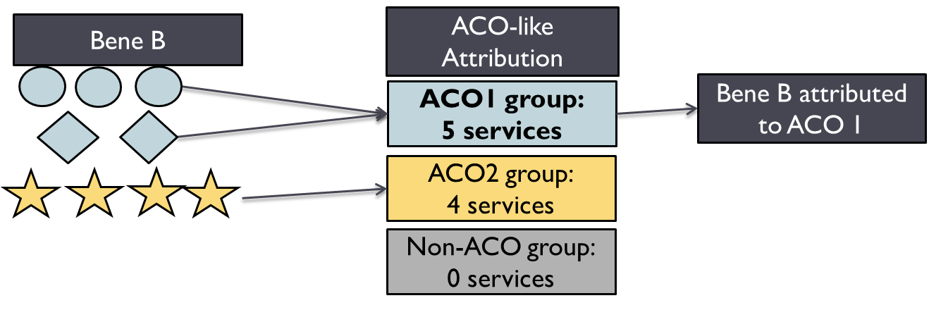
Attribution: Even though the largest number of services at a single provider was 4 from Dr. Star, the plurality of services is 5, from ACO1, so the beneficiary is attributed to ACO1.

What if the beneficiary also sees providers not in an ACO?
Answer: Providers not in an ACO are grouped together as a Non-ACO collection, which is distinct from the other ACO groupings. The beneficiary is attributed to the group with the plurality of services

What happens to beneficiaries attributed to a non-ACO group?
EXAMPLE
Beneficiary C sees Dr. Circle for 3 visits, Dr. Diamond for 2 visits, and Dr. Star for 4 services, but also sees Dr. Rectangle (no ACO) for 2 visits.
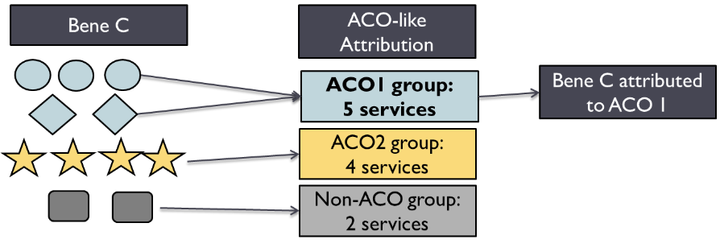
Attribution: The plurality of the services is still 5 at ACO1, so the beneficiary is attributed to ACO 1
Answer: If the plurality of services is with Non-ACO providers, the beneficiary will be not be attributed under the ACO-like attribution and will move on to the PCP-like part of the attribution.
Example Scenario: Beneficiary D has 4 services with Dr. Star, 3 with Dr Rectangle and 2 with Dr. Triangle. Dr. Rectangle and Triangle are not with an ACO.
ACO-like Attribution: For Beneficiary D, although the most from a single provider was 4 from Dr. Star, the plurality of services are with non-ACO providers, so Beneficiary D is not attributed to any ACO. Beneficiary D was not attributed to an ACO and moved to PCP-like.

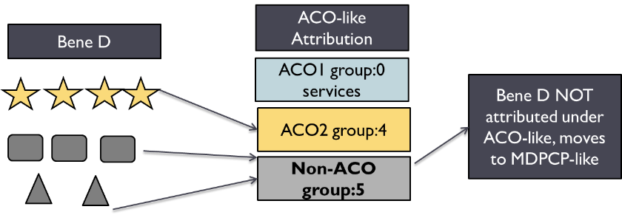

PCP-like Attribution: Because the plurality of services were with Dr. Star, beneficiary D is attributed to Dr. Star under PCP-like. Because PCP-like is done on the individual provider, not on a collection of ACO providers, the provider with the plurality of visits is attributed the benefciary.
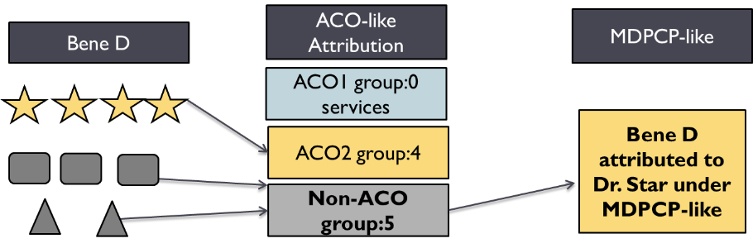

Using Equivalent Case-mix adjusted discharges (ECMADs)

