RY 2021 MHAC Program Potentially Preventable Complications:
Rate and Variation Detail
Prepared for December 19, 2018 Performance Measurement Work Group Meeting
PPC List
PPC # | PPC Description | Eligible Hospitals | Observed PPCs  (2 yrs) | At Risk Discharges  (2 yrs) | Obs/At-Risk*1,000 | 3M v33 PPC Wt-Based Marginal Cost | HSCRC Staff Recommendation
 |  |  |  |  | Rate >1.0 per 1,000
 |  |  |  |  | Rate >0.5 per 1,000
3 | Acute Pulmonary Edema and Resp Failure w/o Ventilation | 46 | 1238 | 696950 | 1.78 | 0.7958 | Meets rate and variation criteria. Clinically supported. Small overlap with PSI 11 Postoperative Respiratory Failure. PSI is limited to post-operative patients but PPC applies to broader patient population.  Include in payment program
4 | Acute Pulmonary Edema, Resp Failure w/ventilation | 47 | 848 | 698946 | 1.21 | 2.7409 | Meets rate and variation criteria. Clinically supported. Small overlap with PSI 11 Postoperative Respiratory Failure. PSI is limited to post-operative patients but PPC applies to broader patient population.  Include in payment program
7 | Pulmonary Embolism | 44 | 407 | 824106 | 0.49 | 1.3671 | Nearly meets rate criteria and has variation. Clinically preventable with well-defined interventions. Overlap 25% with PSI 12 Perioperative Pulmonary Embolism and Deep Vein Thrombosis but PPC includes broader patient population. DRA HAC is measured only in patients with total knee or hip replacements.  Include in payment program.
9 | Shock | 46 | 984 | 833605 | 1.18 | 1.5133 | Meets rate criteria and has variation Clinically preventable.  Include in payment program.
16 | Venous Thrombosis | 44 | 297 | 822712 | 0.36 | 1.4346 | Below rate threshold but has variation. Clinically preventable with well-defined interventions. Some overlap with PPC 12 but PPC rate is lower but with applicability to a broader population. DRA HAC is measured only in patients with total knee or hip replacements.  Include in the payment program.
28 | In-Hospital Trauma and Fractures | 38 | 110 | 827456 | 0.13 | 0.3353 | In hospital injuries are highly preventable and serious. PPC includes more injury types than PSI 08 In Hospital Fall with Hip Fracture Rate but PPC rate is lower as it is applicable to a broader patient population. DRA HAC applies to a broader set of in hospital injuries. Include in payment program.
35 | Septicemia & Severe Infections | 47 | 801 | 289205 | 2.77 | 1.3722 | Meets rate and variation criteria. Clinically important.  Include in payment program.
37 | Post-Operative Infection & Deep Wound Disruption Without Procedure | 39 | 319 | 128674 | 2.48 | 1.2701 | Meets rate and variation criteria. Clinically preventable. Overlaps slightly with PSI 14- Postop Wound Dehiscence, and with NHSN SSI and with DRA HAC but PPC is broader in scope.  Include in payment program.
40 | Post-Operative Hemorrhage & Hematoma without Hemorrhage Control Procedure or I&D Proc | 44 | 1067 | 306410 | 3.48 | 0.5881 | Meets rate and variation criteria. Overlap with PSI 15 Unrecognized Abdominopelvic Accidental Puncture or Laceration Rate. PPC is applicable to a much broader patient population but has a lower rate. Include in the payment program.  POST SUBGROUP: Clinicians feel strongly there are coding issues and recommend removing.  Do not include in payment program.
41 | Post-Operative Hemorrhage & Hematoma w/ Hemorrhage Control Procedure or I&D | 32 | 167 | 241162 | 0.69 | 1.0951 | Meets rate and variation criteria. Clinically preventable. Overlap with PSI 09- Perioperative Hemorrhage or Hematoma Rate with PSI having similar applicability but higher rate.  Include in payment program.
42 | Accidental Puncture/Laceration During Invasive  Procedure | 43 | 440 | 897351 | 0.49 | 0.4466 | Meets rate and variation criteria. Clinically supported. Overlap with PSI 15 Unrecognized Abdominopelvic Accidental Puncture or Laceration Rate. PPC is applicable to a much broader patient population so has a lower rate.  Include in the payment program.
49 | Iatrogenic Pneumothorax | 40 | 154 | 829953 | 0.19 | 0.6090 | Does not meet rate criteria but observed events are >100. This is an important clinical measure with national focus. There is hospital variation in performance, some PSI 06 Iatrogenic Pneumothorax Rate overlap andDRA HAC is applicable to patients with infusion catheter insertion procedures only.  Include in the payment program.
60 | Major Puerperal Infection and Other Major Obstetric Complications | 27 | 123 | 125667 | 0.98 | 0.1729 | Meets rate and variation criteria; 3M believes clinical concerns are addressed in the risk adjustment, and will address this PPC's overlap with other PPCs in v. 36. Obstetric morbidity is clinically important in an all-payer environment.  Include in the payment program.
61 | Other Complications of Obstetrical Surgical & Perineal Wounds | 25 | 100 | 122183 | 0.82 | 0.1172 | Meets rate and variation criteria; 3M believes clinical concerns are addressed in the risk adjustment, and will address this PPC's overlap with other PPCs in v. 36. Obstetric morbidity is clinically important in an all-payer environment.  Include in the payment program.
67 | Pneumonia Combo | 47 | 1282 | 713219 | 1.80 | 1.3002 | Meets rate and variation criteria. Clinically supported in combined PPC.  Include in payment program.

Frequency Histograms of PPCs Selected for MHAC
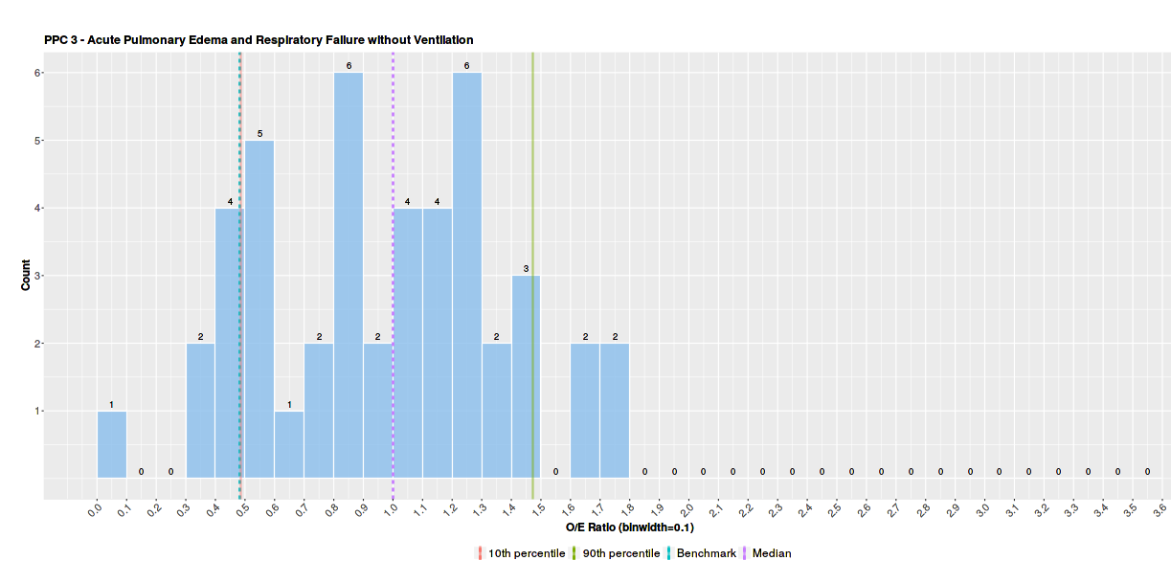

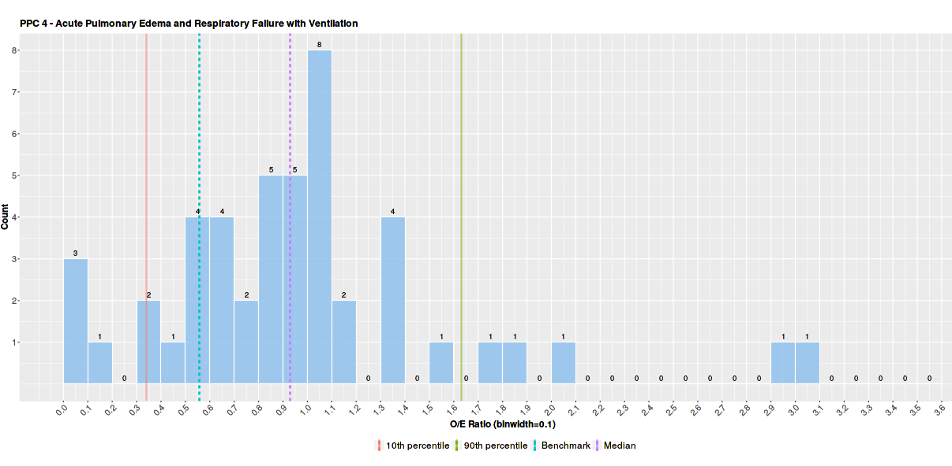
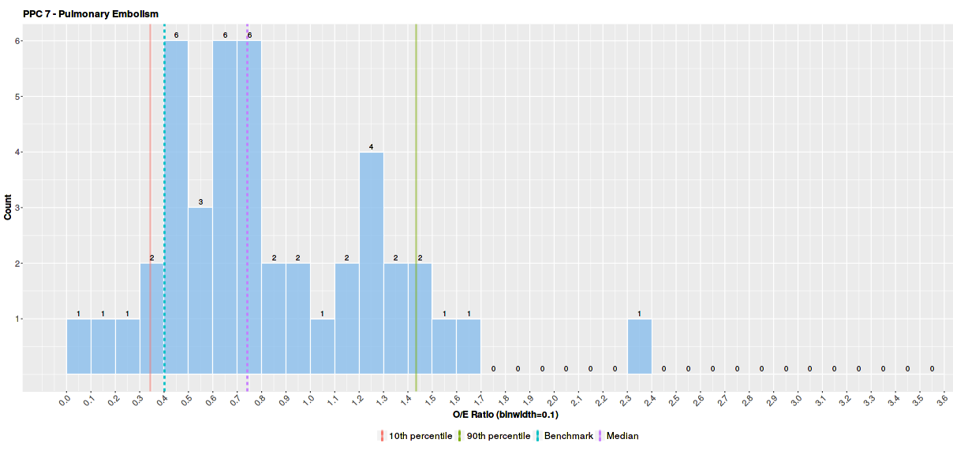

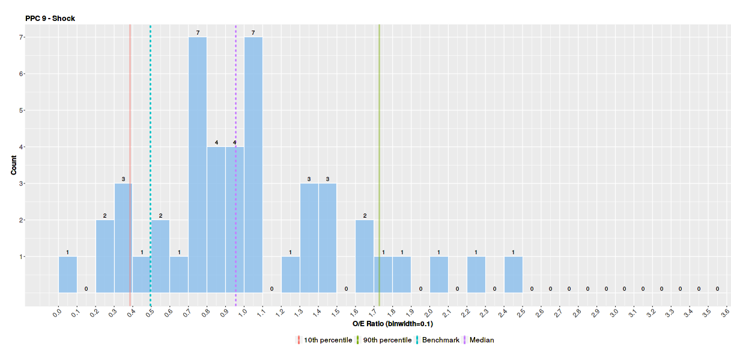
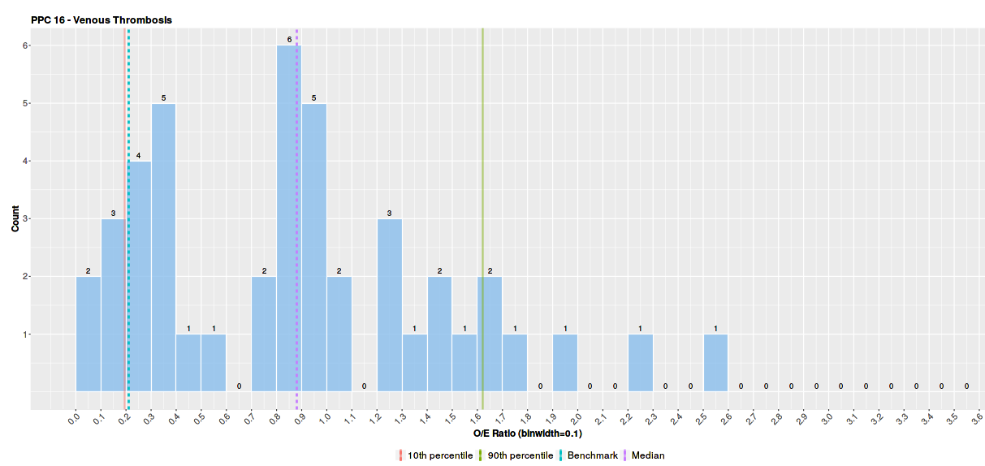

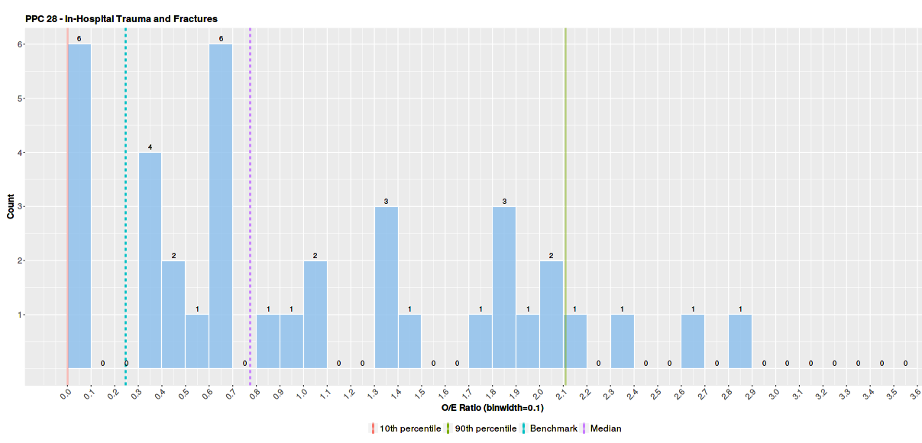
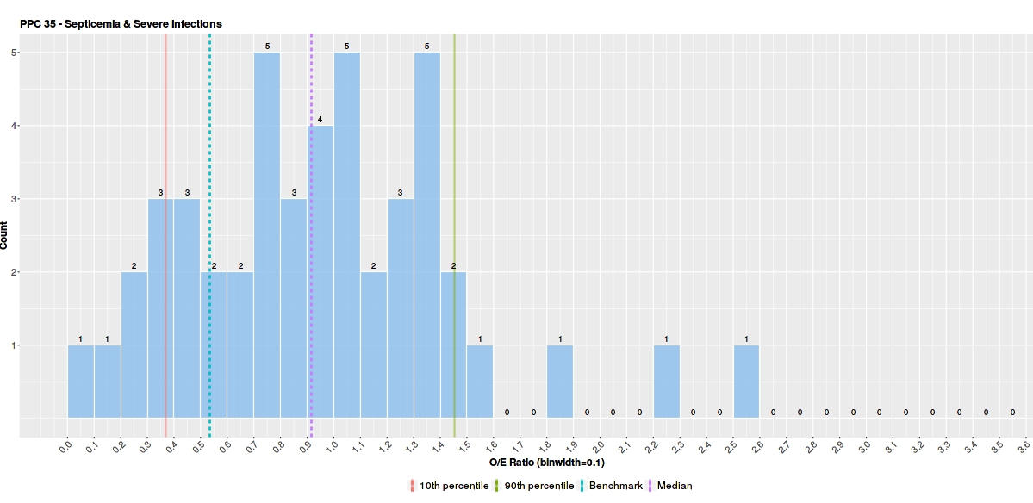

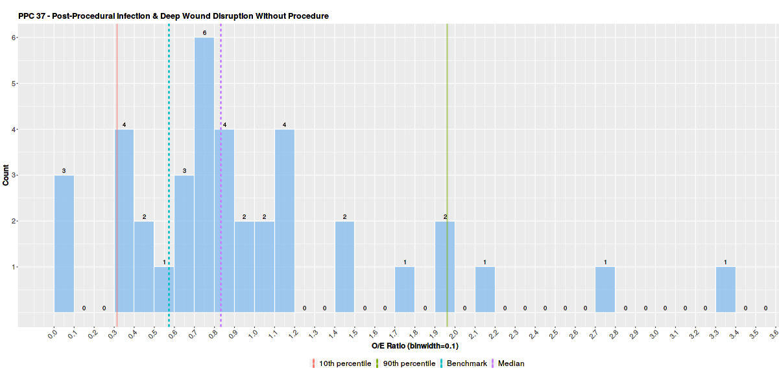
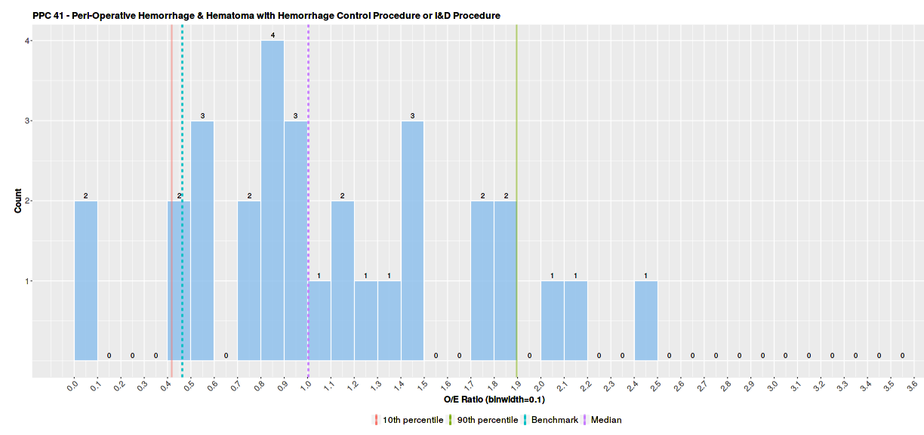
*MedStar Union Memorial (210024) removed as outlier with O/E of 4.988

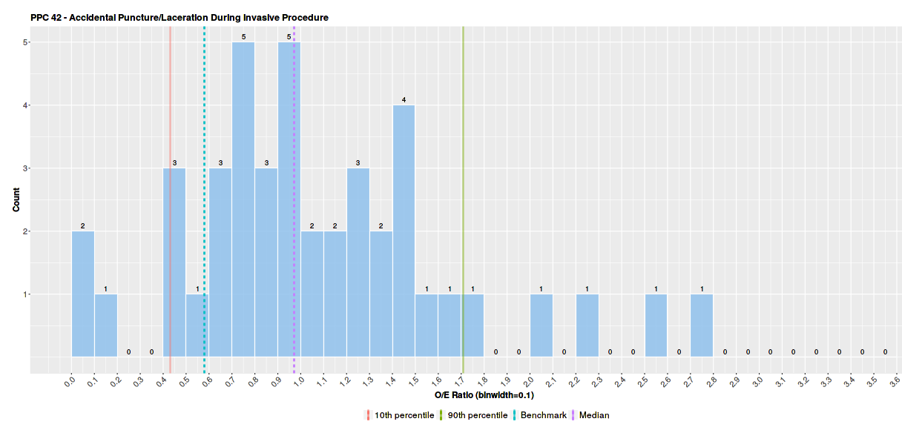

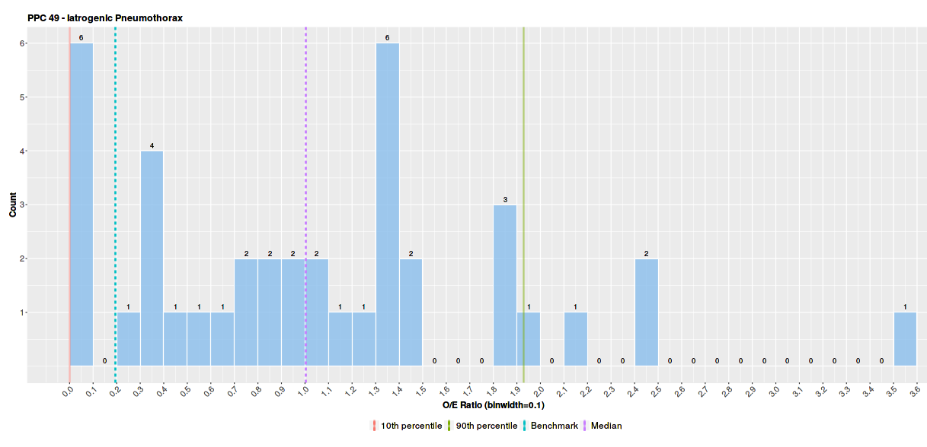

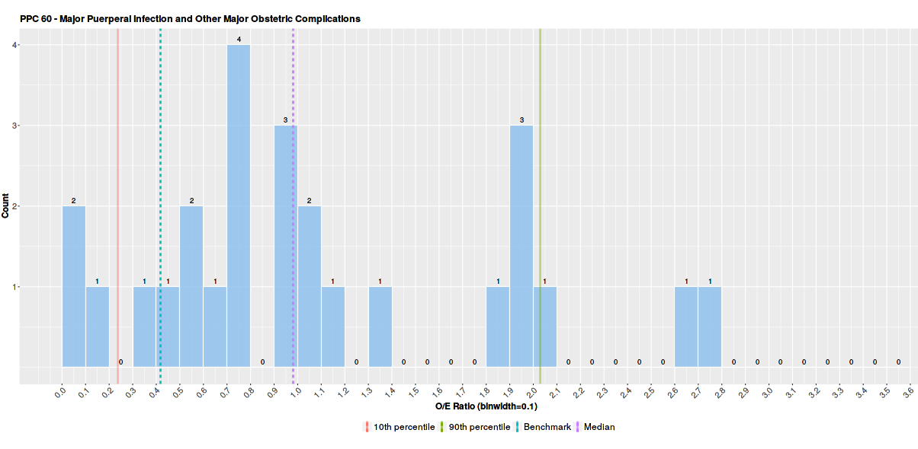
*Washington Adventist (210016) removed as outlier with O/E of 3.988

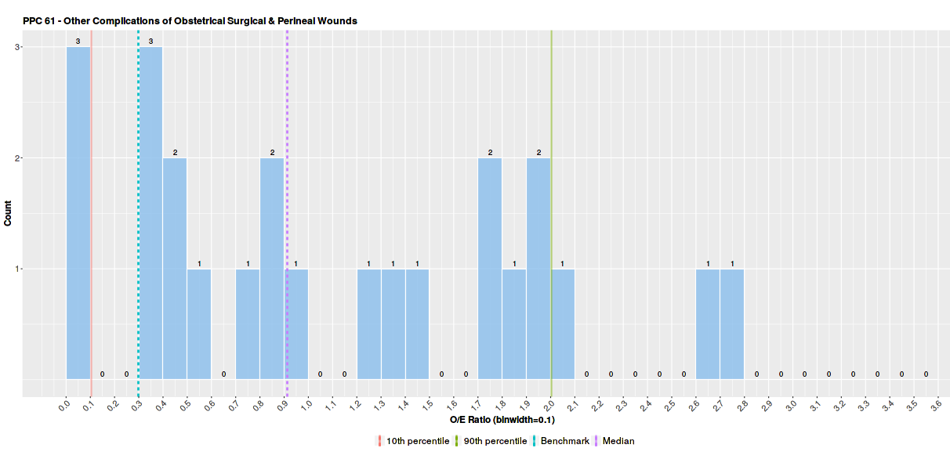
*UM-Charles Regional (210035) removed as outlier with O/E of 3.615

