**Nelson J. Sabatini**

**Chairman**

**Joseph Antos, PhD**

**Vice-Chairman**

**Victoria W. Bayless**

**Stacia Cohen**

**John M. Colmers**

**James N. Elliott, M.D.**

**Adam Kane**

**Katie Wunderlich**

**Executive Director**

**Allan Pack, Director**

**Population Based Methodologies**

**Chris Peterson, Director**

**Payment Reform &**

**Provider Alignment**

**Gerard J. Schmith, Director**

**Revenue & Regulation Compliance**

**William Henderson, Director**

**Medical Economics &**

**Data Analytics**

Health Services Cost Review Commission

4160 Patterson Avenue, Baltimore, Maryland 21215

Phone: 410-764-2605 · Fax: 410-358-6217

Toll Free: 1-888-287-3229

[hscrc.maryland.gov](http://www.hscrc.maryland.gov)

**State of Maryland**

**Department of Health**



To: Hospital CFOs

Cc: Hospital Quality Liaisons

Case Mix Liaisons

From: HSCRC Quality/Performance Measurement Team

Date: February 24, 2020 (with amendments to the January 6 memo)

Re: Maryland Quality Based Reimbursement Program Methodology and Measure Standards for Rate Year 2022

This memo summarizes the Quality Based Reimbursement Program (QBR) that will impact hospital rates in Rate Year (RY) 2022. This memorandum contains updates regarding the timing of the base period data release, mortality performance standards, and updated information regarding the Total Hip-Total Knee Replacement (THA-TKA) Complication Measure base period data to be used for RY 2022. Updates to the previous memo are provided in red text.

## Scaling Methodology and Revenue At-Risk

On December 11, 2019, the Commission approved the staff recommendations for updating the Quality-Based Reimbursement (QBR) Program for RY 2022. Consistent with the RY 2021 policy, the preset scale for RY 2022 uses a full distribution of potential scores (scale of 0-80%), and a score cut point of 41% for rewards and penalties. The maximum reward will remain at 2%, and the maximum penalty will remain at 2%; the preset scale is included as Appendix A of this memorandum.

## Aligning the QBR program with the CMS Value Based Purchasing (VBP) Program

### VBP Exemption

Exemptions from CMS quality hospital programs enable Maryland to operate programs with incremental revenue adjustment scales established prospectively with all hospitals having the opportunity to earn rewards based on their performance. As required, HSCRC has submitted to the Centers for Medicare & Medicaid Services (CMS) Maryland’s QBR program reports and requests for exemptions from the Value-Based Purchasing (VBP) program for FY 2013 through FY 2020. The exemption requests have emphasized that the QBR policy continues to heavily weight the Hospital Consumer Assessment of Healthcare Providers and Systems (HCAHPS) scores due to concerns regarding progress on these measures. Under the TCOC Model, HSCRC is updating performance targets and requirements for its portfolio of quality and value-based payment programs; in order for Maryland to maintain its exemptions from Federal pay-for-performance quality programs under the Model, the State must ensure that there is no backsliding on the progress made under the All-Payer Model, and the policies must continue to be aggressive and progressive, as reflected in annual reports submitted to CMS along with our exemption request.

### RY 2022 Measure Changes and Updates

For the QBR program, the HSCRC generally follows the VBP programs in terms of measures and calculation of measure scores. Below are the updates to the QBR program measures for RY 2022.

* 1. Remove the ED-2b measure commensurate with its removal from the CMS Inpatient Quality Reporting (IQR) program.
  2. Through the work of the QBR Redesign Sub Group HSCRC will convene during CY 2020, consider options for readopting ED Wait Time measures into the program for the RY 2023 policy and beyond.

## Domain Weights

The Final Measure Domain Weights for the QBR program compared with the VBP Program for RY 2022 are listed below in Figure 1.

**Figure 1. QBR Measure Domain Weights Compared with the VBP Program**

|  | **Clinical Care** | **Person and Community Engagement** | **Safety** | **Efficiency** |
| --- | --- | --- | --- | --- |
|
| **QBR** | 15% (2 measures- inpatient all-cause mortality measure +1 THA/TKA complication measure) | 50% (8 measures- HCAHPS) | 35% (6 measures- CDC NHSN HAIs) | N/A |
| **CMS VBP** | 25% (6 measures- 5 condition specific 30-day mortality measures + 1 THA/TKA complication measure) | 25% (8 measures- HCAHPS) | 25% (6 measures- CDC NHSN HAIs) | 25% |

## Measurement Periods

The base and performance measurement periods used for the QBR program for RY 2022 are illustrated below in figure 2.

**Figure 2. RY 2022 QBR Base and Performance Timeline**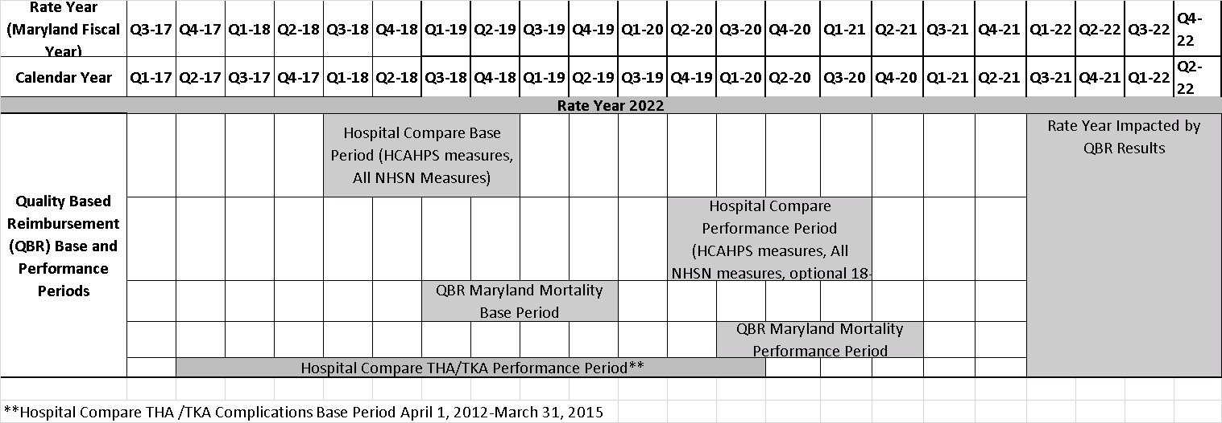

## QBR Data Sources, Score Calculations and Performance Standards for RY 2022

As stated previously, to the extent possible, HSCRC has aligned the QBR program data, scoring calculations, measures list and performance standards with the VBP program. Appendix B provides an overview of the QBR methodology. Key points regarding this are outlined below.

* HSCRC will use the data submitted to CMS for the Inpatient Quality Reporting program and posted to Hospital Compare for calculating hospital performance scores for all measures with exception of in-hospital mortality measure, which is calculated using HSCRC case mix data.
  + NOTE: If NHSN data are unavailable on CMS Hospital Compare for the relevant time periods for some or all hospitals, the HSCRC may obtain these data directly from CMS, or may download the data directly from the NHSN by MHCC. Results from MHCC may be pulled at a different time and may not match CMS data.
* CMS rules will be used when possible for minimum measure requirements for scoring a domain and for readjusting domain weighting if a measurement domain is missing for a hospital. Hospitals must be eligible for a score in the HCAHPS domain (i.e., must have at least 100 completed surveys in the performance period) to be included in the program.
* Maryland Mortality summary reports and case level data are provided to hospitals quarterly based on preliminary and final data. Reports are available on the CRS Portal. Appendix C contains the specifications for the Maryland Mortality measure.
* For hospitals with measures that have no data in the base period, staff reserves the right to assess hospitals on attainment-only, since HSCRC will be unable to calculate improvement scores.
* For hospitals that have measures with data missing for the base and performance periods, staff reserve the right to give hospitals a score of zero for these measures. It is imperative, therefore, that hospitals review their data as soon as it is available and contact CMS with any concerns related to preview data or issues with posting data to Hospital Compare, and to alert HSCRC staff in a timely manner if issues cannot be resolved.
* THA/TKA Complication Measure Base Period: In compiling the base period data, HSCRC staff has noted that the data for this measure was suppressed and not available through Hospital Compare for RY 2022; to address this issue, the weighted average of the base period data for RYs 2021 and 2023 will be used to establish the base period data for each hospital. Facilities with insufficient case volumes for the performance period will not be scored on this measure.
* The performance standards for each of the Safety, Clinical Care, and Person and Community Engagement measures for RY 2022 are listed below in Figure 3.
  + NOTE: In prior years, CMS has adjusted the VBP thresholds and benchmarks mid-year for certain measures (most notably, the C. diff measure). Should any VBP measure included in the RY 2022 QBR program be updated, HSCRC will notify industry and provide an updated calculation sheet at that time.

Figure 3. QBR Performance Standards for RY 2022

|  |  |  |  |
| --- | --- | --- | --- |
| **Person and Community Engagement Domain\*** | | | |
| **Dimension** | **Benchmark** | **Achievement Threshold**  **(50th percentile)** | **Floor**  **(Minimum)** |
| Communication with Nurses | 87.53 percent | 79.18 percent | 15.73 percent |
| Communication with Doctors | 87.85 percent | 79.72 percent | 19.03 percent |
| Responsiveness of Hospital Staff | 81.29 percent | 65.95 percent | 25.71 percent |
| Communication about Medicines | 74.31 percent | 63.59 percent | 10.62 percent |
| Cleanliness and Quietness of Hospital Environment | 79.41 percent | 65.46 percent | 5.89 percent |
| Discharge Information | 91.95 percent | 87.12 percent | 66.78 percent |
| 3-Item Care Transition | 63.11 percent | 51.69 percent | 6.84 percent |
| Overall Rating of Hospital | 85.18 percent | 71.37 percent | 19.09 percent |
|  |  |  |  |

*The Person and Community Engagement performance standards displayed in this table were calculated using four quarters of calendar year 2018 data, and published in the CMS Inpatient Prospective Payment System FFY 20 Final Rule.

|  |  |  |  |
| --- | --- | --- | --- |
| **Safety Domain\*** |  |  |  |
| **Measure Short ID** | **Measure Description** | **Benchmark** | **Achievement Threshold** |
| CAUTI | Catheter-Associated Urinary Tract Infection | 0.00 | 0.727 |
| CDI | Clostridium *difficile*Infection | 0.047 | 0.646 |
| CLABSI | Central Line-Associated Blood Stream Infection | 0.00 | 0.633 |
| MRSA | Methicillin-Resistant Staphylococcus*aureus* | 0.00 | 0.748 |
| SSI | SSI - Abdominal Hysterectomy | 0.00 | 0.727 |
| SSI - Colon Surgery | 0.00 | 0.749 |

*The Safety Domain performance standards were published in the CMS Inpatient Prospective Payment System FFY 20 Final Rule.

|  |  |  |  |
| --- | --- | --- | --- |
| **Clinical Care Domain** | |  |  |
| **Measure Short ID** | **Measure Description** | **Benchmark** | **Achievement Threshold** |
| Mortality | All Condition Inpatient Mortality (expressed as survival rate) | 97.256 | 96.193 |
| THA/TKA RSCR* | Total Hip/Knee Arthroplasty Risk Standardized Complication Rate | 0.021493 | 0.029833 |

*THA/TKA standards were published in the CMS Inpatient Prospective Payment System FFY 20 Final Rule.

HSCRC staff anticipates that the following will be provided via the CRISP Reporting Services (CRS) Portal with the February 2020 updates*, and will also be posted to the HSCRC Website:

* An excel workbook with base period data.
* A score calculation workbook containing a worksheet for each domain for hospitals to use to calculate and monitor their scores.

*NOTE: The base period data and calculation sheet are now anticipated for release on the CRISP portal in March 2020.

For any questions, please email [hscrc.quality@maryland.gov](mailto:hscrc.quality@maryland.gov) or call Dianne Feeney (410-764-2582) or Alyson Schuster (410-764-2673).

## Appendix A: RY 2022 QBR Preset Payment Scale

Please see below for approximate revenue adjustments associated with QBR scores.

|  |  |
| --- | --- |
|  |  |

*For RY 2022, hospitals receiving a score from 0.00 to 0.40 will receive a penalty, and hospitals receiving 0.42 and above will receive a reward. Any hospital receiving a score of 0.80 or higher will receive the maximum reward.

## Appendix B: RY 2022 QBR Methodology: Converting Performance Scores to Payment Adjustments

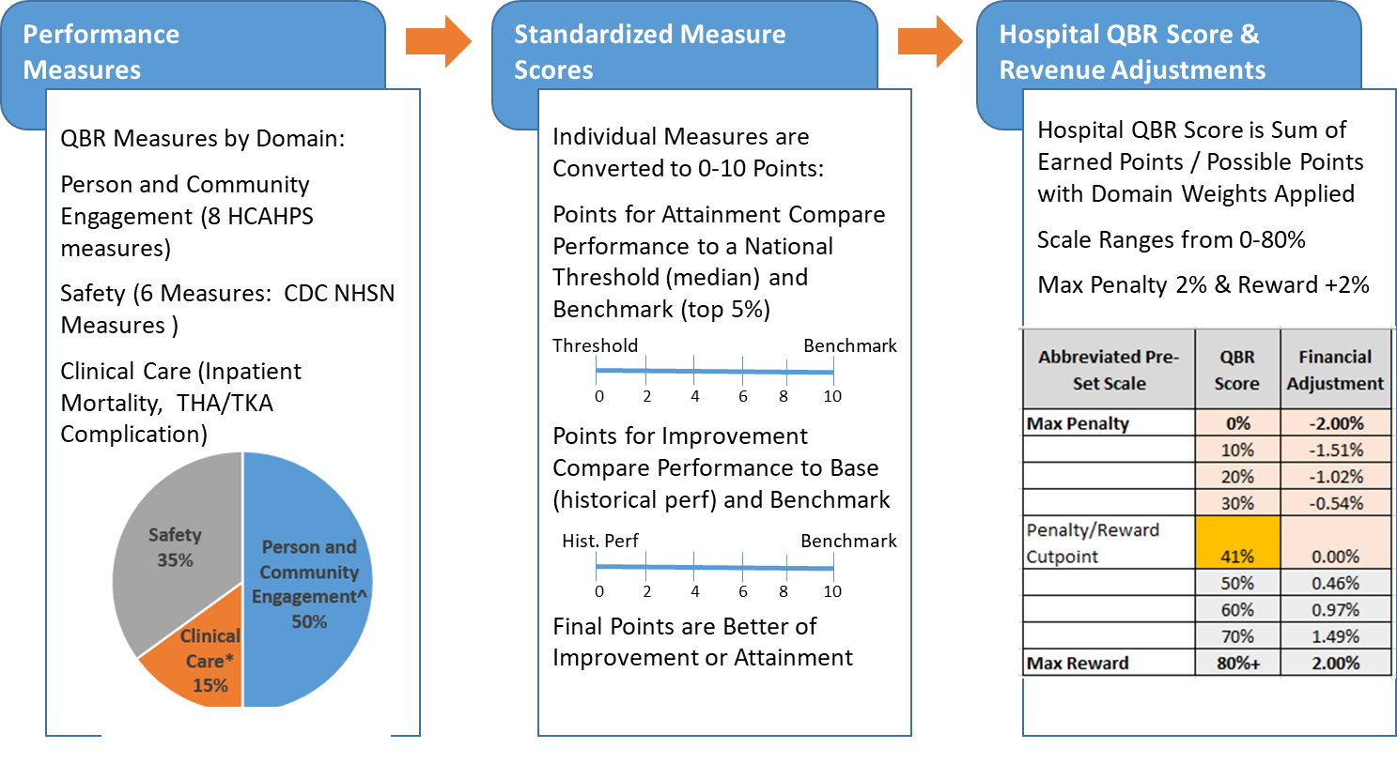

## Appendix C: RY 2022 Maryland Mortality Measure Specifications

**Inpatient Mortality Rates using 3M, Health Information Systems Risk of Mortality Adjustment**

As 3M Risk of Mortality (ROM) categories--which comprise four levels similar to severity of illness classifications used in the All Patient Refined Diagnosis Related Group (APR DRG) payment classification system-- account for risk adjustment for deaths in the hospital, the ROM may provide an appropriate measure of hospital mortality with a broader focus. 3M APR DRGs and ROM are also used as the risk adjustment methodology for other mortality measures, such as those developed by the Agency for Healthcare Research and Quality.

**Exclusions**

The following categories are removed from the denominatorsandtherefore not included in the mortality rate calculations (excluded from both mortality counts and denominator)**:**

1. APR-DRGs that are NOT in the 80% of cumulative deaths after removing all the exclusions. DRGs are chosen without palliative care discharges and then discharges with palliative care for selected DRGs are added back. In RY2022 the logic is adjusted to get all DRGs that have same number of observed deaths when selecting the 80%

1. APR-DRG ROM with a state-wide cell sizes below 20 after removing all the exclusions
2. Rehab hospitals (provider ids that start with 213)
3. Hospitals without HCAHPS (RY 2019: Levindale, UMROI, McCready)
4. Transfers to other acute hospitals (discharge destination= 40 BEFORE July 1st 2018 02,05,07 AFTER July 1st 2018)

1. Age and sex unknown

1. Hospice Daily service=10

1. University of Maryland Shock Trauma Patients (daily service=02, and trauma days>0)
2. Left Against Medical Advice admissions: (discharge destination=71)
3. Trauma and Burn admissions: Admissions for multiple significant trauma (MDC=25) or extensive 3rd degree burn (APR DRG = 841 “Extensive 3rd degree burns with skin graft” or 843 “Extensive 3rd degree or full thickness burns w/o skin graft”)
4. Error DRG: Admissions assigned to an error DRG 955 or 956
5. Other DRG: Admissions assigned to DRG 589 (Neonate BWT <500G or GA <24 weeks), 591 (NEONATE BIRTHWT 500-749G W/O MAJOR PROCEDURE), 196 (cardiac arrest) due to high risk of mortality in these conditions
6. "APR DRG 004 (Tracheostomy w MV 96+ hours w extensive procedure or ECMO) due to low cell size; starting in RY 2022 will also remove discharges with primary or secondary procedure code for ECMO (""5A1522F"", ""5A1522G"", ""5A1522H"",""5A15223""))

Medical (non-surgical) Malignancy admissions: Medical admissions with a principal diagnosis of a major metastatic malignancy (see below)

**Adjustments**

The Maryland inpatient hospital mortality measure was developed in conjunction with Performance Measurement workgroup and other stakeholders. Based on this stakeholder input mortality is assessed using a regression model that adjusts for the following variables:

1. Admission APR DRG with Risk of Mortality (ROM)
2. Age (as a continuous variable) and age squared
3. Gender
4. Palliative Care Status (ICD-10 code = Z51.5)
5. Transfers from another institution defined as source of admission codes of

04 = FROM (TRANSFER) A DIFFERENT HOSPITAL FACILITY (INCLUDES TRANSFERS FROM ANOTHER ACUTE CARE HOSPITAL (ANY UNIT), FREESTANDING EMERGENCY DEPARTMENT, MIEMSS-DESIGNATED FACILITY). NOT LIMITED TO ONLY IP SERVICES.

**Mortality Reporting**

Hospitals will be provided with summary level quarterly reports based on preliminary and final HSCRC case-mix data. In addition, case level detailed files will be provided to each hospital. These summary and case level reports will be posted through the CRISP Reporting Services portal.