GREATER BALTIMORE MEDICAL CENTER

Transformation Implementation Program

Greater Baltimore Medical Center

Expansion and Management of Chronic Conditions
Through Improved Integration of

- Mental Health Services

- Palliative Care Services

and

- Care Coordination



December 21, 2015

Contents
Transmittal Letter 1
SECTION 1: TARGET POPULATION 2
SECTION 2: PROPOSED PROGRAM/INTERVENTIONS 4
SECTION 3: MEASUREMENT AND OUTCOMES 11
SECTION 4: RETURN ON INVESTMENT 11
SECTION 5: SCALABILITY AND SUSTAINABILITY 13
SECTION 6: PARTICIPATING PARTNERS AND DECISION-MAKING PROCESS 14
SECTION 7: IMPLEMENTATION WORKPLAN 15
SECTION 8: BUDGET AND EXPENDITURES 15
SECTION 9: BUDGET AND EXPENDITURES NARRATIVE 18
SECTION 10: SUMMARY OF PROPOSAL 18
APPENDIX A 21
APPENDIX B 26
APPENDIX C 28
APPENDIX D (a) 29
APPENDIX E 42
APPENDIX F 44
APPENDIX G 45

Transmittal Letter

Steve Ports, Director
Center for Engagement and Alignment
Maryland Health Services Cost Review Commission
4160 Patterson Avenue
Baltimore, MD 21215

Re: Transmittal Letter for HSCRC Transformation Implementation Program

Dear Mr. Ports,

This letter serves to as our application to be given the opportunity to expand our collaborative care management and care coordination model. With the addition of three programs: Behavioral Health embedded in the PCMH, Supporting Our Elders and expanding Care Coordination/Care Management, many more Medicare patients will be supported. The goal of providing services outside of the acute care setting and within the community and primary care physicians is one of patient centricity. As the programs are rolled out and are successful, GBMC will expand the programs to other payers to achieve a population health model that is payer agnostic.

The primary contact information at GBMC for this RFP is: Michael Myers

Michael Myers
6545 N. Charles Street
Baltimore, MD 21204
mmyers@gbmc.org
443-849-4328

Sincerely,
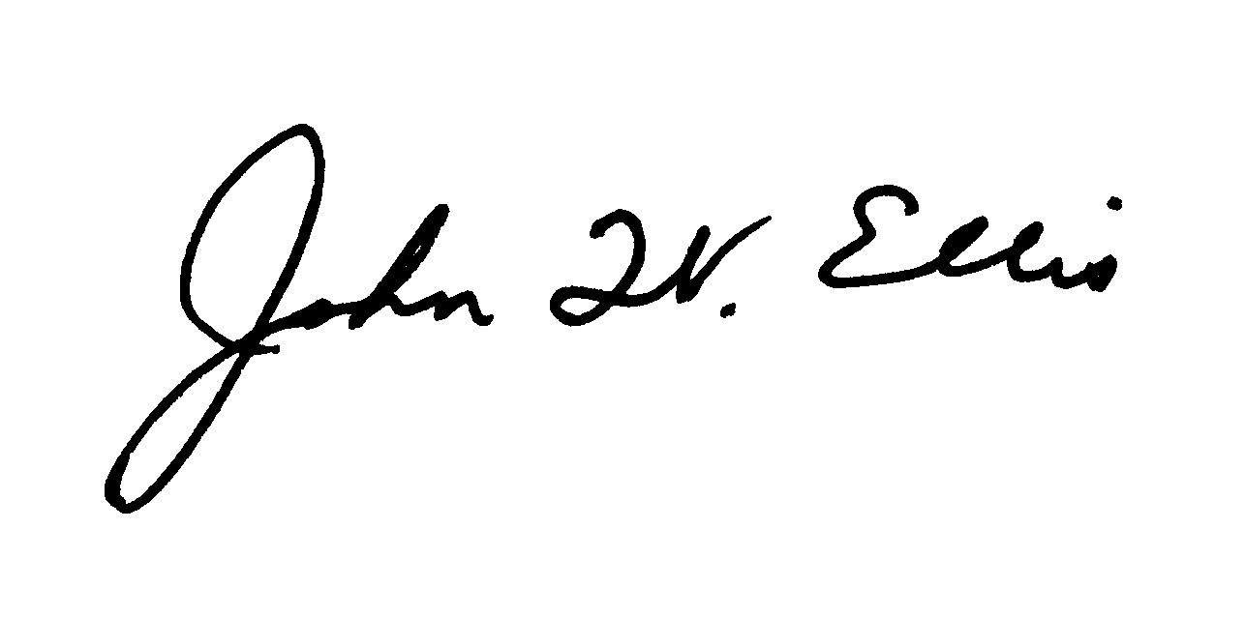
John W. Ellis
Senior Vice President, Corporate Strategy and Business Development
Greater Baltimore Medical Center

SECTION 1: TARGET POPULATION
Background – The GBMC HealthCare system currently includes the Greater Baltimore Medical Center, a 281-bed acute care hospital; Greater Baltimore Medical Associates, a group of more than 40 primary care and multispecialty physician practices across the region; Greater Baltimore Health Alliance, an alliance of GBMC-employed and private practicing physician partners who form a Medicare Shared Savings Accountable Care Organization with 12,000 enrollees; and Gilchrist Services, Maryland’s largest hospice organization provides in-home hospice care as well as inpatient hospice care in Towson and in Howard County.

GBMC has built a network of 15 patient-centered medical homes (PCMH’s) that emphasize team-based care, continuity of care, and evidence-based medicine. The PCMH model has truly transformed service delivery across GBMC practices, using the health care team model that includes physicians, nurse practitioners, physician assistants, and healthcare navigators, supported by partnerships with community-based organizations. This integrated team focuses on a patient's wellness and long-term care, rather than the traditional model of episodic care (i.e. waiting until an individual has a problem and then "fixing" that problem). GBMC has demonstrated the success of this model in numerous respects:
- GBMC has earned Level Three NCQA Patient Centered Medical Home (PCMH) certification for eight primary care practices, with two additional practices applying in 2016. Level III certification signifies team-based care, access to services during and after hours, effective care coordination, use of evidence-based guidelines, and effective use of data for population health management and quality improvement.
- The PCMH model now serves more than 80,000 patients across 15 practice sites.

GBMC’s Gilchrist Services, in addition to providing hospice care, also consists of Gilchrist Greater Living, which provides geriatric primary care in over 25 skilled nursing and long term care facilities, the in-home Support our Elders program, and hospital and facility-based Palliative Medicine consultation. Additionally, GBMC has a long-standing Post Acute Network that connects Gilchrist and GBMC services to other community providers. Gilchrist Services is complementary to the PCMH and fills the gaps when the patient is too sick to come to the office and when the evidenced-base disease specific therapies are no longer effective, desired, or tolerated by the patient.

GBMC’s service area – Is comprised of primary and secondary service area zip codes representing approximately 1 million Marylanders; these communities account for 70% of GBMC’s total patient population (see figure 1 below). In 2013, a Community Health Needs Assessment (CHNA) was prepared jointly for GBMC, Sheppard Pratt, and University of Maryland St Joseph Medical Center to profile the Greater Baltimore area population, and included 9 of the zip codes surrounding GBMC. GBMC has used the information from this study, as well as the assessment provided by the Baltimore County Health Coalition Local Action Plan (2012), to align the hospital’s priorities with community health needs and to guide the development of intervention strategies.

Patient Population
In the program’s initial iteration, GBMC’s targeted patient population will be the hospitals’ patients residing in the zip codes located in proximity of the hospital and PCMH. The following zip codes were used to define the patient population: 21903, 21234, 21286, 21204, 21030, 21212, 21208, 21236, 21220, 21222, 21117, 21057, 21221, 21131, 21136, 21215, 21209, 21239, 21111, and 21128. While the focus of GBMC’s program will be on patients identified as high utilizers within the Medicare patient population, construction of the profile for the high-utilizer was gleaned from Hospital patient information from CRISP as well as independent data analysis drawn from CY 2014-15 patient data across the GBMC health system.

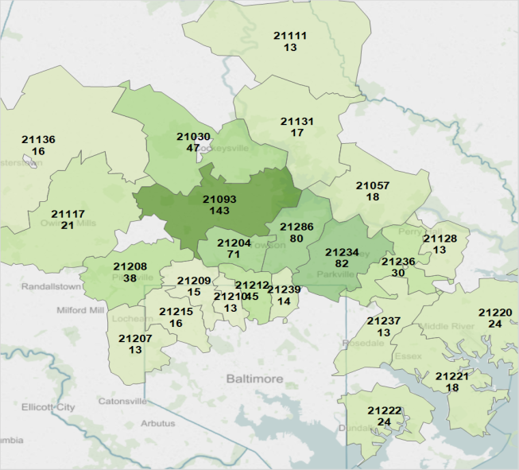

Figure 1: Map of GBMC’s Service Area

The criteria that were used to identify the high utilizers were the following:

Criterion 1: All patients that were admitted as an inpatient, observation or emergency department visit
Criterion 2: Patients who have had greater than 3 bedded care encounters or observation greater than 24 hours within the past 12 months
Criterion 3: Patients classified as medically complex (2 or more Chronic Conditions) with or without mental health diagnosis
The total population identified totaled 1,054 Medicare Patients; followed by 160 Medicaid Patients and 115 Dual Eligible Patients. The utilization statistics identified as follows:

Medicare | Medicaid Eligible
- 1,054 Patients  - 3,120 Total Encounters  - $35.1M Total Charges  - 2.4 Encounters per Patient  - $33,300 charges per Patient | - 160 Patients  - 638 Total Encounters  - $5.5M Total Charges  - 2.5 Encounters per Patient  - $34,500 charges per Patient

Population Health Needs
Prominent issues emerged from the Community Health Needs Assessment and from GBMC’s follow-up analyses are the following:
Access to Health Care
Overweight/Obesity
Mental Health
Chronic Health Conditions

Increased morbidity and mortality is attributed to a number of issues including inadequate physical activity, poor nutrition, smoking, side effects from antipsychotic medication, and lack of access to health care services. A meta-analysis also showed a significant relationship between depression and noncompliance; therefore, depression can be considered a risk factor for poor outcomes due to low adherence to medical advice (DiMatteo, 2000). Finally, under-recognition and under-treatment of mental health illness can result in deteriorating medical conditions and increased service utilization. This pattern may be tied to a confluence of factors including lack of attention by primary care practitioners due to time constraints and financial barriers for patients to seek care.

As SMHSA notes “Many of these health conditions are preventable through routine health promotion activities, primary care screening, monitoring, treatment and care management, coordination strategies and/or other outreach programs” (PBHCI announcement). In this context, GBMC presents the following proposal.

SECTION 2: PROPOSED PROGRAM/INTERVENTIONS
GBMC Program Background and Description
Integrating with existing PCMH model – As the Institute of Medicine and the AHRQ cites, “the PCMH is grounded in the Chronic Care Model….which is also needed to address individuals’ mental health needs.” GBMC’s new behavioral health program model will build upon its existing medical home network and provide the following 3 services:
- Behavioral Health Enhanced Patient-Centered Medical Homes (BHE-PCMH) - Mental health professionals will be embedded in these primary care practices to provide screening, short-term intervention, ongoing counseling/behavioral management, care management, and telephonic support; medical homes will also provide urgent psychiatric services on-site through telehealth technology. This includes a comprehensive Behavioral Health Network in which Psychiatrists will provide evaluations on inpatient and ER patients and provide post-discharge mental health support (time-limited services). Specialty outpatient psychiatric services and consultation services will be provided at GBMC’s medical homes. The Behavioral Health Network will also function as a referral center to community based programs and services
- Support Our Elders and Palliative Care Services – GBMC’s Gilchrist Services, in partnership with MedStar’s Total Elder Care (TEC) program, will expand the program Support Our Elders. Medicare patients who are unable to make frequent visits to the primary care physician are currently supported at home by a rounding Nurse Practitioner who can care for complex chronic conditions within the patient’s home. This program will be expanded by adding physicians, nurse practitioners, social workers, and administrative coordinators to mirror the TEC model. Gilchrist Services will also expand the palliative care program in partnership with area nursing homes, which provides palliative services by a nurse practitioner to better manage symptoms and discuss patient care plans.
- Expansion of Care Coordination and Care Management- GBMC will expand its hospital-based care management function to focus on the top utilizers defined as patients with 11 or more ER visits in the past year and 4 or more visits. Through the addition of a Case Manager and Service Coordinator for high utilizers as well as additional care coordination staff in each practice, the team will work with each of these patients proactively to meet their individual needs.

GBMC Targeted Patient Population
As identified extensively in Section 1, the initial target patient population for GBMC will be the patients residing in the zip codes identified in the section above. While GBMC intends to expand the appropriate programs to other payers such as Medicaid, Duals and unmanaged commercial patients; by wrapping services around Medicare’s high utilizing patients within the GBMC service area, GBMC is building resources and core competencies around chronic conditions and mental health diagnosis.

The targeted patient populations for this program are adult patients defined by either of the following:
- Adult patients with one or more chronic medical condition who are identified as also having a mental health problem - As a collaborative care model, the program will be designed to support effective management of both medical and mental health problems.
- Adult high utilizers who are identified as having a mental health problem – As a PCMH-based model, the program will aim to link patients to a medical home and match the level of behavioral health services to the need for treatment.
- For Gilchrist Services target patients, the population is defined as patients with a life expectancy of 1-3 years who are frail, immobile, high users of the ED and hospital, and experience decreasing effectiveness of maximal disease-specific therapies.
- Adult high utilizers of care, as measured by patients with 11 or more ER visits in the past year and 4 or more visits to the hospital.

The population to be served will be residents of the GBMC’s service area who may be:
- identified in the hospital (ER or acute care setting)
- identified in a medical home practice site
- referred by a specialty practice site
- referred by community-based organizations, or
- self-referred from the community to the Behavioral Health Program

Services
- The Behavioral Health Enhanced Patient-Centered Medical Home (BHE-PCMH)
Program Description and Rationale
The proposed program builds upon the patient-centered medical home model already operating in GBMC’s primary care practices by strengthening existing primary care teams with a mental health professional and by providing ready access to psychiatric consultation services. More specifically:
- An established screening tool will be implemented for use in medical homes
- Licensed mental health professionals will be embedded as new and core members of the primary care team in each of GBMC’s medical homes– Within each primary care practice, a mental health professional (a PhD clinical psychologist or Masters level clinical social worker) will be available to provide a range of services and supports. As patients with behavioral health needs are identified, this professional will (a) Offer brief behavioral intervention/structured psychotherapy to patients in the primary care setting and in collaboration with the primary care team; this will include behavioral counseling and support to patients with chronic conditions who can benefit from behavioral changes and lifestyle adjustments to improve compliance, self-management, and overall health status, (b) Link those patients who require specialty behavioral health treatment (outside the scope of the primary care setting) to a psychiatrist in the Behavioral Health Network , and (c) Link patients to community-based resources that operate in collaboration with the BHE-PCMH program.
- Evidence based guidelines will be adopted in primary care sites to guide evaluation and treatment approaches and referral protocols – These guidelines will direct the “stepped” care approach for referral to a psychiatrist for therapy.
- In partnership with Sheppard Pratt, one psychiatrist will be formally assigned as a consultant to multiple primary care sites to provide and care managers with ready access to consultation – Psychiatric consultation both on and off site, but available by telephone or telehealth devices to provider teams and to patients. A total of 2 psychiatrists will provide this function. These psychiatrists will also be responsible for regular, systematic caseload reviews and consultation for patients who do not show clinical improvement.
- Telemedicine equipment will be installed in primary care offices to assure increased compliance by decreasing the stigma of a psychiatric visit and increasing the familiarity of the relationship. The availability of a behavioralist and care team members will remove many of the traditional barriers to treatment, including scheduling appointments, transportation, compliance, and medication reconciliation.
- Care management – the nurse care manager will be managing the patient and obtaining feedback from the other professionals
- 24-hour access will be provided by the primary care physician
- The Behavioral Health Network (BHN) - The proposed model integrates new behavioral health resources into the continuum of care to provide the following:
- Specialty psychiatric services for outpatients – The BHN will provide specialty psychiatric services, on an outpatient basis, in the conventional office setting of a psychiatrist, for patients whose needs lie outside the scope of the mental health professionals in the medical home (referred to as “stepped up care”)
- Psychiatric consultation in the hospital – As more patients are identified through the screening tool, the BHN will provide psychiatrists to respond to referrals for in-house evaluations and care plan development, drawing on the broader resources of the new program
- Case identification in the hospital – Utilizing the Risk Score, a Care Manager will flag these patients
- Post-discharge mental health support – The BHN will provide transition mental health services to patients who would benefit from short-term behavioral health services immediately after discharge from the hospital or after an ER episode; this will assure that patients are connected to mental health resources more immediately after an episode of care, consistent with GBMC’s focus on effective care transitions
- Telehealth operations and mHealth device communications –GBMC will continue its partnership with Transitions guides from Johns Hopkins Hospital, who use these devices and incorporate the information into Epic
- 24 hour call line – A 24-hour phone line will be provided by primary care provider and, when necessary, the psychiatrist

- Palliative Care and Support Our Elders: Home- and Facility-Based Care for Complex Chronic Patients
Program Description and Rationale
As Americans age, their care becomes increasingly complex and expensive. Medicare and Medicaid data shows that in 2012, each spent almost $60 billion on post-acute care and long-term care (Bencic and Sandghavi, 2013). Surveys and clinical studies have shown that patients and families are extremely concerned about what they or a loved one will face in the event of advanced illness, both medically and financially. Additionally, survival and quality of life benefits are possible when patients receive specialized advanced illness care (Temel et al, 2010). Substantial cost savings can be achieved with advanced illness care without reducing patient and family satisfaction or quality of life (Krakauer et al, 2009). Finally, many accreditation, professional, and advocacy organizations are advocating the development of these services as key components of the continuum of care. In light of the fact that almost 90% of seniors wish to stay in their home as long as they can (Farber et al, 2011), health care services must evolve to provide better care at a lower cost to these individuals.

The GBMC Health Care system offers a variety of services to the patient population across the spectrum of age and degree of illness. Patients with serious chronic disease and a life expectancy in the one to three year range are a group that requires special attention as many are elderly, frail, and homebound. A patient with advanced illness is typically older (age 75+), or is younger with cancer or multi-organ failure. They are experiencing decline in effectiveness of disease treatments and may have frequent, sudden critical events. These patients are unable to travel to the doctor’s office to receive their care and are at risk for ED visits and repeated hospitalizations.

GBMC/Gilchrist Support Our Elders Program is a home-based primary care model developed in 2014 to serve such frail elders. GBMC SOE is growing this model to serve the population in zip codes 21093, 21204, 21286, 21234, 21208, and 21030. These ill elders have difficulty getting to a doctor’s office and have high annual Medicare costs, usually over $25,000 / year. By providing in-home care, the SOE program is part of a coordinated system that can help patients achieve better health outcomes. In addition, it is anticipated that the program will reduce ED visits and hospitalizations by monitoring care and providing appropriate interventions before conditions escalate to an acute level. The SOE is an integral part of Gilchrist Greater Living (GGL) which was founded in 1990 within GBMC’s division of Geriatrics. GGL is dedicated to the medical care of frail elders and has grown to 34 physicians and nurse practitioners. GGL has a long history of meeting patient and family needs in the hospital, home hospice, assisted living, skilled nursing and long-term care settings.

An additional program offered by Gilchrist Greater Living is the palliative care service in area skilled nursing facilities (SNFs). Palliative care is an interdisciplinary specialty that aims to relieve suffering and improve quality of life for patients with advanced illness and their families. It is provided simultaneously with all other appropriate medical treatment, with the goals of symptom management, open communication about the patient’s illness, establishing goals of care, and ensuring that advanced directives are in place. Palliative care in nursing homes is associated with decreased unnecessary therapies, fewer hospitalizations, improved pain and symptom management and higher family satisfaction with care (Ersek and Stevenson, 2013). GGL’s palliative care program currently supports two nurse practitioners who see patients in three local SNFs and one large assisted living facility and coordinate patient care with the facility’s attending physicians.

Support Our Elders Program Results
GBMC initiated the Support our Elders program in December 2014, and has served 102 patients through November 2015. The program is currently supported by one nurse practitioner, with an average daily census of 55 patients. Since the program’s inception, there have been only eight emergency department visits and 32 hospitalizations (or 2.6 per 1000 patient days) in this group of patients. The program is growing but with the current staffing levels and geographic constraints of having a single provider, it needs additional staffing and funding to succeed.

Staffing Expansion for Support Our Elders and Palliative Care
Support Our Elders:
- GBMC/Gilchrist Services plan to expand the Support Our Elders program with a goal of serving 300 patients in our defined service area.
- The expanded program team will include two physicians, two nurse practitioners, two social workers, two administrative coordinators, and a part-time nurse case manager
Palliative Care
- Gilchrist Greater Living plans to support palliative care programs in two additional skilled nursing facilities in the Baltimore area
- For this expansion, the program plans to hire an additional nurse practitioner, as well as an administrative coordinator to improve communication, reporting and scheduling

Proposed Partnership with MedStar Total Elder Care: Please see Appendix D for MedStar and GBMC Service Area
The planned SOE growth comes as Maryland is moving to value-based payments and supporting infrastructure for interventions that prevent high-cost events. The SOE growth will occur within the natural catchment area of GBMC, which is adjacent to the northern catchment areas of Medstar Good Samaritan Hospital and Medstar Union Memorial Hospital. The proposed expansion is based on the MedStar Total Elder Care (MTEC) program, which is a home-based primary care model developed to serve such frail elders. Founded in 1999 in Washington D.C., the MTEC model has a history of meeting patient and family needs with dedicated home-based primary care teams and reducing Medicare costs by 17-20%.

Given the robust services in place at GBMC Geriatrics and the experience and proven effectiveness of MTEC in Washington, D.C. GBMC intends to partner with MTEC as it expands into Baltimore to meet the needs of patients in the region through clinical partnerships in home-based primary care, hospital services, hospice, and sub-acute care. The interdisciplinary Geriatrics teams of MTEC and GBMC will jointly cover a larger geography than either can do on their own. This offers an opportunity to work together and ensure that patients from both systems are managed appropriately across settings and discharged safely to their respective care teams in the community.

Specifically, MedStar TEC teams and GBMC SOE will refer eligible patients living in zip codes beyond their service area to the other’s home care medicine programs. We will engage in joint efforts to ensure a standardized approach to clinical care and hand-offs between settings, and share our knowledge of high-quality community service partners. We will track common outcome metrics and share best practices from our respective clinical services.

This collaborative will ensure that very ill and high-cost elders in the Baltimore region receive coordinated and skilled geriatrics home-based care across all settings.

- Expansion of Care Management, Care Management in the Emergency Department and Pharmacy Program:
Please see Appendix D for Cm model and Cm site expansion map
GBMC has embraced the PCMH model in nine primary care offices with a deliberate focus on care coordination, preventive health care and population health. GBMC’s approach placed an emphasis on helping patients achieve and maintain better health with tactics in place to reduce avoidable hospital admission and unnecessary emergency department use, eliminate gaps in care for routine screenings and improve quality outcomes for patients with chronic conditions.
This proposal describes the expansion of the care management component of the PCMH to populate all of the offices and focus attention to the highest utilizers of clinical services. We expect to exceed the results note in Appendix D (b).

Keeping in line with the organization’s goal of keeping patients healthy and providing care in the most appropriate setting, a major focus of the care team is reducing avoidable hospital admissions and unnecessary emergency department visits. Through the regional health information exchange Chesapeake Regional Information System for our Patients (CRISP), GBMC is notified in real time when its patients visit any hospital or emergency department in the state of Maryland through the CRISP Encounter Notification System (ENS). This process allows the RN Care Manager and Care Coordinator to work with the patient and provider to address any unmet needs following the visit. The care team ensures resources are in place to prevent readmissions or unnecessary emergency department use in the future. It also allows for a secure, HIPPA-compliant exchange of patient information, diagnosis and follow-up care needs.

GBMC will expand its hospital-based care management function to focus on the top utilizers defined as patients with 11 or more ER visits in the past year and 4 or more visits. Through the addition of a Case Manager and Service Coordinator, the team will work with each of these patients proactively to meet their individual needs. The team will connect these patients to the proper provider in the medical home and other community resources. The long range plan is to utilize the team to develop a profile of high utilizer patients, understand the population and continually test different interventions depending on individual needs.

GBMC will enhance the services of the PCMH through the addition of a full time clinical pharmacist to provide medication reconciliation in the patient’s home. Medication reconciliation has been identified as a major issue with the elderly population as the highest utilizers of clinical services who typically are prescribed more than 10 drugs. We will partner closely with Nurse Transition Guides from Hopkins Homecare. We will also continue a longstanding community partnership with Stevenson University Pharmacy students to supervise and educate students in providing medication reconciliation for patients. The pharmacist will also support the Support Our Elders Program for homebound, frail elderly with complex medication routines.

The 3 interventions/expansions list above will enhance the effectiveness of the PCMH that has demonstrated significant cost savings since July 2012, as noted in Appendix D (b). The interventions are meant to work together in a collaborative manner to ensure Medicare high utilizers have the resources needed to reduce their utilization in the acute care setting.

Behavioral Health Model
The program is modelled on the collaborative care model for behavioral health integration based on the premise that the preferred location for behavioral health screening and therapeutic intervention is the primary care office:
- 80% of people with a behavioral health disorder will visit a primary care provider at least one time per year (Source: Patient-Centered Primary Care Collaborative, Annual Fall Conference, 2015)
  - Providing mental health supports in the PCP office will promote early identification
- The first point of contact for individuals seeking mental health care is typically a primary care provider (Source: Mechanic, D, 2004)
  - This office setting is often the most comfortable service setting for patients
  - This office setting removes the stigma of a psychiatric office setting
- 30-50% of patient referrals from primary care to an outpatient behavioral health clinic do not make the first appointment (Source: Patient-Centered Primary Care Collaborative, Annual Fall Conference, 2015)
  - Providing care in the PCP office removes the need for patients to “navigate” elsewhere and responds to patients most immediately, when they may be most motivated to follow through with treatment
- Co-locating mental health and medical providers supports coordinated care planning, goal-setting, and adherence to medical regimens.
  - In addition, co-locating mental health and medical providers allows each professional to communicate early alert signals to one another.
- In GBMC’s own pilot program patients who were identified as needing behavioral health services and had a PHQ-9 completed pre visit and post visit:
- Out of the 52 patients seen in the pilot since mid-June, there were only 4 ED visits as compared to their 19 visits in the previous 12 months
- Total number of patients in the pilot over a 5 month period of time was 52 with a maximum of 12 visits

The new program, an evidence-based care model, is designed around three service delivery components that will closely communicate with each other and operate with a shared infrastructure:

Program Model
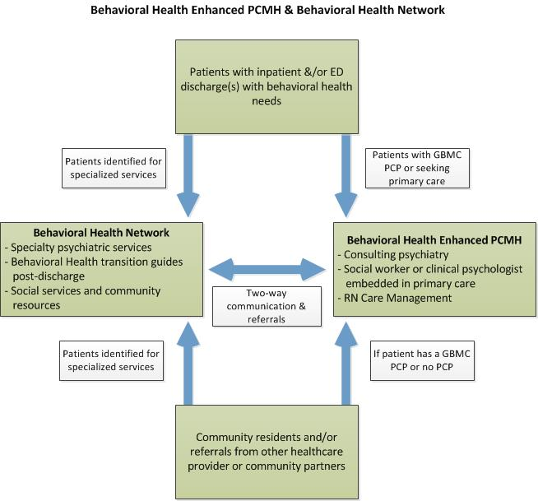

Supporting the broader population health strategy
GBMC expects the proposed program will help lower morbidity rates and have lasting effects on quality of life and the costs of care for Baltimore County residents by directly addressing the following dynamics and interplay of factors:

- By providing counseling and behavioral health support in the primary care setting, GBMC hopes to reduce rates of tobacco use, obesity, low birth weight babies, and drug and alcohol abuse. Mental health diagnoses are proven to have an impact on other behavioral risk factors, such as diet, exercise, and smoking; studies show that people with depression are more likely to have adverse risk behaviors such as smoking, poor diet, and sedentary lifestyle (Katon, 2010). Therefore, as the Program engages and provides services to Baltimore County residents, the Behavioral Health Program will have a positive “ripple effect” on the major risk factors identified by the Baltimore County Health Improvement Coalition and State Health Improvement Plan
- By working with formal screening tools and evidence-based protocols, the Program will more properly identify and treat more patients in need of services. National estimates report that only 20 percent of adults with common mental disorders receive care from a mental health specialist in any given year (Unutzer, Health Home May 2013).Under-recognition and under-treatment of depression in elderly patients is likely a greater problem, and can result in deteriorating medical conditions and increased service utilization (Cassano, 2002).
- By providing early treatment and steady support for behavior change, the Program will promote improved compliance and promote self-empowerment to further encourage self-management of chronic conditions. As noted earlier, mental health and chronic medical conditions are risk factors for each other; the presence of one condition tends to exacerbate the other condition. By way of illustration:
- Depression has been shown to adversely impact self-management of chronic illness, presumably due to its negative effect on memory, energy, sense of self-efficacy, and interpersonal interactions. These effects can cause patients to miss appointments and practice poor medication adherence. Depression has also been shown to be associated with poor adherence to diet and exercise regimens. Mental health professionals, positioned in the primary care setting, will be positioned to respond to early alerts from the primary care physician.
- Treatment is also expected to result in patient empowerment. As the program supports specific behavior changes, it may be expected to further encourage self-management to support healthier living with chronic disease.

As noted earlier, mental disorders are associated with roughly a two-fold-to-fourfold elevated risk of premature mortality, with the bulk of these deaths due to “natural causes” such as cardiovascular disease rather than accidents or suicides. GBMC is intent on reducing rates of serious mental illness, improving quality of life, and empowering more Baltimore County residents take charge of their health, use health care resources/community supports available, and reduce morbidity rates.

SECTION 3: MEASUREMENT AND OUTCOMES
The overall goals of the programs described above are to reduce readmissions, reduce visits to the emergency room, and reduce PAU’s and to reduce the cost of care to patients. The objective is to move patient care back into the community with primary care physicians and care managers providing the services needed. In order to reach the overarching outcomes GBMC has designed programmatic goals and measures to achieve the global outcomes. Please see Appendix A, tables 1-3 to view the HSCRC required outcomes and GBMC’s programmatic metrics.

SECTION 4: RETURN ON INVESTMENT
Supporting the goals of the All Payer Demonstration Project – The proposed project will focus heavily on patients with chronic conditions and high utilizers with mental health diagnoses. Through increased access to mental health services, greater reliance on community based support services, and strategies for patient empowerment, GBMC expects hospital utilization rates to decline considerably for the patient cohorts served. This will help meet the goals for readmission reduction, reductions in unnecessary utilization, and improved patient satisfaction scores.

 | Medicare Patients |  | Medicare Patients |  | Medicare Patients |  | Medicare Patients
Hospital/RP Name: GBMC | FY 2016  (January - June) |  | FY 2017 |  | FY 2018 |  | FY 2019
A. Number of Patients | 12,000 |  | 12,000 |  | 12,000 |  | 12,000
B. Number of Medicare and Dual Eligible | 1,100 |  | 1,100 |  | 1,100 |  | 1,100
C. Annual Intervention Cost/Patient | $1,097 |  | $3,131 |  | $3,131 |  | $3,131
D. Annual Intervention Cost (B x C) | $1,207,036 |  | $3,444,002 |  | $3,444,002 |  | $3,444,002
E. Annual Charges (Baseline) | $44,115,221 |  | $88,230,442 |  | $88,230,442 |  | $88,230,442
F. Annual Gross Savings (F(a)% x E) | $3,088,065 |  | $8,823,044 |  | $13,234,566 |  | $13,234,566
F(a). Gross Savings % | 7% |  | 10% |  | 15% |  | 15%
G. Variable Savings (F x 50%) | $1,544,033 |  | $4,411,522 |  | $6,617,283 |  | $6,617,283
H. Annual Net Savings (G-D) | $336,996 |  | $967,520 |  | $3,173,281 |  | $3,173,281
Return on Investment | 1.28 |  | 1.28 |  | 1.92 |  | 1.92
Explanations
A: 12,000 lives currently covered in the ACO
B: See the high utilizers in section 1
C: Annual Intervention Cost per Patient is Total Annual Intervention Cost divided by Number of Medicare and Dual Eligible
D: See the estimated Budget in Section 8
E: See the estimated annual charges on Section 1
F: Annual Gross Savings multiplied by the estimated Gross Savings Percent. FY 2016 (January - June) represents half a year of charges
F(a): Estimated Gross Savings Percent based on historical experience with the ACO reference material in Appendix D (b)
G: Variable Savings equal Annual Gross Savings multiplied by 50%
H: Annual Net Savings equal Variable Savings minus Annual Intervention Costs
ROI equals Variable Savings divided by Annual Intervention Costs

Among the Medicare high utilizers at GBMC, specifically, more than 56% of patients have a mental health or substance abuse diagnosis documented. Of the 2,383 admissions, a total of 405 were PQI admissions. GBMC believes that up to 15% of PAU’s in this group can be reduced by the clinical support, telephonic support, and social services supports provided by this program.

We are estimating that the ROI for 2017, 2018 and 2019 are the following: 1.28, 1.92, 1.92.

We anticipate with this ROI and with reductions in PAU’s and PQI’s we will be able to expand our program further by reinvesting in much needed resources for mental health professionals and phases in the dual eligible population. Through our investments in providing care within the community and within the primary care practices we are reducing costs for our payers and anticipate a savings to them.

SECTION 5: SCALABILITY AND SUSTAINABILITY
SCALABILITY:
As mentioned earlier GBMC is putting into place care coordination and care management along with behavioral health resources that are focused on Medicare high utilizers with 2 or more chronic conditions and a mental health diagnosis. As core competencies are built and GBMC builds upon the foundational elements of care management and patient center medical homes, the services within the grant application can be scaled to other payers of high utilizers. GBMC is actively working to prevent the next high utilizer and provide services around those patients.

POTENTIAL FOR SUSTAINABILITY
As new contracting models take shape, and as GBMC’s program proves its value - - in terms of medical cost savings, patient satisfaction, employee productivity, and reduction of long-term risk factors - - GBMC expects that the program will be self-sustaining through contracting models designed around PCMHs, mental health carve-outs, and/or value-based contracts specific to mental health services. ACO funding of the PCMHs: (Please see Appendix B for further details of programs). GBMC is utilizing and leveraging programs that are ‘shovel-ready’. The current programs have the ability to expand rapidly and touch a greater Medicare population with the addition of behavioral health professionals.
- The expectation is that the Greater Baltimore ACO will continue to fund the PCMHs, and that a single funding stream to the ACOs will include support for both the medical and behavioral health services care coordination. Savings from the ACO will also support performance-based activity for behavioral health service providers in the ACO.
- Support Our Elders services will likely be seen as valuable to the growing Medicare Advantage plans. These plans will either need to "build or buy" the in-home SOE-type services. Additionally, if the federal Independence at Home demonstration is expanded, this could present an additional source of shared savings.
- GBMC expects to work with its partner, Evergreen Health, to develop the “value proposition” to payers, accompanied by hard data to demonstrate the costs of under-treatment and the savings of a collaborative care model where more care is shifted to the community-based setting. This is expected to lead to mental health contracts that may take any number of forms:
- Contracts with employers – Depression can be very costly to employers, particularly if the employer is self-funded. Costs to the employer include direct health care expenses, lost days of work, and reduced productivity. Studies show that patients with depression miss an average of 4.8 workdays during a 90-day period, and have a greater loss if reduced productivity is also considered (Valenstein, 2001). GBMC will market directly to employers, including self-funded employers as well as purchasers of health plans, to highlight the opportunity to reduce costs.
- Mental health carve-outs with commercial payers – GBMC may expect any number of different approaches ranging from fully capitated payments to case-rate payments that supplement fee for service billing by primary care provider, accompanied by a shared savings formula based on quality metrics.
- Value-Based Insurance Design (VBID) – A “root cause” of mental health problems escalating is the financial barrier to care; copayments often discourage patients from seeking care, resulting in delays until the point of crisis. Just as health plans have recognized the value of eliminating copayments for routine services to minimize downstream costs of untreated medical conditions, so too is there the need to apply this principle to behavioral health services. GBMC will seek to establish Value-Based Insurance Design products, in which GBMC is identified as a high value provider and copayments would be eliminated. This model would be designed to remove financial barriers and encourage patients themselves to seek high value behavioral health care providers. (Note: GBMC is in the preliminary stages of discussing a partnership with Evergreen Health to develop such a product).
- Medicaid program – As ACOs are established for Medicaid and dual eligibles, GBMC expects that there will be the opportunity for performance incentives based on state defined quality measure, models that are already in place in other states. GBMC would expect a mental health carve-out PMPM to manage patients identified for an integrated care plan.
  - Recent research shows that depression lowers the chance that individuals who are unemployed will reenter the workforce, and individuals who retire early due to depression face long-term financial disadvantage. The systematic implementation of collaborative care programs for depression in primary care can reduce many of these negative economic effects of depression, resulting in improved personal income, employment and other workplace outcomes. As noted in the RWJ report, “these findings suggest the potential for effective treatment to help enrollees successfully return to the workforce, resulting in net savings to the Medicaid program.”

SECTION 6: PARTICIPATING PARTNERS AND DECISION-MAKING PROCESS
Oversight of the population health initiative resides in the governance structure of GBHA, which houses the ACO. The responsibility of this Board is to provide quality review, management and care coordination to support the delivery of health care services and supplies in an accountable and cost efficient manner consistent with the Three Aims and to organize, maintain and operate a formal program, including clinical pathways with operating and clinical protocols (“Population Health Management and Clinical Integration Program”). The duties of the governance board are more fully explained in Appendix B.

Community partners
GBMC will supplement its own services by partnering with organizations to provide related behavioral health and support services. Program partners and services provided are included in Appendix E.

Program planning process
- Meeting to focus on screening, processes, workflow, roles of each team member
- Protocols:
  - Who is screening
  - Referral and criteria for consultation
  - Use of telehealth
- Processes that will need to be developed will include consistent methods for assessment, criteria for treatment, monitoring, tracking systems to determine progress, evidence-based treatment plans, (includes pathways for intensification of treatment), and relapse prevention plans.
- Outcomes and reporting processes
- Accountability

Broader planning processing with partners
- All- day retreats with direct service providers and partner organizations (2/year) - to allow for deeper round table discussions. One will occur early in the planning process in order to identify challenges and any resource constraints/requirements; brainstorm about elements that are most critical to success. Messaging to their organizations in order to be certain there is strong executive buy-in from each organization.
- Another retreat will be held part-way through the process to check on progress and review any areas where continued discussion is required.
- The third retreat will be used to finalize and present the final plan for the partners. The fourth collaborative retreat will be used to report on findings and “lessons learned” post-implementation in order to make changes to improve the model moving forward. Review outcomes.

Measurement, monitoring, accountability -
- Agree on outcomes. A key component to this shared implementation model will require a data driven plan with agreed upon outcomes. It will likely include the use of both clinical and financial data on an ongoing basis to assess the success of the program. Clinical outcomes could include improvement on evidence-based screening tools, such as the PHQ-9, a patient health questionnaire used to measure health outcomes, for patients with depression.

- Data reporting and analytics - development of consistent policies with shared accountability across all the partner organizations built into the plan. IT planning will involve determining the workflows within the currently IT environment. Ideally, there will be one, unified medical record where all the care team members, whether part of primary or specialty care, can document. Additions to the current electronic medical record will include new workflows for enhanced mental health evaluations. Registries will be created from information from all involved partners in order to ensure strong communication between all those involved.

Program operations and program monitoring -A number of key elements will operate to establish shared decision-making, monitoring and measurement, accountability, and continuous quality improvement:

- Monthly meetings – The Behavioral Health Network will meet monthly to review the progress of the program

- Steering committees
(smaller groups to report to Steering Committee)

- Payment models, contracting, and other financing strategies (lobbying; value based contracts; innovative models; etc)
- Care management and service integration; roles of consulting psych and each team member;
- Measurement, outcomes, and IT - tracking progress, outcomes, and status over time
- Workflow and service delivery - use of standard and reliable screening tools, care pathways and evidence based guidelines

SECTION 7: IMPLEMENTATION WORKPLAN
Please see Appendix C

SECTION 8: BUDGET AND EXPENDITURES
Hospital/Applicant: | GBMC
Number of Interventions: | 3
Total Budget Request ($): | $1,207,036 FY16

Workforce/Type of Staff | Description | Amount
Care Coordination Staff
 | 13 - RNs / Care Managers | $371,067
 | 10 - Psychologists or LCSW | 350,000
 | 4 - Nurse practitioners | 160,000
 | 1 - Pharmacist | 57,866
 | 28 - Total Clinical Staff | $938,933
Administrative Staff
 | 2 - Manager of population health services | $139,368
 | 2 - Total Administrative Staff | $139,368
 | Total FY 2016 Salary Expense - 30 Staff | $1,078,301
 | Total FY 2016 Salary Expense with Benefits @ 25% | $1,347,876
IT/Technologies | Description | Amount
Hardware
 | Laptop | 8,000
 | Phone | 1,440
 | Total FY 2016 Technology Cost | $9,440
Other Implementation Activities | Description | Amount
Employee Incurred Expenses | Mileage for Employees ($0.56 per mile x 25,000 miles per year for each clinician and 250 miles for Palliative NP) | $11,872
Contract Fee
 | Kolmac Group (management fee for psychiatric nurse contract) | 20,000
Patient Related Expenses
 | Telemedicine Services | 6,500
 | Ancillary Services | 25,000
 | Total FY 2016 Other Cost | $63,372
Other Indirect Costs | Description | Amount
Employee Incurred Expenses | Overhead (supervision, accounting, billing, etc.) | $99,448
Part B Revenue Collection | Revenue Offset from Part B Collections | (313,100)
Total Expenses/Investments |  | $1,207,036
Hospital/Applicant: | GBMC
Number of Interventions: | 3
Total Budget Request ($): | $4,837,002 FY17
Workforce/Type of Staff | Description | Amount
Care Coordination Staff
 | 17 - RNs / Care Managers | $1,019,544
 | 10 - Psychologists or LCSW | 700,000
 | 6 - Nurse practitioners | 487,500
 | 1 - Pharmacist | 115,731
 | 2 - Psychiatrists | 440,000
 | 2 - Social Workers | 120,000
 | 2 - Geriatrician | 430,000
 | 40 - Total Clinical Staff | $3,312,775
Administrative Staff
 | 2 - Manager of population health services | $139,368
 | 2 - Total Administrative Staff | $139,368
 | Total FY 2017 Salary Expense - 42 Staff | $3,452,143
 | Total FY 2017 Salary Expense with Benefits @ 25% | $4,315,179
IT/Technologies | Description | Amount
Hardware
 | Laptop | -
 | Phone | 8,640
 | Total FY 2017 Technology Cost | $8,640
Other Implementation Activities | Description | Amount
Employee Incurred Expenses | Mileage for Employees ($0.56 per mile x 25,000 miles per year for each clinician and 250 miles for Palliative NP) | $93,744
Contract Fee | Kolmac Group (management fee for psychiatric nurse contract) | 40,000
Patient Related Expenses
 | Telemedicine Services | 13,000
 | Ancillary Services | 50,000
 | Total FY 2017 Other Cost | $196,744
Other Indirect Costs | Description | Amount
Employee Incurred Expenses | Overhead (supervision, accounting, billing, etc.) | $316,439
Part B Revenue Collection | Revenue Offset from Part B Collections | (1,393,000)
Total Expenses/Investments |  | $3,444,002

SECTION 9: BUDGET AND EXPENDITURES NARRATIVE
The total program budget for this new initiative is $3,444,002, which includes clinical professionals, administrative and analytics functions, training, and consulting support.

The proposed program incorporates three categories of resources: (1) Clinical manpower (2) program development and start-up costs, including a central coordinating office, and (3) program leadership costs. All of these resources will be positioned from the start of the program, but there will be a ramp-up of patient volume and an evolving clinical reimbursement system to support program expenses.
Other expenditures such as telemedicine and equipment for the care managers within the BH-PCMH and the SOE program will be necessary to ensure the success of the program.

GBMC expects that early identification, early intervention, and use of community-based supports will significantly reduce ER visits and PQI admissions; care management relationships and community supports will respond to needs of the patient before medical conditions are exacerbated, and patients will become accustomed to rely on supports other than the hospital. In addition, GBMC believes that many more patients will access mental health services early on, as the stigma is removed; this will lead to early identification and more effective management of chronic medical conditions which will reduce the need for hospital services.

Hospital/Applicant: | Greater Baltimore Medical Center
Date of Submission: | 12/21/15
Health System Affiliation: | GBMC
Number of Interventions: | 3
Total Budget Request ($): | $3,444,002 FY16 and FY17

SECTION 10: SUMMARY OF PROPOSAL

Target Patient Population (Response limited to 300 words)
The target population is high-utilizer patients who frequent GBMC’s acute care hospital. These 1,054 adult patients had two or more inpatient or observation encounters in FY 2015, they represent 56% of GBMC’s high utilizing patient population, their usage accounted for 36% of total Medicare charges last fiscal year. More than half (56%) of high-utilizers have at least one chronic condition and/or mental health and substance abuse diagnosis. Of the 1.054 Medicare high utilizing patients 97% have at least 1 chronic condition, 98% of the cases and 97% of charges are associated with Chronic Conditions and 84% of the patients have at least 2 or more chronic conditions (primarily hypertension, diabetes, congestive heart failure, and coronary artery disease). Within the target population of 1,054 high utilizers (emphasizing the middle tier of 840 patients), GBMC plans to focus Medicare high utilizers as the first payer source to provide services to.
Summary of program or model for each program intervention to be implemented. Include start date, and workforce and infrastructure needs (Response limited to 300 words)
Upon awarding of the grant within 10 days we expect to begin rolling out the following programs:
- The Behavioral Health Enhanced Patient-Centered Medical Home (BHE-PCMH) - The proposed program builds upon the patient-centered medical home model already operating in GBMC’s primary care practices by strengthening existing primary care teams with a mental health professional and by providing ready access to psychiatric consultation services.
- The Behavioral Health Network (BHN) - The proposed model integrates new behavioral health resources into the continuum of care to provide the following:
    - Psychiatric consultation in the hospital
    - Post discharge mental health support
    - Telehealth services
- Palliative Care and Support Our Elders: Home- and Facility-Based Care for Complex Chronic Patients – The proposed program in partnership with Gilchrist and MedStar, will identify patients with multiple chronic conditions who require frequent hospitalizations due to the advanced degree of the chronic condition(s). This program will also provide clinical staff for palliative care efforts in 2 nursing homes within the services area. In partnership with MedStar, GBMC will coordinate efforts to provide care within patients home through home visits by a nurse practitioner.
- Expansion of Care Coordination and Care Management Services- GBMC has embraced the PCMH model in nine primary care offices with a deliberate focus on care coordination, preventive health care and population health. GBMC’s approach placed an emphasis on helping patients achieve and maintain better health with tactics in place to reduce avoidable hospital admission and unnecessary emergency department use, eliminate gaps in care for routine screenings and improve quality outcomes for patients with chronic conditions.

Measurement and Outcomes Goals (Response limited to 300 words)
The overall goals of the programs described above are to reduce readmissions, reduce visits to the emergency room, and reduce PAU’s and to reduce the cost of care to patients. The objective is to move patient care back into the community with primary care physicians and care managers providing the services needed. In order to reach the overarching outcomes GBMC has designed programmatic goals and measures to achieve the global outcomes. Please see Appendix A, tables 1-3 to view the HSCRC required outcomes and GBMC’s programmatic metrics.
Return on Investment. Total Cost of Care Savings. (Response limited to 300 words)
The ROI calculated for the years 2017-2019 are: 1.28, 1.92, and 1.92 respectively. From a broad perspective, shifting avoidable acute care to more cost effective care in the primary are and community-based settings will inherently save payers money, as we have found with our ACO and the implementation of patient centered medical homes.

Since each of the interventions are expected to positively impact PAUs and PQIs, the GBMC system will invest these savings to expand upon the proposed program for continued cost savings. Specifically,
GBMC is strategically planning to focus on the Medicare portion of the high utilizer population during the grant period (CY 2016) to secure the highest ROI in the short term. Thereafter, GBMC will reinvest into the program with scalability plans for Dual Eligibles, followed by Medicaid beneficiaries, and finally to commercial payers. Our goal is to meet the waiver requirements and to achieve the mandated of the all payer system.
Scalability and Sustainability Plan (Response limited to 300 words)
Through the three interventions described above, GBMC expects to realize a sustainable and scalable model of integrated health care that better manages high-risk patients and reduces avoidable hospital admissions and ER visits. The requested rate increases will enable GBMC to achieve the population health model proposed in this application, which will in turn reduce healthcare costs and ultimately ensure financial sustainability. Since the three programs are leveraging existing population health efforts the programs are easily scalable across this patient population and eventually across all payers whose patients need the services GMBC is proposing.
Participating Partners and Decision-making Process. Include amount allocated to each partner. (Response limited to 300 words)
In addition to utilizing the current ACO structure to be consistent the population health approach and management of the high utilizers, GBMC has partnered with the following community resources to provide the needed resources to make the three interventions successful.
- Allegeant
- Baltimore County Health Department
- Care Progress, LLC
- Catholic Charities
- Evergreen Health
- Health Care for All Coalition
- Keswick Multi-Care Center
- Kolmac Clinic
- Mosaic community services
- MedStar
- Sheppard Pratt Health System
As such there is representation as advisors to our ACO governance structure from SNF’s, nursing homes, families and patients as well as other community resources GBMC depends upon.
Implementation Plan (Response limited to 300 words)
The attached implementation plan is geared to beginning much of this work February 1st. The initiative to provide care to our elders is a service that is “shovel ready” to begin today. The Behavioral Health network is a referral process that can be provided today. To strengthen our patient centered medical home we will contract with Mosaic and Sheppard Pratt to have psychiatry and other behavioral health resources available to our existing medical home offices as of February 1, 2016. The additional resources to expand our patient centered medical home to care for the top utilizers will fill a need for the patients who are utilizing acute services.
The three new initiatives are leveraging existing population health efforts and providing further services to a much needed patient population.
Budget and Expenditures: Include budget for each intervention. (Response limited to 300 words)
The total program budget for the new initiative is $3,444,002 million which includes clinical professionals, administrative and analytics functions, training, and consulting support. GBMC anticipates that in the first six months of the grant award that there will be a “ramp-up” of clinical staff and more in the following calendar year. GBMC expects that the total clinical staff required for the program will be fully in place by 2017. GBMC does see the challenge of fully staffing mental health professionals in the PCMH, however has partnered with Kolmac and Shepperd Pratt to provide services for patients early on.

APPENDIX A

Table 1. Core Outcome Measures

Table 2. Core Process Measures
Measure | Definition | Source | Population(s) expected
Use of Encounter Notification Alerts | % of inpatient discharges that result in an Encounter Notification System alert going to a physician:  ACO and aligned physicians within the ACO receive ENS alerts 100% | CRISP | - The identified target pt. population  - Continue to monitor part of the daily work flow  - Shared daily with care team
Completion of health risk assessments | % High utilizers with completed Health Risk Assessments:  Currently completed 100% on all patients  Groups with highest scores are managed by CM | Hospital | - All Patients  - High risk receive Care management  - Evolving risk GBMA pt. followed by PCP  - Private physicians are notified of evolving risk
Established longitudinal care plan | 100% of High Utilizers Patients have a care plan:  - ED doc will start a care plan send to PCP. The PCP completes the care plan.  - Hospital will start the pt. on a care plan prior to discharge | Hospital, and PCMH | - High utilizers
Shared Care Profile | 100% of patients with data shared through HIE in Care Profile; utilized by providers | CRISP | - High utilizers
Portion of target pop. with contact from assigned care manager | % of High Utilizers Patients with contact with an assigned care manger:  70% of targeted patient population have contact with a CM or TOC | PCMH | - High utilizers

Table 3. Programmatic Metrics and Goals

# | Project | How will resources be used? | Program goals/outcomes
1 | Top Utilizers case manager | -Top 100 utilizers of care at GBMC will be reviewed monthly and revisited by case manager  -Patients will be followed up by case manager and have individualized care plans | -Reduce ED and hospital utilization at GBMC  -Change location of care from ED to primary care practices
2 | Top Utilizers Service Coordinator - enrollment in community programs in coordination with SW case manager | -High utilizers will be paired with coordinator to sign up for community resources | -Reduce ED and hospital utilization  -Increase enrollment in insurance plans
3 | Clinical pharmacist - partnership with student pharmacists - medication reconciliation | -Having a pharmacist partner with students will provide a full-time resource to review high utilizer patients' medications upon discharge and in the patient’s home explain the purpose of each medication  -Pharmacist will join care management team | -Reduce ED and hospital utilization  -Reduce readmissions
4 | Psychiatric nurse - addiction case manager (contract with Kolmac Group) | -Full-time addiction case manager in ED will address drug seekers in ED and discuss treatment options with them | -Reduce ED utilization  -Address drug seeking behaviors by promoting rehab/counseling
5 | NP, RN case manager, and admin staff for expansion of nursing home-based palliative care | -NP will provide nursing home care in 2-4 additional Genesis and/or Lorien facilities (depending on case volume and geography)  -0.5 FTE RN case manager will provide additional support to NP  -0.5 FTE admin coordinator will manage reporting, scheduling, billing | -Enroll 25% of facility in palliative care program, about 70 patients across all facilities  -Enroll 100% of dementia, vent, and dialysis unit patients in palliative care  -Reduce avoidable hospitalizations  -Reduce ED utilization  -Reduce high rate of readmissions in Genesis and Lorien facilities
6 | NP and admin staff for expansion of Support our Elders program | -SOE will be expanded to western Baltimore County, namely the Owings Mills and Pikesville area (west of I-83), an area we cannot reach with current resources  -Referrals currently turned away from this area due to limited capacity  -Model based on MedStar IAH grant - team of 8 to cover 300 patients:  -2.0 FTE of physicians  -2.0 FTE NP  -2.0 FTE Social work  2.0 FTE of admin coordinator (combined with palliative) will manage reporting, billing, scheduling | -Increase hospice referrals  -Reduce avoidable hospitalizations  -Reduce ED utilization

APPENDIX B
Program Financing: Near Term

- Greater Baltimore ACO – Portion of the PMPM to the PCMH’s
Oversight of the population health initiative resides in the governance structure of GBHA, which houses the ACO. The responsibility of this Board is to provide quality review, management and care coordination to support the delivery of health care services and supplies in an accountable and cost efficient manner consistent with the Three Aims and to organize, maintain and operate a formal program, including clinical pathways with operating and clinical protocols, that includes one or more of the following (“Population Health Management and Clinical Integration Program”):

- Implement systems to establish goals relating to quality and appropriate utilization of services by ACO Participating Providers and other providers, physicians and professionals and to meet the goals of the Three Aims.

- Regularly evaluate all aggregate performance with respect to those goals.

- Modify individual provider and physician clinical practices, where necessary, based on those evaluations, including through a performance improvement and remedial process.

- Utilize care coordination, care management and network development with a focus on areas such as, primary care, specialty care, emergency services, skilled nursing facilities, hospital inpatient and outpatient services and population management, including chronic illnesses, such as diabetes and cardiac issues, to work towards patients receiving services in the right setting and at the right time.

- Develop policies and procedures, including clinical protocols, based on the Three Aims, which: (a) integrate practice standards and evidenced-based protocols to govern treatment, utilization of services and prevention interventions for its population; (b) manage the care of individuals and populations, including patients with chronic illnesses; (c) integrate and connect primary care, specialty and other services across the care continuum, including the development and review of clinical pathways; (d) define and hold accountable the role of primary services in navigation and education of patients; (e) establish and regularly review the financial model, including care coordination fees, shared savings and losses, provider pools and ability to take on risk, as well as create value and savings to support patient care; and (f) coordination with and active review of the care rendered by each ACO Participating Provider and individual physicians and professionals in light of the Company’s policies and procedures, pathways and protocols.

- Secure significant investment of time and capital to: (a) purchase information systems necessary to share and gather aggregate and individual data on the cost, quantity and nature of services provided or ordered by J\CO Participating Provider, hospitals, primary care and specialty physicians and other professionals; (b) analyze data from various payor sources to managed the care of individuals and populations and to provide care coordination across care settings; (c) monitor patient and caregiver satisfaction; (d) utilize health information exchanges to share data and coordinate data across the medical neighborhood; (e) use care coordinators and care managers paired to assist primary care providers and others in the network with patient navigation and efficient utilization of services; and (f) comply with applicable state and federal laws and regulations, including laws related to transaction sets, fraud and abuse, and privacy and security of patient information.

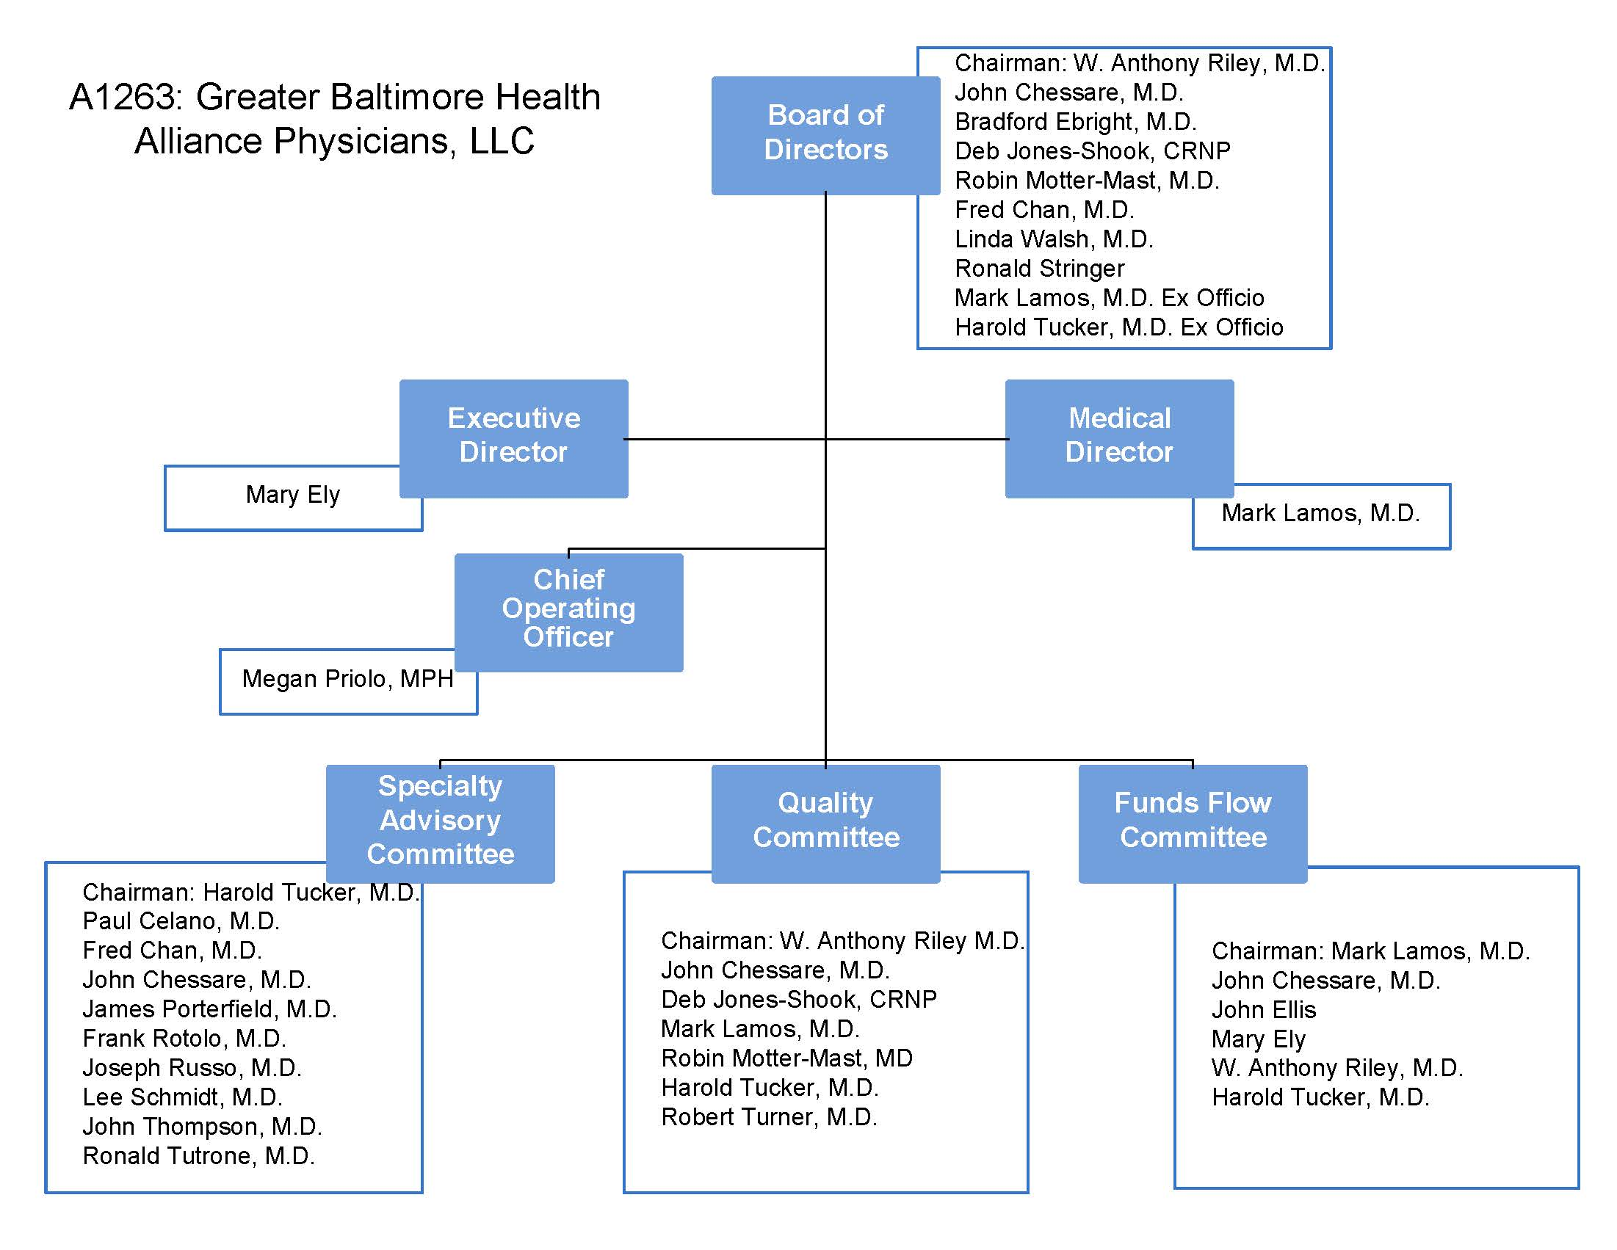

APPENDIX C
Please see the attached project plan

APPENDIX D (a)

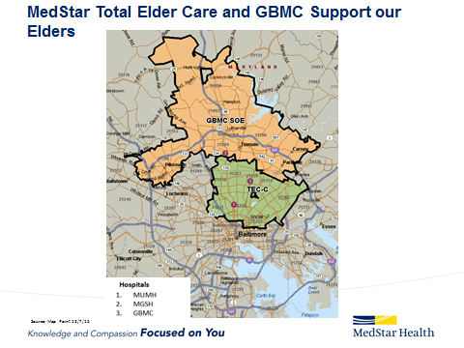

Care Management Model and Site Expansion Map

Care Management Model
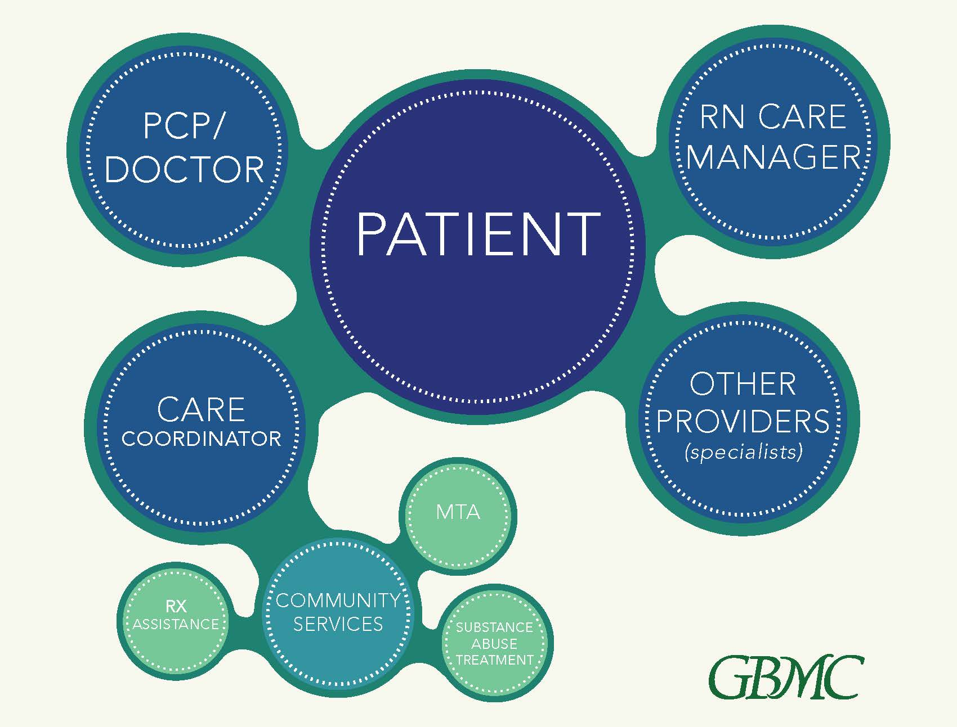

Site Expansion Map
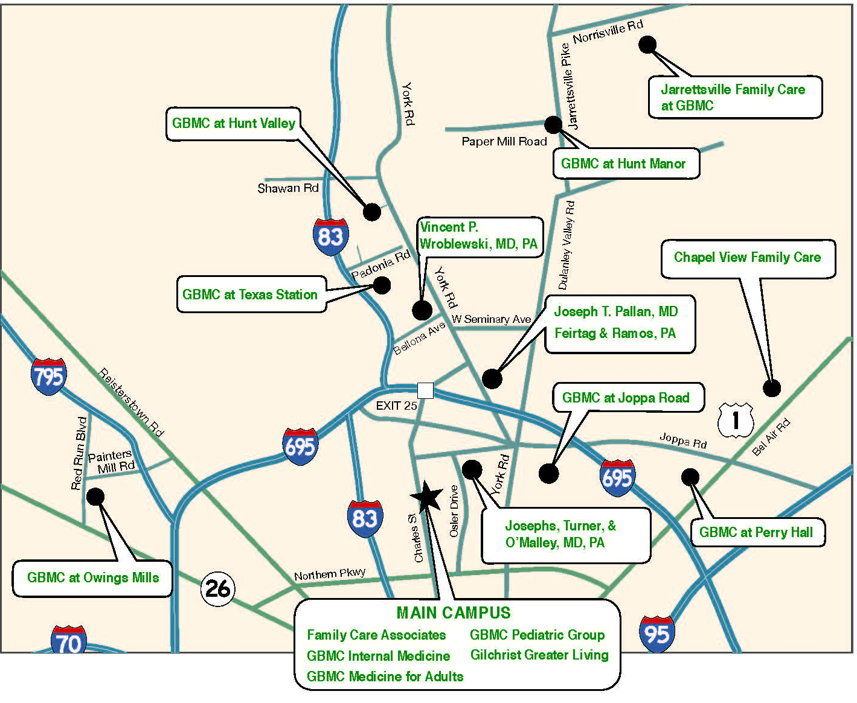

APPENDIX D (b)

Evidence to support the proposed model – The proposed model - -centered around the primary care setting, with “stepped care” approaches to mental illness management - - complements and integrates with GBMC’s existing medical homes model, and is supported by evidence of success in the literature. In particular, the model has proven effective in patients with comorbid depression, diabetes, coronary heart disease, and chronic pain. A selection of evaluations/findings is presented below:
- IMPACT Collaborative Care Program (“Improving Mood: Promoting Access to Collaborative Treatment”) - Results from this randomized controlled trial, examining 18 different primary care clinics spanning 5 states, are compelling. Results showed that this collaborative care approach was associated with a reduction in depression, improved physical functioning, improved quality of life, and reduced medical costs over a four year period. Although the costs are initially higher with the onset of program participation, the study found a four year cost savings in outpatient mental health, pharmacy, and inpatient costs. Results showed an initial cost of approximately $500 per patient, and an average of approximately $3,300 in savings per patient. The IMPACT model included a care team comprised of the primary care provider, a behavioral health care manager, and a consulting physician, similar to the BHE-PCMH Program structure. Worth noting is the more recent findings showing that the IMPACT program was effective for diabetics, including low-income Spanish speaking patients.
- A 2013 review of collaborative care evaluation studies, prepared by the Robert Wood Johnson Foundation, conducted across a diverse set of health care settings, concluded that studies “consistently demonstrated higher effectiveness than usual care.” Moreover, these studies indicated that the model was effective for safety net patients and patients from ethnic minority groups, and can reduce disparities in care across populations (RWJ, ## 34-39).
- A 2014 RAND evaluation of the SAMHSA Primary and Behavioral Health Care Integration Program examined a broad range of integrated behavioral health programs. However, the RAND report specifically noted that co-locating primary care and behavioral health services was critical to effectively improving access to care (RAND 2014).
- The Mayo Clinic (2015) – The Mayo Clinic implemented the collaborative care model and the DIAMOND program (Depression Improvement Across Minnesota) aimed at managing adult depression in primary care. Key features included: Use of the PHQ-9 for screening and ongoing measures; a registry to track patient progress; stepped care approach for treatment; a relapse program; a care manager; and a psychiatric consultant engaged with the care managers and PCPs. The program was enormously successful and the program has been expanded to all of The Mayo Clinic’s primary care clinics.
- UnityPoint Health Trinity (Rock Island, IL) – This health system implemented formalized behavioral health screenings in the ER and PCP offices, and provided behavioral health therapists (LCSWs) in high volume primary care clinics to provide immediate access to patients identified. This 3-year initiative reported a 50% reduction in ED visits, a 54% decline in psychiatric admissions, and a 32% reduction in medical readmissions for the 366 patients served by the behavioral health program. This was accompanied by a 137% improvement in quality of life scores.
http://www.unitypoint.org/quadcities/filesimages/services/Sg2_Case%20Study_UnityPoint_RYC_011315.pdf

GBMC HealthCare, Inc. is continually looking for ways to apply its vision, which states "To every patient, every time, we will provide the care that we would want for our own loved ones.” This vision is carried out at every stage of patient care, and is centered on the general practitioner and the primary care setting. Since 2010, GBMC has been at the forefront of comprehensive primary care by embracing the patient-centered medical home (PCMH) model. Marked by increased access to healthcare and a coordinated team of providers working together to manage patients’ health outcomes, the PCMH is an advanced primary care concept.
GBMC has embraced the PCMH model in fifteen primary care offices, with a deliberate focus on care coordination, preventive healthcare and population health. GBMC’s approach places an emphasis on helping patients achieve and maintain better health, with tactics in place to reduce avoidable hospital admissions and unnecessary emergency department use, eliminate gaps in care for routine screenings, and improve quality outcomes for patients with chronic conditions.
When a patient utilizes GBMC HealthCare, Inc., they are instantly connected with resources designed to help them take control of their health and well-being. By deploying both RN Care Managers and Care Coordinators at its primary care practices, GBMC is bridging the gap between patients and providers. The presence of these additional resources in the primary care practices is one way GBMC separates itself from its competitors, as the RN Care Managers and Care Coordinators are integral facets of GBMC’s PCMH model. These individuals work collaboratively to provide clinical, administrative and social support, which provides patients in the primary care setting with tools to improve their health. Together with the practice staff, provider and other community resources, these individuals make up what is referred to as the “care team.” The care team efforts have been recognized by the National Committee for Quality Assurance resulting in Level 3 PCMH certification.
CRISP
Keeping in line with the organization’s goal of keeping patients healthy and providing care in the most appropriate setting, a major focus of the care team is reducing avoidable hospital admissions and unnecessary emergency department visits. Through the regional health information exchange Chesapeake Regional Information System for our Patients (CRISP), GBMC is notified in real time when its patients visit any hospital or emergency department in the state of Maryland through the CRISP Encounter Notification System (ENS). This process allows the RN Care Manager and Care Coordinator to work with the patient and provider to address any unmet needs following the visit. The care team ensures resources are in place to prevent readmissions or unnecessary emergency department use in the future. It also allows for a secure, HIPAA-compliant exchange of patient information, diagnosis and follow-up care needs.
TRANSITION OF CARE
The above mentioned process is commonly referred to as the Transition of Care. This process, which aims to reduce readmissions and avoidable utilization, is achieved through collaboration with the primary care team. Within 48 hours of hospital discharge, though in many cases the same day, RN Care Managers contact patients to review discharge instructions including medications and discuss the patient’s next steps. They help to ensure that patients have a primary care appointment scheduled within at least 14 days of discharge, many times even sooner, and that they are educated about any potential complications or side effects. Moreover, RN Care Managers conduct post-discharge Medication Reconciliation, providing the patient with medication education, including proper dosage and side effect information. As part of this process, the Care Coordinators ensure patients’ medical records are updated and that all medical records, including discharge summaries, physician’s notes, test results, and specialist visits are documented and posted in the medical record.
CHRONIC CONDITION CARE PLANS
In addition to the Transition of Care process, the RN Care Managers also provide clinical support and education related to chronic conditions to at-risk patients. Patients that benefit from these services include patients with newly diagnosed chronic conditions such as diabetes, high blood pressure or congestive heart failure; patients with multiple chronic conditions; or individuals with frequent hospital utilization. RN Care Managers work to ensure patients understand their care plans and provide ongoing support and counseling, working together with the patient to develop goals and an action plan for their chronic condition. This is done in a mutual, collaborative manner based on the level of patient activation or readiness to change. The clinical targets for the chronic condition are set by the RN Care Manager and provider, however the goals are written in the patient’s own words based on what they are ready and willing to work on at their particular stage of their chronic condition. Available for 1:1 support via phone, email or in-person appointments, RN care managers serve as a point of contact for all health concerns not requiring immediate physician attention.
COMMUNITY RESOURCES
While RN Care Managers have an overarching focus on “at-risk” patients, the role of the Care Coordinators involves helping all patients in the primary care setting navigate the healthcare system. By establishing relationships with community organizations and connecting patients with essential services, Care Coordinators work to remove barriers that can prevent patients from accessing the care they need. The Care Coordinators help patients find resources like public transportation, mental health/substance abuse treatment, home health care, durable medical equipment and prescription assistance, connecting them with organizations like Mosaic Community Services, Maryland Transportation Authority, Towson Medical and County Ride, to name a few.
QUALITY IMPROVEMENT
Clinical quality is a fundamental to primary care delivery and a key focus of both the RN Care Manager and Care Coordinator. Each month, all primary care physicians receive a quality scorecard. Scorecards use data analytics that allow each provider to monitor his or her progress in regard to a list of Accountable Care Organization (ACO) clinical quality measures. The Centers for Medicare and Medicaid Services (CMS) benchmarks are also included on the scorecards so that providers can compare themselves not only to their practice and ACO, but to national goals set by CMS. The scorecards are distributed to both the individual provider and his or her practice, allowing providers, care managers and care coordinators to work together to identify patient care gaps or other risk factors. All providers and practices receive all scorecards, not only their own, in addition to rankings for each measure by provider. In this way, GBMC promotes transparency and can promote learning and spread of successful strategies across the system. An example of a scorecard is displayed below.

The monthly scorecards provide a snapshot of quality metrics related to both chronic disease management and care gaps for illness prevention, including immunizations, diabetes, hypertension, weight management, falls risks, medication reconciliation, breast and colorectal cancer screenings and more. Providers are able to easily identify specific measures to focus on and improve. Other examples of scorecard benefits include identification of patients overdue for screenings or with uncontrolled chronic conditions, which prompts proper interventions to occur. The ambulatory care manager and care coordinator, described above, are integral to this process. They work together with the providers to engage patients that may have gaps in care or who may need additional resources. This is possible due to the ability for the care team to drill down on any measure to see the patient level detail of who has or has not met a particular measure, which guides the care teams as to which patients may be in need of outreach for follow-up care.
GBMC was able to develop and implement these scorecards out of its system-wide integrated data warehouse. This data warehouse pulls information from various systems and medical records across the organization and merges them together for integrated reporting. The data for the scorecards updates every night and therefore is close to real-time making it incredibly actionable for the practices.
GBMC custom-built these scorecards to mirror the Medicare Shared Savings Program (MSSP) ACO clinical quality measures. However, in July 2015, GBMC broadened the scope of these measures to include an even larger denominator to further emphasize population health. As of July 2015, the patients included on the scorecards include any patient that was seen at least once in any practice throughout the system, regardless of payer, over the previous 18 months. This is a rolling number that updates daily. In this way, we aim to capture more patients than only those that were seen in the calendar year as many measure definitions stipulate. Furthermore, GBMC is actively adding additional measures to align with other patient populations and payer requirements.
Since the implementation of these scorecards in the practices, there has been significant improvement in the quality measures at GBMC, detailed in the graphs below. This has been achieved through a team approach which involved cleaning up data entry, scheduling patients for overdue screenings and tests, doing system-wide outreach and education coordinated with our marketing team, and providing education and counseling via care management and coordination in the primary care practices. In addition to improving performance rates, the use of these scorecards has increased awareness of ambulatory care quality throughout the entire system. It has also promoted engagement in delivering the highest quality outcomes possible. The quality measures are now an integral component of the system workflow, from the medical assistants, to the nurses, to the providers, to management, to the executive team, and even the board.
ACCESS
When patients can access their healthcare providers during weekend, early morning and evening hours, the need for most emergency room visits is eliminated. GBMC’s PCMH delivery model facilitates after-hours access to care for sick patients. The resulting cost savings benefit both the patient and the organization. Furthermore, all GBMC HealthCare patients have secure, 24/7 access to an electronic patient portal which allows them to securely view medical records, test results and prescriptions as well as send confidential messages to their care team.
RESULTS
The goal of the care team is to meet the needs of patients in a responsible, effective, reliable fashion. Ultimately, the goal of Care Coordination at GBMC is to ensure better health, better care, least waste and more joy for those providing care.
Positive outcomes for our patient population are a direct result of the above efforts and investments. There has been a marked improvement in several key indicators for the GBHA MSSP population as depicted graphically below. Since 2012, the number of hospital discharges per thousand has decreased by 28.21 percent since 2012. Emergency department visits per thousand in this same population decreased by 11.7 percent, and there has been a 7.8 percent decrease in 30 day all cause readmissions. The readmission rate of GBMC hospital for all patients and payers in 2012 was 6.63 percent with a steady decline to the current level of 5.59 percent, which represents a decrease of about 30 patients per month. GBMC currently has the lowest severity adjusted readmission rate in the state. In addition to improved utilization, total annual expenditures for the GBHA MSSP population have decreased by 9.75 percent since 2012.

Investments in population health information technology, care management and care coordination have been pivotal in the steady improvement of clinical quality performance rates at GBMC. As a healthcare system, GBMC has focused on all ACO metrics with particular emphasis on population health metrics such as Diabetes Composite, Colorectal Cancer Screening, and Breast Cancer Screening. In each of these measures, GBMC has improved dramatically over time as shown below. This is a direct result of targeted focus on quality metrics through the scorecard process, the efforts of the RN Care Manager in providing chronic care education, and the efforts of the Care Coordinator in closing gaps in care. The rate reduction visible in all graphs below in July 2015 is due to an expanded denominator as described above.

Additional quality measures that have improved over time include but are not limited to Falls Risk Screening, BMI Screening and Follow-Up, and Hypertension Blood Pressure Control.
In addition to these real-time quality improvements for the entire patient population, positive quality results were also achieved in the MSSP with a quality score of 88.76 percent, higher than both the state and national averages of 82.61 percent and 83.08 percent respectively.

APPENDIX E
Program Partners
GBMC will be supplementing its own services by partnering with organizations to provide related behavioral health and support services. Program partners and services provided will include (in alphabetical order):

- Allegeant: A wellness organization that works with payers and employer groups to improve the overall health of their communities. Allegeant has expertise in telephonic health coaching and will be a partner in engaging the “rising risk” patients, who might not need medication or psychiatric intervention, but who could benefit from information on topics that contribute to mental health including nutrition, stress management, and exercise.
- Baltimore County Health Department: The Baltimore County Health Department provides home visits for high risk members of community, an invaluable resource for patients who are currently homebound. GBMC also expects to refer patients to primary care services operated by the Health Department, as needed, and to the community health education programs sponsored by the Health Department.
- Care Progress, LLC: This health technology company designs programs for medication reviews and medication reconciliation, particularly important for patients on high numbers of unique medications
- Catholic Charities: Gilchrist has an existing relationship in at 4 residential settings managed by Catholic Charities and has joint plans with Catholic Charities to expand into the population of frail elders living in single family homes in Towson.
- Evergreen Health: Evergreen will help design the telemedicine service expected to operate across primary care settings. In addition, as the only Maryland non-profit health insurance co- operative, Evergreen is interested in building value-based insurance designs that center around mental health conditions, and GBMC has begun working with Evergreen Health on this product.
- Health Care for All Coalition: Health Care for All is a grassroots organization focused on health care consumer advocacy. One of its strengths is the “Faith Community Health Network” that it sponsors to coordinate outreach activity through faith-based organizations and inform the community about resources available for health improvement. GBMC will leverage this network to provide information to the community about new Behavioral Health program offerings, and encourage those with behavioral health needs to take advantage of these services.
- Keswick Multi-Care Center: GBMC has developed post-acute networks for both home health and skilled nursing facilities (SNF) that now includes ten facilities. As a group, the SNF network reviews discharge statistics, readmission statistics, and case studies for continued learning and for improved collaboration. Keswick Multi-Care Center provides expertise in the integration of mental health services into the primary care and hospital setting, as well as dementia care and medical adult day care programs.
- Kolmac Clinic: The Kolmac Clinic will provide services and expertise in substance abuse treatment. The Clinic currently operates outpatient treatment centers in the Baltimore/Towson area and will be a major referral site for patients with substance abuse problems.
- Mosaic community services: Mosaic community services provides mental health and substance abuse services including outpatient behavioral health clinics and a residential rehabilitation program to help recovering patients with mental health diagnoses find housing and appropriate support services. Mosaic also operates a psychiatric rehabilitation day program, a valuable service to help patients with chronic illnesses develop proper nutrition patterns, financial wellness, physical wellness, and medication management. Mosaic also provides case management services for those with mental health diagnoses
- Medstar: Total Elder Care and Support our Elders: Medstar TEC teams and GBMC SOE will refer eligible patient living in zip codes beyond their service area to each other’s home care medicine programs.
- Sheppard Pratt Health System: Sheppard Pratt will provide the psychiatrists to support consultation services to GBMC’s medical homes. Sheppard Pratt will also be headquarters for telemedicine communications/urgent care requests, and will develop the protocols for use of telemedicine consultation.

APPENDIX F
Please see PDF “Appendix F: Letter of Support.”

APPENDIX G
REFERENCES

Abt Associates, Inc. (2006). Complex reimbursement regulations create obstacles to mental health services. Abt Associates, Inc. Recent Results. Retrieved March 13, 2015, http://www.abtassociates.com/collateral/10a-Complex_Reimbursement.pdf

Cassano, P., & Fava, M. (2002). Depression and public health: an overview. J Psychosom Res, 53(4), 849-57.

Chiles, J., Lambert, M., & Hatch, A. (1999). The impact of psychological interventions on medical cost offset: A meta-analytic review. Clinical Psychology: Science and Practice, 6(2), 204-220.

Cooney, G., Dwan, K., Greig, C., Lawlor, D., Rimer, J., Waugh, F., . . . Mead, G. (2013). Exercise for depression. Cochrane Database of Systematic Reviews, (9).

CRISP (2013). CRISP: Maryland’s health information exchange. Retrieved from: http://www.msda.com/files/Daniel%20Wilt.pdf.

Defife, J., Conklin, C., Smith, J., & Poole, J. (2010). Psychotherapy appointment no-shows: Rates and reasons. Psychotherapy: Theory, Research, Practice, Training, 47(3), 413-417.

Dimatteo, M., Lepper, H., & Croghan, T. (2000). Depression is a risk factor for noncompliance with medical treatment: Meta-analysis of the effects of anxiety and depression on patient adherence. Archives of Internal Medicine, 160, 2101-2107.

Gilbody, S., Bower, P., Fletcher, J., Richards, D., Sutton, A.J. (2006). Collaborative care for depression: a cumulative meta-analysis and review of longer-term outcomes. Archives of Internal Medicine, 166, 2314-2321.

HSCRC (2012). Regional partnerships chronic condition-high utilizers reports. Retrieved April 1 from: http://www.hscrc.maryland.gov/regional-partnerships.cfm.

Kathol, R., & Gatteau, S. (2007). Healing body and mind: A critical issue for health care reform. Santa Barbara, CA: Praeger.

Katon, W., Lin, E., Von Korff, M., Ciechanowski, P., Ludman, E., Young, B., . . . McCulloch, D. (2010). Collaborative care for patients with depression and chronic illnesses. The New England Journal of Medicine, 363, 2611-2620.

Katon, W., Robinson, P., Von Korff, M., Lin, E., Bush, T., Ludman, E., Simon, G., & Walker, E. (1996). A multifaceted intervention to improve treatment of depression in primary care. Archives of General Psychiatry, 53(10), 924-932.

Lenze, E.J., Rogers, J.C., Martire, L.M., Mulsant, B.H., Rollman, B.L., Dew, M.A., Schulz, R.,
& Reynolds III, C.F. (2001). The association of late-life depression and anxiety with physical disability: A review of the literature and prospectus for future research. The American Journal of Geriatric Psychiatry, 9(2), 113-135.

Lin, E.H., Katon, W., Von Korff, M. (2004). Relationship of depression and diabetes self-care, medication adherence, and preventive care. Diabetes Care, 27, 2154-2160.

Luppino, F.S., de Wit, L.M., Bouvy, P.F., Stijnen, T., Cuijper, P., Penninx, B.W.J.H., Zitman,
F.G. (2010). Overweight, obesity, and depression. Archives of General Psychiatry, 67(3), 220- 229.

Mathers, C. (2008). Burden of disease: DALYs. In The global burden of disease 2004 update. Geneva, Switzerland: World Health Organization.

McGlynn, E., Asch, S., Adams, J., Keesey, J., Hicks, J., DeCristofaro, A., & Kerr, E. (2003). Quality of health care delivered to adults in the United States. New England Journal of Medicine, 348(26), 2635-45.

Murray, C., & Lopez, A. (2013). Measuring the global burden of disease. New England Journal of Medicine, (369), 448-457.

Mynors-Wallis, L. (2000). Randomised controlled trial of problem solving treatment, antidepressant medication, and combined treatment for major depression in primary care. BMJ, 320(26), 26-30.

Partnership for Solutions. (2002). Mental illness: The impact of multiple chronic conditions. Retrieved March 13, 2015, from http://www.partnershipforsolutions.org/DMS/files/2002/mentalillness.pdf

Raney, L. (2015). The Collaborative Care Team in Action. In Integrated care: Working at the interface of primary care and behavioral health (pp. 17-41). Arlington, VA: American Psychiatric Publishing.

Robert Wood Johnson Foundation. (2011). Mental disorders and medical comorbidity. Princeton, NJ: Druss, Goodell S.

Robinson, J., Callister, L., Berry, J., & Dearing, K. (2008). Patient-centered care and adherence: Definitions and applications to improve outcomes. Journal of the American Academy of Nurse Practitioners, 600-607.

Strosahl, K.D., & Sobel, D. (1996). Behavioral health and the medical cost offset effect: Current status, key concepts, and future applications. HMO Practice/ HMO Group, 10(4), 156-162.

Unutzer, J., Katon, W.J., Fan, M.Y., Schoenbaum, M.C., Lin, E.H.B., Della Penna, R.D., Powers, D. (2008). Long-term cost effects of collaborative care for late-life depression. American Journal of Managed Care, 14(2), 95-100.

Conditions obtained from the CHNA executive summary.

