HSCRC Transformation Grant Budget FY2018 Report

Prepared by:

University of Maryland St. Joseph Medical Center
September 14th , 2018

HSCRC Transformation Grant - FY 2018 Report

Regional Partnership – Key Information
Regional Partnership Name: UM SJMG Transitional Care- Behavioral Health Center (TCC-BHC)
Regional Partnership Hospital(s): UM St. Joseph Medical Center
Number of Interventions in FY 2018: Med-Management; 1:1 therapy, Group therapy that includes CBT, DBT, Substance therapy, family support, 6 types of interventions.
Total FY 2018 Budget (Please copy from Budget Report): $868,775
Key Community Partners in FY 2018: Maxim CBCM, SJMG Primary Care Providers, VNA Home Health and The Center for Eating Disorders, Baltimore County Department of Health, CRISP, Transformation Grant Regional Partnership Collaborative

Overall Summary of Regional Partnership Activities in FY 2018
(Free Response: 1-3 Paragraphs):
Addressing and managing the behavioral health population has never been an easy process. In the last 2 years, we have learned that recruiting capable providers to work on this population health continuum was not an expedient process. In the short 2 years, we have also had to turnover staffing and slightly modify the structure to fit the needs of our referrals and handoff process. We learned that as a bridge center that provides individual and group sessions while case managing the patients, it is much easier to facilitate a handoff to a community therapist who accepts Medicare / Medicaid, however to find a community psychiatrist to accept new Medicare patients continues to be a huge barrier. Because of this, we have modified our structure to incorporate a midlevel practitioner as an extender to our psychiatrist for med-management, and scale down from 3 LCSWCs to 2 LCSWCs to facilitate therapies and case management hand off to community.
On the referral side, we continue to have strong partnerships with primary care providers, community health workers (CHWs) and VNA home health. It is not surprising to know that for so long, PCPs have been managing mental health patients without much support, having the TCC-BHC as a resource helps augment the PCPs in managing their patients. We also rely on our community partners who see patients in their home setting, recognizing mental health indicators, having a conversation with the clients – and having a resource to refer patients to be seen timely at our TCC-BHC. Most importantly, our main focus is patients discharged from our inpatient psych unit and mental health patients by providing a bridge center for them to transition back into the community. In the month of June 2018, we have also successfully partnered with Baltimore County Department of Health peer support program for the substance abuse. In our partnership, Baltimore County is providing UM SJMC 2 FTE substance peer specialist to support our substance abuse population. We recognize the severity substance overdose that is occurring nationwide, and are working diligently with community and governmental agencies to curb this epidemic.
On patient management, it is interesting to analyze their pre- and post- utilization and follow the outcomes out to 12 months. In our Transitional Care Center, we address two population (medicine vs. behavioral health) in a slightly different manner. In TCC-Medicine, we are able to show that patients who received care at our center have a better outcome (in hospital utilization) than patients who went back to their community after a recent hospital discharge. We are able to continue to show improved outcomes over the 12 months period on TCC-Medicine patients. On average, a patient will visit TCC-Medicine 2.7 times before handed off to a community provider. For TCC-Behavioral Health, patients are managed for 90 days before a community hand off. Although we do not have a comparison of this population to patients who were seen by their own providers, it is interesting to see an improved pre-post- utilization during the 90 days, with no huge difference at 12 months in comparison to the NoShow population. Based on this year’s operation, we have decided to roll up TCC-Med and BHC staffing since there is a high referral crossover between the two departments, and added a primary care provider (and additional PCP staffing) to augment community hand off support. You will see in the budget spreadsheet that this addition causes an increased in expense to the budgeted column.

By-Intervention/By-Program
(Please repeat this section for each intervention/program that your partnership maintains, if more than one.)
- Name of Intervention: UM SJMG Transitional Care – Behavioral Health Center (TCC-BHC)

- Partnership Hospitals Participating in Intervention (if All, please indicate; otherwise, please indicate which of the Partnership hospitals are participating): UM SJMC

- Brief description of the intervention (2-3 sentences)
- At the Behavioral Health Center, the psychiatrist and psychiatric nurse practitioner perform a full diagnostic workup on each patient. A transitional treatment plan is developed with an emphasis on intensive relapse prevention and reintegration to community, with comprehensive case management. Each patient is assigned to a licensed clinical social worker who conducts individual psychotherapy, and patients are assigned to selected group therapies including cognitive behavioral therapy, dialectical behavior therapy, substance abuse therapies if indicated, and family counselling. Patients are seen for pharmacological visits by the psychiatrist or psychiatric nurse practitioner. The goal is to provide a high intensity treatment for up to 90 days which will prevent the need for re-hospitalization or repeating emergency room visits.

- Participating Program Partners: Maxim CBCM, SJMG Primary Care Providers, VNA Home Health and The Center for Eating Disorders, Baltimore County Department of Health

- # of FTEs in FY 2018: 8.3 FTEs
  - Description of FTE type(s):
a. Psychiatrist (0.6 FTE)
b. LCSWC (3.0 FTE) on and off 3.0 FTE, employee turnover
c. midlevel NP - recruitment completed, started in FY19
d. Program development
e. Support staff (by UM SJMC) 1.0FTE
f. Addition of Transitional Care Center
f.1 support staff Medical Assistant 1.0 FTE
f.2 support staff Medical Secretary 1.0 FTE
f.3 practice manager 0.4 FTE
f.4 Providers (2.5FTE), pharmacist (0.5 FTE), care manager (1.0FTE)
- # of Patients Served:
  - # of Patients Currently Served (as of 6/30/2018): _53 unique patients are currently on our active panel
  - # of Patients Served throughout FY 2018: 271 unique patients (July 2017 – June 2018)
  - Denominator of Eligible Patients: (Please estimate using population category that best applies to the intervention from RP Analytic files from CY 2017)
    - All Payer eligible for readmission: 66,265
    - Medicare FFS eligible for readmission: 21,874
    - Internal denominator based on appropriate referral volume (includes patient decline, unable to contact) is 432 for FY18.

- Pre-Post analysis for Intervention (optional)
(If the partnership wishes to share Pre-Post Analysis, may submit as screenshot or other file format of analysis)
  - Please see appendix Figure 2 series for pre-post- analysis since inception of program to track patient outcome over long term.
  - Our Pre-Post- Analysis was performed using panels from the beginning of the program in October 2016 through June 2018 in order to follow 12 month longitudinal outcome, rather than just FY18’s panel.

- Intervention-Specific Outcome or Process Measures (optional)
  - See Appendix Figure 1.
  - Process measure focuses on referral volume, show vs. no show, patient referred location (hospital vs. PCP), % patient decline (or unable to reach)
  - Outcome measures focusses on hospital utilization, which includes 30 day readmissions.
  - Patient satisfaction outcome is measured with a final survey after patient has graduated from the practice – we have since stopped sending the survey out due to poor response. We will include some of the responses we received before we stopped the process. See Figure 3.
(These are measures that your partnership maintains and uses to analyze performance; are not generic measure definitions across partnerships). Examples may include: Patient satisfaction; % of referred patients who received intervention; operationalized care teams; etc.)
Successes of Intervention/Program in FY 2018: (Free Response, up to 1 Paragraph)
In our initial report, we were able to show from hospital utilization data (all payer) that patients engaged in the BHC had lower rates of rehospitalization and emergency department utilization. At the time of that report, we had not yet gathered enough data to make statistically valid conclusions regarding the effectiveness of the program in diminishing subsequent ER and hospital utilization over a 12 month period. Further analysis at this time reflects diminished rehospitaliztion at 180 days in the Medicare / Medicaid population when comparing BHC patients with a control group consisting of patients who did not enter the BHC.

- Lessons Learned of Intervention/Program in FY 2018: (Free Response, up to 1 Paragraph)
- Developing a new clinic designed to reduce relapse and hospital utilization in a heterogeneous diagnostic group of the chronically mentally ill with a history of multiple hospitalizations and repeating ER visits has been a challenging endeavor. We have struggled to recruit and retain staff with the necessary skill set. As mentioned previously, we have had to adjust staffing levels in order to facilitate patient flow and throughput. We continue to refine treatments and strategies to prevent recidivism and diminish potential for staff burnout while working with this resistant and at times, vexing population. We also struggle with attempts to follow the path of psychiatric patients following their BHC treatment, because of limited behavioral health information in CRISP and EPIC, and inability to receive patients admitted to freestanding psychiatric facilities in Maryland such as Sheppard Pratt. We are continuing to develop methods to assess the impact on our transitional program on patients’ subsequent clinical course.

- Next Steps for Intervention/Program in FY 2019: (Free Response, up to 1 Paragraph)
- At the end of FY 18, we have stabilized our recruitment and staffing modification to reflect 2 FTE LCSWC, 1 psychiatric nurse practitioner and 0.6 FTE psychiatrist. The addition of psychiatric nurse practitioner with the ability to prescribe psychotropic medications will help decrease a backlog of patients as there are ever increased referrals from PCP partners who are managing chronic patients with comorbid psychiatric illness adversely affecting their medical care. We continue to build a multidisciplinary team to assess and treat these complex patients during a three month bridge period.

Core Outcome/Process Measures
(Please fill in this information with the latest available data from the CRS Portal Tools for Regional Partnerships, sources suggested in parentheses below):

Utilization Measures
- Total Hospital Cost per Capita – Partnership IP Charges per Capita
(Please use either):
- Executive Dashboard for Regional Partnerships – ‘Regional Partnership per Capita Utilization’ – Hospital Charges per Capita – reported as average 12 months of FY 2018)
- RP Analytic File – ‘Charges’ over ‘Population’ (Column E / Column C) – for CY 2017
  - Using the RP Analytic File, UM SJMC’s all payer, total hospital charges per capita for CY 17 is $3,800
  - Using the RP Analytic File, UM SJMC’s Medicare FFS, total hospital charges per capita for CY 17 is $8,183

- Total Hospital Admits per Capita - Total Admissions per 1,000
(Please use either):
- Executive Dashboard for Regional Partnership – ‘Regional Partnership per Capita Utilization’ - Hospital Discharges per 1000 – reported as average 12 months of FY 2018)
- RP Analytic File – ‘Visits’ over ‘Population’ (Column F / Column C) – for CY 2017
  - Using the RP Analytical File, UM SJMC’s all payer hospital discharges /1000 for CY17 is 1.42
  - Using the RP Analytical File, UM SJMC’s Medicare FFS hospital discharges /1000 for CY17 is 2.28

- Total Health Care Cost per Person - Partnership TCOC per Capita - Medicare
(Please use Total Cost of Care Report – ‘4. PBPY Costs by Service Type’ - sorted for ‘Total*’)
For CY17, total PBPY Cost is $3,935 for a total of 29,538 members, see below for details.

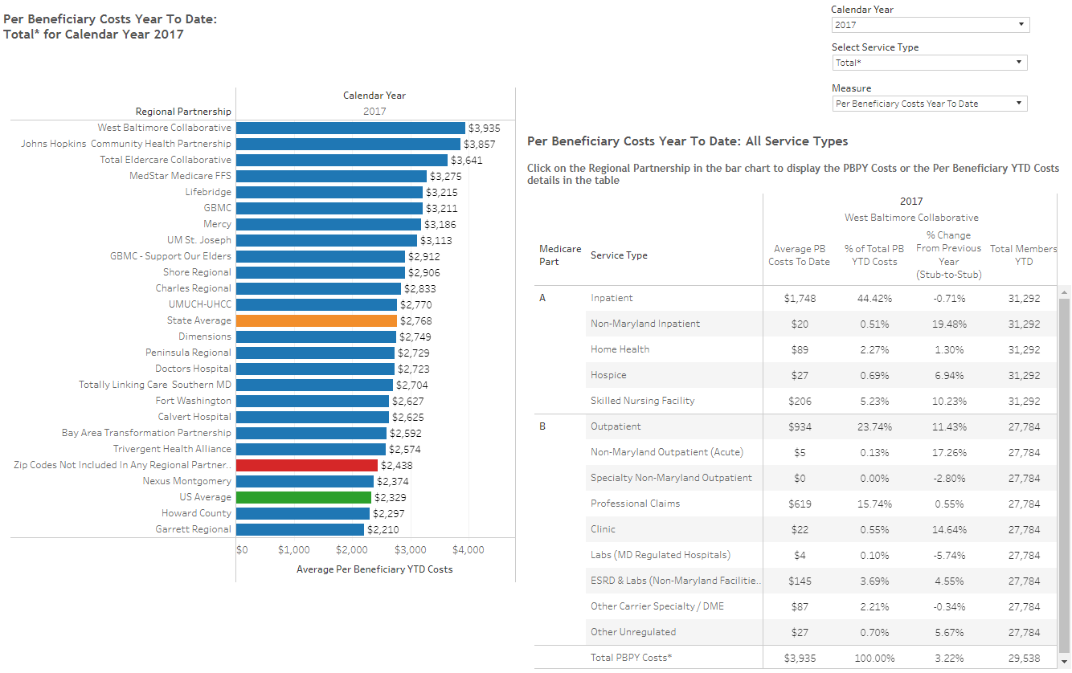

- ED Visits per Capita – Ambulatory ED Visits per 1000
(Please use either):
- Executive Dashboard for Regional Partnership – ‘Regional Partnership per Capita Utilization’ - Ambulatory ED Visits per 1000 – reported as average 12 months of FY 2018)
- RP Analytic File – ‘ED Visits’ over ‘Population’ (Column H / Column C) – for CY 2017
  - Using the RP Analytical File, UM SJMC’s all payer ED visits per capita for CY17 is 0.358
  - Using the RP Analytical File, UM SJMC’s Medicare FFS ED visits per capita for CY17 is 0.29

Quality Indicator Measures
- Readmissions – Unadjusted Readmission rate by Hospital (by Partnership)
(Please use either):
- Executive Dashboard for Regional Partnership – ‘[Partnership] Quality Indicators’ – Unadjusted Readmission Rate by Hospital – reported as average 12 months of FY 2018)
- RP Analytic File – ‘IP Readmit’ over ‘EligibleforReadmit’ (Column J / Column I) – for CY 2017
  - Using the RP Analytical File, UM SJMC’s all payer unadjusted inter-hospital readmit rate for CY17 is 13.2%
  - Using the RP Analytical File, UM SJMC’s Medicare FFS unadjusted inter-hospital readmit rate for CY17 is 14.4%

- PAU – Potentially Avoidable Utilization
(Please use either):
- Executive Dashboard for Regional Partnership – ‘[Partnership] Quality Indicators’ – Potentially Avoidable Utilization – reported as sum of 12 months of FY 2018)
- RP Analytic File – ‘TotalPAUCharges’ (Column K) – for CY 2017
  - Using the RP Analytical File, UM SJMC’s CY17 All Payer PAU charges are $275,528,771
  - Using the RP Analytical File, UM SJMC’s CY17 Medicare FFS PAU charges are $111,595344

Core Process Measures (CRISP Key Indicators)
These measures are new, and we anticipate that these data will become more meaningful in future years.
- Established Longitudinal Care Plan - % of patients with Care Plan recorded at CRISP
(Please use Executive Dashboard for Regional Partnership – ‘High Needs Patients – CRISP Key Indicators’-- % of patients with Care Plan recorded at CRISP - average monthly % for most recent six months of data)

Below is a snapshot UM SJMC’s June care plan indicators. At UM SJMC, we have a heavy focus and strict guidelines on utilizing the Care Alert and PCP CRISP process in comparison to other recorded plan of care. In our Care Alert, it contains key contact information and a brief program / careplan names, barriers to care and recommended plan of actions to readers. The Care Alert is where our providers are trained to lookout for meaningful information and plan-of-care. Our monthly average Care Alert recorded at CRISP is at 36.6% and patients with PCP recorded at CRISP is 76.8% from the recent 6 months. For patients with Care Plan recorded at CRISP, we are at an average of 2.5%, this is mainly used by payers with CRISP access, not UMSJMC.

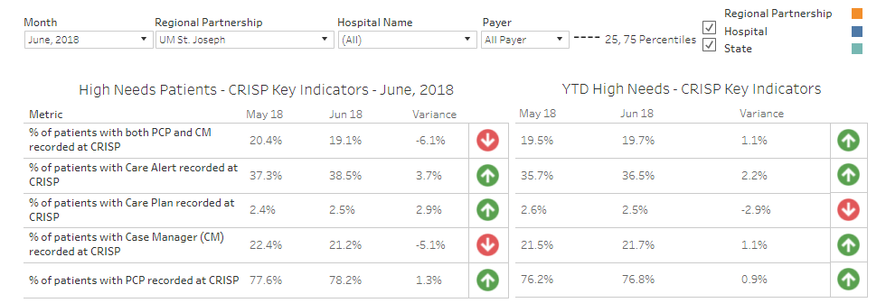

- Portion of Target Population with Contact from Assigned Care Manager - % of patient with Case Manager (CM) recorded at CRISP
(Please use Executive Dashboard for Regional Partnership – ‘High Needs Patients – CRISP Key Indicators’- % of patient with Case Manager (CM) recorded at CRISP -average monthly % for most recent six months of data)

In the Dashboard, our reported CRISP average monthly case manager relationship is 21.7%. This may not be a true reflection of our rate since there has only been a recent integration between our EMR EPIC to tie the case manager relationships into CRISP. In general, each high risk patients who has a care manager will select that relationship in EPIC – the flow of this information is being worked on at UMMS IS&T level to ensure it is pushed out seamlessly to CRISP. UMSJMC does not have local control of this process.

Self-Reported Process Measures (Optional)
Please include (if available) any process measures not currently captured under Executive Dashboard (examples are shared care plans; health risk assessments; patients with care manager not recorded in CRISP; etc.)
N/A

Return on Investment
Please indicate below how the Partnership is working to generate a positive return on investment (Free Response; no more than one paragraph). HSCRC is working to clarify a standardized definition.
The Transitional Care Center’s mission is to serve post discharge patients with a significant risk of high medical utilization and relapse. In our Behavioral Health unit, we have finally attained the desired staffing level to care of this complex population and we are seeing steady growth and benefit of the programs. Our gradual ramp up of appropriate staffing levels directly impacts our FY18 sustainable volume and creates a challenge in developing a proper ROI calculation. Our patient collection rate for FY18 is $94,691, and the expense prior to TCC staffing integration was set to be $868,775. With a revised model incorporating a primary care provider and full staffing, we closed out FY18 with total expenses of $1,020,887.
We will continue to grow referral volume in FY19 and continue to work with our UMMS EPIC team to track PAU correlation with the behavioral health population. We have had challenges in accurately tracking PAU and chronic condition illnesses in behavioral health patients. Further, we have had continuing challenges in receiving timely discharge information on many of our behavioral health population who are readmitted to other due to federal disclosure policies. We hope to partner with CRISP in the coming year to develop methodologies to receive timely information on these patients that will allow for an accurate calculation of the ROI in the FY19 report.

Conclusion
(Free Response – 1-3 Paragraphs: Please include any additional information you wish to share here).
In summary, the TCC-Behavioral Health Center, made possible through the HSCRC innovation grant investment in population health has led to a stable and successful component of the mental health continuum of care at UM-SJMC. We have now established outpatient mental health setting with a talented multidisciplinary staff with a singular vision of reducing the burden of chronic mental illness and its associated impact on repeating hospital and emergency department stays. On the inpatient side, the UM-SJMC inpatient unit now can more rapidly discharge high risk patients, leading to shortened inpatient stays. Further, the Emergency Department now can refer repeating, high risk chronic patients to the clinic as well. The UM-SJMC Primary Care Group and community primary care providers are also able to get rapid consultation and support on difficult patients through the Center. In the next phase of development, we aim to develop new service enhancements, and the ability to systematically monitor outcomes of patients after discharge from the clinic.

Appendix:
Figure 1. FY18 referral volume, payor distribution and show / no show rate for TCC-BHC.
Overall, 40% of the referral comes from inpatient discharged psych unit or medicine floor; 42% comes from UM SJMC ambulatory departments including cancer center, cardiovascular rehab center, primary care providers, community health workers and home health agency screening; and 18% comes from UM SJMC ED or observation units.

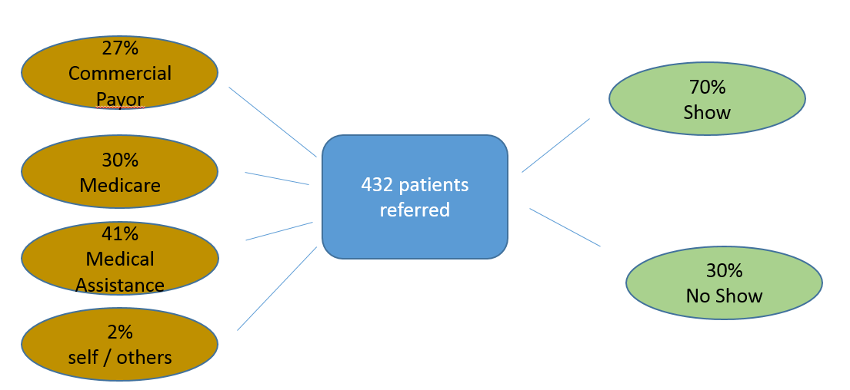

Figure 2a. Pre-Post- Analysis of All Payor, No Show vs. *Show patient ED +obs 23 hours Utilization Trended over 12 Months.
The below data shows an improvement by at least 16% of less ED utilization for patients who has received at least one time of treatment at the TCC-BHC at the 30 day period upon initial intervention, and continues to sustain a better outcome in less ED utilization at least up till 3 months, and no significant improvement after patients have left the 90 day bridge program at the TCC-BHC. The data also reflects a 40% reduction in ED / Obs utilization in the first 30 days of first intervention compared to a pre-intervention utilization.
*Show-patients is defined as completed at least one appointment at the TCC-BHC.
No show patients
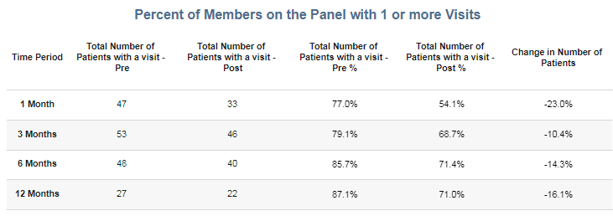
Show patients
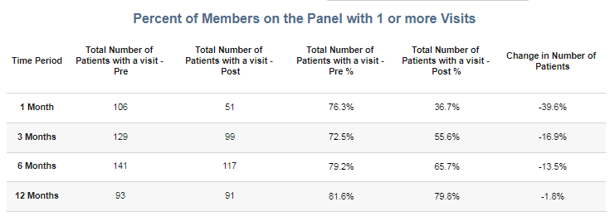

Figure 2b. Pre-Post- Analysis of All Payor, No Show vs. *Show patient Inpatient Utilization Trended over 12 Months.
The below data shows an improvement by 10% less inpatient readmission over 3 months period for patients who has received at least one time of treatment at the TCC-BHC, and continues to sustain a better outcome in less inpatient readmission for 12 months, in comparison to those who did not receive a TCC-BHC treatment. The data also reflects an average of 60% reduction in inpatient utilization compared to a pre- intervention utilization.
*Show-patients is defined as completed at least one appointment at the TCC-BHC.

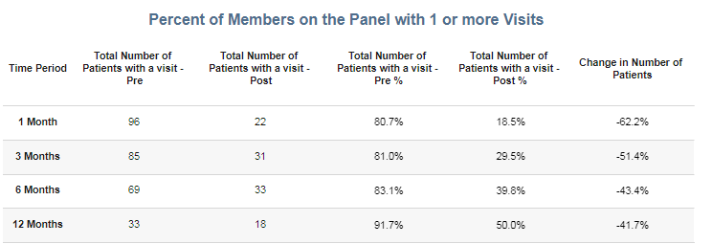
No show patients

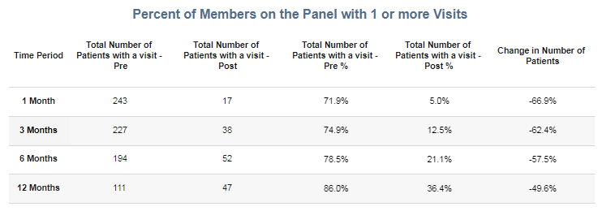
Show patients

Figure 2c. Pre-Post- Analysis of Medicare /Medicaid, No Show vs. *Show patient ED +obs 23 hours Utilization Trended over 12 Months.
The below data shows a decrease of patient’s pre-post- utilization after the first intervention, trended over 12 months. When compared to the No Show population, there is no significant difference between the 2 groups. Both groups showed similar in decreased ED utilization.
*Show-patients is defined as completed at least one appointment at the TCC-BHC.

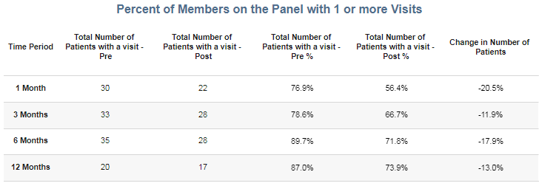
No show patients

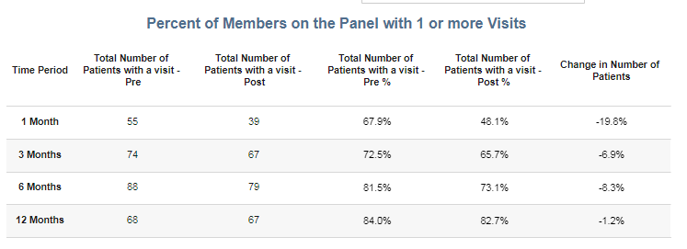
Show patients

Figure 2d. Pre-Post- Analysis of Medicare /Medicaid, No Show vs. *Show patient Inpatient Utilization Trended over 12 Months.
The below data shows a significant decrease inpatient 30 days – 180 days readmission, with a compelling 90% decrease in inpatient utilization in the first 30 days. In comparison to the No Show group, the Show group fares 20% better in overall comparison up to 6 months. At month 6 and 12, there is only a slight improvement in the Show group compared to the No Show group.
*Show-patients is defined as completed at least one appointment at the TCC-BHC.

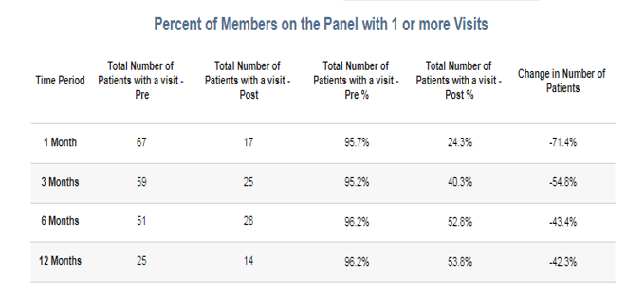
No show patients

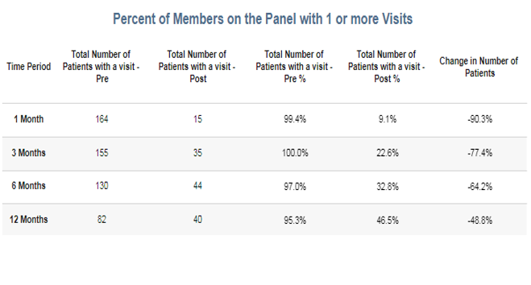
Show patients

Figure 3. Patent Satisfaction Survey: 78 surveys were sent out, 5 came back with bad addresses, 13 responded.
This is the same data set as previous Year 1 ending report.

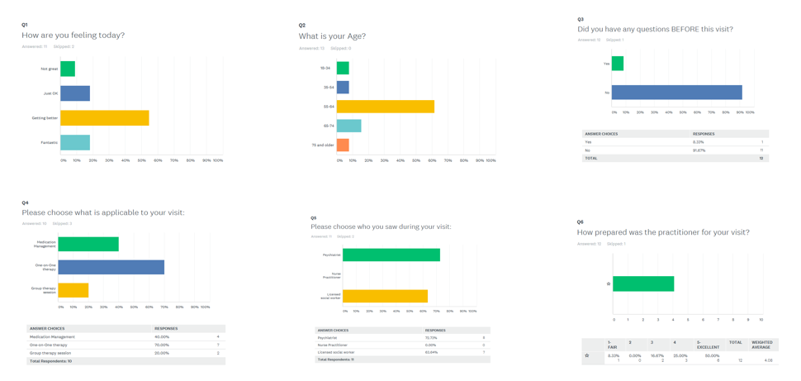
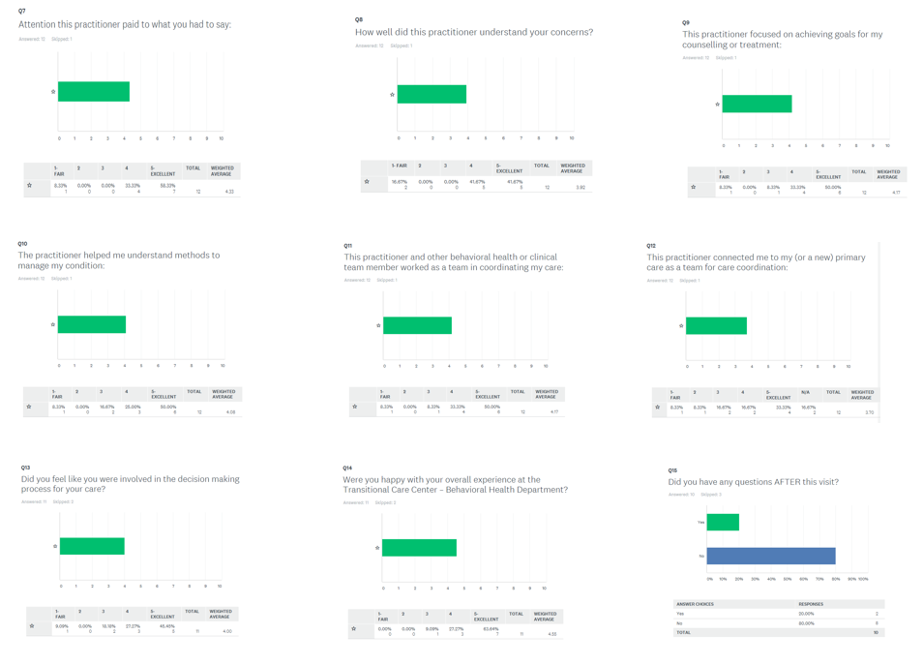
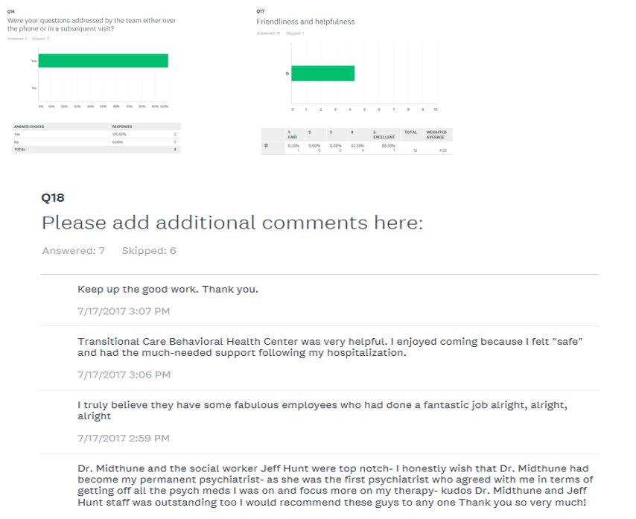

Figure 4. Program Partners
Behavioral Health Partner in Implementation Application | Owned by Hospital or Independent | Purpose of Partnership as Stated in Implementation Application | Status of Partnership and Meeting Goals of the Application
Maxim Transition Assist | Independent | To provide Community Health Workers or Behavioral Health Technician to patients post discharge for in-home non-clinical services to augment their clinical care. | Shovel ready
Center’s for Eating Disorders (CED) | Independent | To provide program development partnership including staffing the Center with psychologist, psychiatrist and LCSWCs to support the clinical care of target patients | Contract signed October
SJMG Primary Care Provider Group | Hospital | To care for community providers’ patients with underlying behavioral health factors that impacts proper treatment of chronic conditions. | Referral started July, 2017 after 3rd LCSWC was hired for the workflow
VNA | Independent | To care for community providers’ patients with underlying behavioral health factors that impacts proper treatment of chronic conditions. | Referral started August 2017 after 3rd LCSWC was hired for workflow
Baltimore County Health and Human Services | Independent | Work in progress. But the goal is to create a legion of social network and resources for our partners to appropriately root patients back to the community. | Continual partnership, MOU signed August 2, 2017
Chase Brexton | Independent | Work in progress. But the goal is to create a legion of social network and resources for our partners to appropriately root patients back to the community – affordable healthcare is one of them. | Continual partnership
UMMS High Risk Clinic workgroup | UMMS hospital | Best practice sharing and collaborative workgroup to maximize UMMS EMR: EPIC | Continual learning process
CRISP engagement | Independent | Best practice resources, dashboard and metrics development | Continual partnership for data mining and pre-post- analysis
Transformation Grant Regional Partnership Collaborative | All Transformation grant stakeholders | Best practice, lessons learn resources, dashboard and metrics development | Continual partnership

Figure 5. Timeline of Program Implementation:

April 2016
- Interview with HSCRC, Final determination of Behavioral Health Center to be housed within Transitional Care Center.
May 2016
- Approval of HSCRC Funding

June 2016
- UM SJMG Ambulatory went Live on EPIC, along with Transitional Care Center
- Maxim Contract expansion:
  - Maxim Community Health Workers (CHW) expansion from inpatient access to Transitional Nurse Navigator and ambulatory offices.
July 2016
- Contracting process with Sheppard Pratt private psychiatry group and initiate recruitment process for the Behavioral Health Center (BHC).
- Standing meetings with BHC Steering Committee.
- Workflow processes with partners and stake holders for the BHC

Aug 2016
- Finalizing Contract with private psychiatry group, recruitment in process.
- Standing meetings with BHC steering committee for program development
- Finalize PCP and home health care screening criteria
  - Workflow standardization
  - Sub-acute partner workgroup
  - Primary care provider work group
Sept 2016
- First LCSW-C hired to start September 12th, 2016 with 1 week internal training and orientation
- Standing meetings with BHC steering committee for program development
- Formation of population health steering committee
- Continual recruitment for LCSW-Cs, psychiatrist and psychologist

October 2016
- Started seeing patients in October by 1 LCSW-C: Target is Medicare discharged inpatient psych unit with existing psychiatrist relationship.
- Standing meetings with BHC steering committee for program development
- Continual recruitment
- Engage CRISP in developing dashboard for measurable outcomes

November 2016
- Psychiatrist joined Nov 17th, 2016
- Ramp up on patients, target: Medicare discharged inpatient psych unit with and without existing providers
- Standing meetings with BHC steering committee for program development
- UMMS high risk clinic workgroup collaborative

December 2016
- Ramp up on patients, target: Medicare discharged inpatient psych unit with and without existing providers and Transitional Care Center referrals
- Standing meetings with BHC steering committee for program development
- UMMS high risk clinic workgroup collaborative
- Continual recruitment

January 2017
- Ramp up on patients, target: Medicare discharged inpatient psych unit with and without existing providers and ED high utilizers with multiple chronic co-morbid condition, and Transitional Care Center referrals
- Standing meetings with BHC steering committee for program development
- UMMS high risk clinic workgroup collaborative

February 2017
- Hired midlevel psych NP to conduct group therapy
- Start group therapy, CBT sessions
- Joined Bay Area Transformation Grant Collaborative for best practices and develop dashboard with CRISP

April 2017
- Hired 2nd LCSWC, patient volume increased, continual referral from inpatient discharged and ED high utilizers. New referrals from Transitional Care Center (UM SJMC high risk center) high risk Cancer Center patients with underlying behavioral health factors impacting chronic care.

June 2017
- Hired 3rd LCSWC, patient volume increased, continual referrals from existing sources, new referrals from PCPs and Visiting Nurse Association
(VNA) home health agency.
- Established relationship with Lyft ride to enable ease of patient transportation.

Jan - June 2018
- Increased awareness of service with PCP partners and community health workers, increase referrals
- April and May 2018, LCSWc turn over, bottle neck in psychiatrist med-management due to increased community referral, re-start recruiting
and reorganization to consist of 2 LCSWC, 0.6FTE nurse practitioner and 0.6 FTE psychiatrist.
- Improve operational workflow and refine therapy programs to maximize clinical benefit and relapse prevention to clinic patients.
- Establish ongoing free support groups for current and prior patients of BHC.

