Date: March 24, 2026
To: Hospital Chief Financial Officers and Case Mix Liaisons
From: Claudine Williams, Principal Deputy Director, HDMI
Subject: FY 2026 Q3 Data Forum Follow-up
Thank you to all who participated in the FY 2026 Q3 Data Forum held on March 13, 2026. Below is a summary of what was discussed and next steps.
Quality Update
AHEAD Model Transition
HSCRC staff provided an update on Maryland’s participation in the AHEAD Model, which began January 1, 2026. Key elements included:
- CMS will begin setting Medicare FFS global budgets in 2028.
- The State will continue setting all‑payer hospital global budgets during PY1–PY2 (2026–2027).
- Between 2028–2030, the State may redirect a portion of the Medicare global budget in a revenue‑neutral manner to smooth the transition.
- Maryland must achieve $460M in additional Medicare FFS savings between PY1–PY7 (through 2032).
CY 2026 PMWG Priorities & RY 2028 Quality Policies
Staff reviewed development timelines for QBR, MHAC, RRIP and ED Best Practices programs and discussed CY 2026 priorities, including alignment with CMS programs, evaluating non‑Medicare measure strategies, and collaboration on statewide dashboards.
Grouper Transition (RY 2028)
Updates were provided on the shift to SolventumTM APR/PPC Version 43 for quality programs, including timelines for base years, performance periods, and implementation dates.

Alignment Prioritization
Staff outlined the approach for alignment across QBR, MHAC, and RRIP, including measure updates, domain weighting, and digital measures reporting incentives.
ED LOS Update
Staff reviewed performance data for CY 2025, noting final CY 2025 data will be available in April 2026.
Key points included:
- Improvement goals for RYs 2027 and 2028 will remain consistent with prior years.
- Risk‑adjustment methodology will not be implemented for RY 2027–2028.
- Development of an ED LOS dashboard is ongoing, with Version 1 expected in April/May 2026.
Audit and Integrity Update
Labor & Delivery Rate Center RVU Workgroup
A technical workgroup convened in November 2025 to review potential updates to Relative Value Units (RVUs) for the Labor & Delivery Rate Center. Updates are intended to remain revenue‑neutral. Hospital clinicians or reimbursement staff wishing to participate were encouraged to contact HSCRC.
Updated Regulations for Hospital Financial Assistance
New regulations were promulgated December 11, 2025, requiring updated financial assistance policies by April 30, 2026. Revisions include expanded eligibility regardless of citizenship status and updated forms available on the HSCRC website.
Financial Data Update
Kaiser Permanente (KP) & Medicaid Variables
Staff introduced new variable requirements in response to KP patient volume redistribution and the AHEAD model. Hospitals must report new data elements beginning with January–February 2026 submissions, due March 30, 2026. Additionally, FY 2026 Q3 reconciliation reports (due June 8, 2026) must incorporate the new variables.

Reminders
Several program reminders were reviewed:
- CDS‑A report is available on the CRISP portal for proactive error resolution.
- Complete the Data Forum survey distributed via SurveyMonkey.
- FY 2025 Annual Filing (Schedule CCS) requirements and deadlines were reiterated.
Insurance Denials Workgroup Update
The subgroup met multiple times between October 2025 and February 2026. Consensus was reached on:
- Initial vs. final denial definitions
- Denial reason categories
- Revised reporting template
- Timeline for historical data submissions and FY 2027 routine reporting
A detailed data element description and sample template were reviewed.
Data Processing Update
Beginning January 1, 2026:
- New file naming rules apply for Experience, FSA, and FSB submissions.
- Metadata must match file names exactly; beginning March 12, 2026, mismatches will trigger file rejection.
- Automated file rejection notices are now being issued for common errors (naming, submission channel, data integrity, metadata issues).
- New validation checks apply to all submissions for FY 2026 forward.
- 2‑Factor Authentication (2FA) will be implemented platform‑wide by Q3 2026.
Data Processing Reminders
- Rate Center Trend Monitoring Report is now available in Case Mix error reports.
- EHR Survey updates are required every six months via DAVE.
- Hospitals should maintain current DAVE user access through hMetrix.
Case Mix Audit Update
Staff highlighted ongoing reminders:
- Attention to new July 1, 2024 variables (e.g., ED arrival/departure times, inpatient arrival).
- Monitoring of ED duration and NPI accuracy.
These elements continue to be focus areas for audit and compliance reviews.
Upcoming Workgroups
Staff provided timelines and next meeting dates for:
- AHEAD All‑Payer TCOC TAC
- Insurance Denials Workgroup
- Payment Models Workgroup
- Performance Measurement Workgroup (including subgroups)
- Total Cost of Care Workgroup
- Volume Technical Subgroup
Meeting schedule details and contact information were provided.
Next Meeting
The next Quarterly Data Forum is scheduled for June 12, 2026. Meeting materials and slides will be posted to the HSCRC website. If you have any agenda items, please send them to Nancy, Curtis, or myself by June 3, 2026. If you have any questions or concerns about the topics discussed above, please contact Claudine Williams (Claudine.Williams@maryland.gov), Nancy Chiles Shaffer (nancy.shaffer@maryland.gov), or Curtis Wills (Curtis.Wills@maryland.gov).
Q & A from the Data Forum
- Q: When do you expect the RY 2028 QBR Calculator Workbook to be made available in CRISP?
  - A: A workbook with preliminary performance standards will be made available on 4/10/2026.
- Q: This document (Denials Report Timeline FY2026.docx) has 7/31/26 as the due date for Q4 and not 7/30/26.
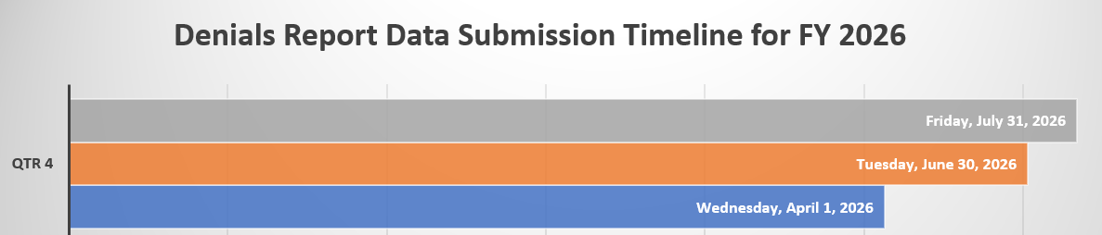
- A: The timeline has been updated to reflect the correct due date.

