**Adam Kane**

**Chairman**

**Joseph Antos, PhD**

**Vice-Chairman**

**Victoria W. Bayless**

**James N. Elliott, M.D.**

**John M. Colmers**

**Katie Wunderlich**

**Executive Director**

**Allan Pack, Director**

**Population Based Methodologies**

**Chris Peterson, Director**

**Payment Reform and Provider Alignment**

**Gerard J. Schmith, Director**

**Revenue & Regulation Compliance**

**William Henderson, Director Medical Economics and Data Analytics**

Health Services Cost Review Commission

4160 Patterson Avenue, Baltimore, Maryland 21215

Phone: 410-764-2605 · Fax: 410-358-6217

Toll Free: 1-888-287-3229

[hscrc.maryland.gov](http://www.hscrc.maryland.gov)

**State of Maryland**

**Department of Health**





**To:** Hospital Case Mix Liaisons

**From:** Claudine Williams, Associate Director, Clinical Data Administration

**Date:** April 21, 2020

**Re:** FY 2021 Inpatient, Outpatient and Psychiatric Data Submission Requirements, FY 2021 Production Schedule, Error Threshold Reduction and partial delay in implementation.

This memorandum serves to inform hospitals of the revisions to the Inpatient, Outpatient and Psychiatric Data Submission Requirements (DSR) for FY 2021, reductions to the 10 percent error threshold, and the FY 2021 Production Schedule.

Due to the COVID-19 emergency, HSCRC will be delaying most of the revisions that were slated to go in effect for July 2020. The changes that will be implemented for FY 2021 and the changes that will be delayed until FY 2022 are detailed below.

# FY 2021 Data Submission Requirements

**Changes to be implemented for FY 2021**

The following changes are applicable to the Inpatient, Outpatient and Psychiatric datasets and will be implemented for FY 2021.

1. **New Edits:** 
   1. All of the newly adopted edits (except the edits for Expected Payers and Health Plan Payers) are highlighted in red in the DSRs.
   2. **An additional edit is being proposed for FY 2021 to address negative charges that are reported in the case mix data:**
      * **Record Type 3, Total Charge: Fatal Error: If value is < 0**
   3. Timeline for implementing new edits:
      * **July 1, 2020:** Sandbox in DAVE will be available, new edits will be flagged as warnings.
      * **October 1, 2020:** New edits will be displayed as warning in production
      * **January 1st 2021:** New Edits will be switched to errors
2. **Patient Zip Code:** Added a usage note to the Homeless code with the definition of homelessness from the Department of House and Urban Development (HUD).
3. **Point of Origin:** 
   1. Add new code for Newborn born outside of the hospital (“NO”)
   2. Revise code for Newborn, born at the hospital (from “NB” to “NI”)
   3. Added usage notes to codes
   4. Removed requirement to provide associated provider ID for transfers from SNFs
4. **Expected Payer Code:** Reinstate code for Not Applicable (77) (this code was missing in the FY2020 DSR)
5. **Expected Health Plan Payer:** Removed terminated health plans and updated names
6. **Provider Specific Admission Source:** Removed “777777” as a valid code and allowing only blanks for Not Applicable
7. **Patient Disposition:** 
   1. Added usage notes for codes
   2. Removed code for recurring claims (00). HSCRC is no longer tracking recurring claims. Hospitals should report the actual discharge disposition of the patient (i.e., if the patient went home, then report code 01 (Home))
   3. Removed requirement to provide associated provider ID for discharges to Medicare-certified SNF and certified Medicaid nursing facilities.
8. **Units of Service:** Expanded max length for Units of Service from 5 to 6.

**Changes to be delayed until FY 2022**

The following changes that are applicable to the Inpatient, Outpatient and Psychiatric datasets will be delayed until FY 2022.

1. **File Naming Convention:** A new naming convention will be implemented to standardize the files that are being transmitted on a monthly basis. This will reduce confusion when retrieving multiple files from the same hospital.

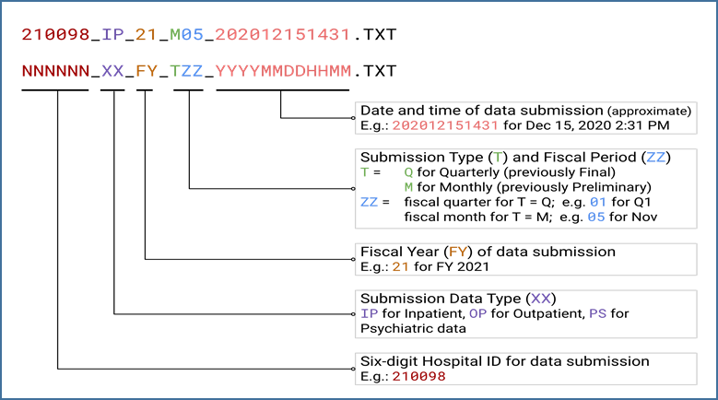

1. **Expected Payer Codes:** 
   1. Combine Blue Cross (04), HMO (12), Blue Cross National Capital Area (16), Blue Cross – Other State (17) with Commercial Insurance (05)
   2. Combine Title V (03) with Other Government Programs (06)
   3. Combine Donor (11) with Other (10)
   4. Added new code for Behavioral Health Plans (19)
2. **Health Plan Payer Codes**
3. Combine various health plan products into major plans (for example, CareFirst of Maryland, CareFirst Group Hospitalization and Medical Services Inc., and CareFirst Blue Choice are merged into CareFirst BlueCross BlueShield
4. **New Edits:** The edits for expected primary, secondary and tertiary payer and expected primary, secondary and tertiary health plan payer are highlighted in red and are applicable to the new codes described above.

# Error Threshold Reduction

At the last Data Edits Workgroup meeting, staff presented analyses of hospital error percentages based on finalized data. For the FY 2019 – Q1 FY 2020 final data, almost all of the acute care hospitals were below 6 percent for both inpatient and outpatient. This supports the notion that the current 10 percent threshold is too high. Hospitals participating in the meeting were amenable to keeping the 10 percent threshold for the preliminary monthly submissions; and reducing the error threshold for final submissions after a grace period for 2 quarters.This would allow time for hospitals to adapt to the new edit checks that are effective for FY 2021. Therefore, HSCRC proposes to:

* Reduce the error threshold from 10 percent to 5 percent for final quarterly submissions, effective January 2021; and
* Assess the state of affairs in the fall to determine whether another delay is necessary.

# FY 2021 Production Schedule

Table 1 displays the production schedule for FY 2021.

| **Table 1: FY 2021 Case Mix and Financial Reporting Due Dates** | | | | | | |
| --- | --- | --- | --- | --- | --- | --- |
| **Dataset** | | **Case Mix** | | **Financials** | **Reconciliation Reports** | |
| **Submit to:** | | **hMetrix** | | **HSCRC** | **HSCRC** | |
| **FY 2021 Production Schedule** | **Mon/Qtr End date** | **Days from End Date** | **Due Date hMetrix** | **Due Date to HSCRC** | **Due Date to HSCRC** | **Variance Threshold** |
| **FY 2020 Q4** |  |  |  |  |  |  |
| April 2020 | 4/30/2020 | 15 | 5/15/2020 | 6/1/2020 | N/A | |
| April & May 2020 | 5/31/2020 | 15 | 6/15/2020 | 6/30/2020 |
| April, May & June 2020 (Prelim) | 6/30/2020 | 15 | 7/15/2020 | 7/30/2020 |
| **4th Qtr Final** | | 62 | 8/31/2020 | N/A | **9/8/2020** | 2% |
| **FY 2021 Q1** |  |  |  |  |  |  |
| July 2020 | 7/31/2020 | 17 | 8/17/2020 | 8/31/2020 | N/A | |
| July & August 2020 | 8/31/2020 | 15 | 9/15/2020 | 9/30/2020 |
| Jul, Aug & Sept 2020 (Prelim) | 9/30/2020 | 15 | 10/15/2020 | 10/30/2020 |
| **1st Qtr Final** | | 61 | 11/30/2020 | N/A | 12/7/2020 | 2% |
| **FY 2021 Q2** |  |  |  |  |  |  |
| October 2020 | 10/31/2020 | 16 | 11/16/2020 | 11/30/2019 | N/A | |
| Oct & Nov 2020 | 11/30/2020 | 15 | 12/15/2020 | 12/30/2020 |
| Oct, Nov & Dec 2020 (Prelim) | 12/31/2020 | 15 | 1/15/2021 | 2/1/2021 |
| **2nd Qtr Final** | | 60 | 3/1/2021 | N/A | 3/8/2021 | 2% |
| **FY 2021 Q3** |  |  | |  |  |  |
| January 2021 | 1/31/2021 | 16 | 2/16/2021 | 3/1/2020 | N/A | |
| Jan & Feb 2021 | 2/28/2021 | 15 | 3/15/2021 | 3/30/2021 |
| Jan, Feb & Mar 2021 (Prelim) | 3/31/2021 | 15 | 4/15/2021 | 4/30/2021 |
| **3rd Qtr Final** | | 62 | 6/1/2021 | N/A | 6/7/2021 | 2% |
| **FY 2021 Q4** |  |  | |  |  |  |
| April 2021 | 4/30/2021 | 17 | 5/17/2021 | 5/30/2020 | N/A | |
| April & May 2021 | 5/31/2021 | 16 | 6/16/2021 | 6/30/2021 |
| April, May & June 2021 (Prelim) | 6/30/2021 | 15 | 7/15/20201 | 7/30/2021 |
| **4th Qtr Final** | | 61 | 8/30/2021 | N/A | 9/7/2021 | 2% |

Thank you again for your hard work and continued partnership with the HSCRC.

If you have any questions regarding the information in the memo or regarding the submission of monthly and quarterly hospital discharge data, please contact Claudine Williams on 410-764-2561, or by email at [claudine.williams@maryland.gov](mailto:claudine.williams@maryland.gov).