**Hospital Care Improvement Program Track Implementation Template**

**Performance Period Seven (January 2022 – December 2022)**

**Hospital Name: HOSPITAL NAME**

**Submission Date: __________________**

# Introduction

The Hospital Care Improvement Program (HCIP) is a track under the Care Redesign Program (CRP) designed to allow a hospital that has signed a CRP Participation Agreement (Hospital) to improve inpatient medical and surgical services delivery and support effective transitions of care and delivery of care during acute care events both in the Hospital and beyond Hospital walls. Additionally, the HCIP will focus on maintaining and improving the quality of care. Though the HCIP focuses on reducing avoidable utilization, the byproduct is reduced cost per acute care event.

The HCIP will also focus on the efficient use of resources. The Hospital and its Care Partners will collaborate to implement more efficient resource management processes. Efficient resource management examples include implementing more efficient practice patterns to discharge patients in a timely manner, using generic drugs wherever warranted, and using critical care beds (e.g. ICU and CCU beds) and operating rooms effectively. Even further, Hospital physicians assisting with post discharge responsibilities – follow up appointments, coordination with skilled nursing care, use of home care – will be more likely to discharge patients efficiently, reducing length of stay, and possibly preventing future Hospital readmissions and re-encounters. The HCIP provides hospitals with an opportunity to share cost savings with Care Partners that manage inpatient resources efficiently, improve quality of care delivery and support effective transitions of care.

HCIP promotes the following objectives.

* Improve inpatient medical and surgical services delivery
* Provide effective transitions of care
* Ensure an effective delivery of care during acute care events both in the Hospital and beyond Hospital walls
* Encourage the efficient management of inpatient resources
* Reduce avoidable utilization with a byproduct of reduced cost per acute care event

# Hospital Roles and Responsibilities

In order to participate in the HCIP, the Hospital’s Care Partners must perform CRP Interventions. To help facilitate the Care Partners’ performance of the CRP Interventions allowable under the HCIP (Allowable CRP Interventions), Hospitals may provide Intervention Resources to Care Partners. The HCIP consists of two major components: 1) Allowable CRP Interventions and 2) Incentive Payments.

**(1) Allowable CRP Interventions**. Allowable CRP Interventions are activities and processes that the Hospital may choose to do for HCIP implementation. Refer to **“Track Implementation Template Instructions” section** **4 Table 2. Allowable CRP Interventions**.

**(2) Incentive Payments paid to Care Partners**. The Health Services Cost Review Commission (HSCRC) or its third party designee will determine the “Responsible Physician” – i.e. the physician most responsible for inpatient resource utilization decisions identified directly from the Uniform Bill – and calculate the internal cost savings attributed to admissions overseen by the Responsible Physician. Incentive Payments to the Responsible Physician, the Care Partner for the HCIP, will be calculated utilizing the AMS PBIS® or similar methodology tool reflecting financial performance. A uniform methodology will be used across all participating providers. Refer to **Section** **E Incentive Payment Methodology: Incentive Payment Pool Development, Care Partner Incentive Payments** for additional details on the Hospital Care Improvement Program Incentive.

**(3) Health information technology (HIT).** The Hospital must support a HIT system to track quality measures. This may be done at the Hospital or through the use of CRISP. The Hospital must use the HCIP methodology discussed in section **E Incentive Payment Methodology: Care Partner Incentive Payments, Incentive Payment Pool Development** to track internal costs, quality performance, and changes in care that can be attributed to CRP Interventions performed by Care Partners that will be used to inform incentive payment decisions. The HCIP methodology relies on inpatient hospital discharge claims data for all inpatient cases, including observation cases greater than 23 hours. The system used to track changes in payment, cost, and quality has the capacity to identify the cost savings achieved per beneficiary; identify the providers furnishing care to beneficiaries and the quality of that care; and compare the costs and quality of that care to benchmarks, established baselines and best practices norms.

**(4) Physician Identification.** A Responsible Physician (RP) is defined as the physician most responsible for resource utilization while the Medicare beneficiary is hospitalized.  The RP must be a party to a valid Care Partner Arrangement with the Hospital and be on the Hospital’s Certified Care Partner List. The identity of the RP is determined from the two physician fields on the Medicare claims form:

Attending Physician     UB-04 Form Locator 76

Operating Physician     UB-04 Form Locator 77

Other hospital-based physicians, such as consultants, emergency room physicians, etc., may be added to the HCIP, as approved by the CRP Committee.

**(5) Monitoring and Reporting.** Hospitals are responsible for the overall operations of the HCIP.

All patients admitted to a hospital participating in HCIP will receive information stating that the hospital and its medical staff are participating in the program. The disclosure should indicate that if the physicians and hospital meet specific performance goals of improving quality, streamlining care and achieve cost saving, the physician may receive a payment as a share of the hospital savings from the cost reduction.

Hospitals will be expected to provide the State with ongoing monitoring information by tracking and reporting various measures of performance improvement efforts and operational metrics. In addition to the CRP reporting requirements in the Participation Agreement, the State will also produce additional metrics to evaluate the overall performance of HCIP:

|  | Required Metrics |
| --- | --- |
| Physician Enrollment and Activities | * Number of Care Partners participating in the HCIP, including number of cases * Total incentives paid per 6 month performance period |
| Hospital Utilization, Efficiency and Care Redesign Impact | * 30 day readmission rates * 30 day emergency room visit rates post discharge * Average LOS * Total Internal Cost Savings |
| Patient Safety and Patient Satisfaction | * Mortality Rates * Potentially Preventable Complications * HCAHPS Scores –Communication with Physicians, Discharge Instructions, and Care Transitions |

The third party administrator, designated by the HSCRC, provides detailed Care Partner dashboards semi-annually which will compare physician-specific resource utilization compared to Best Practice Norms as well as calculate incentive information based on financial performance and identify where there are opportunities for improvement. In addition to the dashboard, a detailed report will be provided to the Care Partners from the third party administrator semi-annually that includes summary information as well as detailed case information. The Hospital will be responsible for generating quality reports on care redesign as well as physician-specific quality performance on the Allowable CRP Interventions that are used as conditions of Incentive Payments on a semi-annual basis. Hospitals will be provided a template to use for submission of the CRP Report. Sample dashboards and reports are shown in **Appendix A.**

If hospitals wish to make changes to their interventions or measures during the performance period, they must first request approval by emailing [jsurpin@appliedmedicalsoftware.com](mailto:jsurpin@appliedmedicalsoftware.com) or [gweideman@appliedmedicalsoftware.com](mailto:gweideman@appliedmedicalsoftware.com).

# Care Partner Roles and Responsibilities

**Responsible Physician – Eligibility to Participate**

The HCIP is applicable to hospital-based physicians on a voluntary basis who satisfy the Care Partner Qualifications and the Care Partner requirements described in the Participation Agreement.

Physicians who admit patients exclusively to the Hospital are eligible to receive the full Incentive Payment. A physician may participate as a Care Partner in more than one Hospital’s HCIP; however, physicians with dual admitting privileges will be capped at their prior year patient volume at the Hospital for incentive payments that they may be able to receive. Dual privileged physicians that increase their total volume of admissions during the payment period may receive incentive payments up to the proportion of admissions at the Hospital in the previous year. Eligibility requirements and the physician enrollment form are included in the physician handbook.

Each potential Care Partner must meet, at a minimum, the following Care Partner Qualifications specific to the HCIP in addition to the Care Partner requirements described in the Participation Agreement:

* + - 1. The physician must have a National Provider Identifier and not be a Regulated Maryland Hospital;
      2. The physician must have privileges to provide professional services at the Regulated Maryland Hospital;
      3. The physician must participate in the Medicare program, or if not applicable for the provider’s specialty, in the Medicaid program;
      4. Physicians must be on staff for a minimum of twelve (12) months (except as provided in Physician Handbook, Section II – Eligibility);
      5. Physicians must maintain their credentials in good standing at the Hospital;
      6. Physicians must have at least 10 cases to the hospital during the 12-month period immediately preceding the date of election to participate in HCIP;
      7. Physicians must participate in the Hospital’s quality program.
      8. Physicians will be subject to the federal program integrity screening process.

# Incentive Payment Methodology: Incentive Payment Pool Development, Care Partner Incentive Payments

Care Partners must perform Allowable CRP Interventions in order to receive Incentive Payments. Allowable CRP Interventions may include:

* Discharge planning aimed at reducing readmission
* Performing clinical care according to evidence-based practices
* Participating in patient safety programs such as self-reporting errors
* Completing activities to promote patient experience and population health improvement
* Improved use of resources such as ICU beds and certain supplies or medications

Methodology for Calculating Hospital Changes in Resource Utilization

The hospital realized savings when comparing resource utilization from the current period to a prior period (or base year) adjusted for case mix and severity. To ensure Care Partner performance is fairly evaluated, cases are classified into APR DRGs, which adjust for the patients’ severity of illness (SOI). Cost outliers, defined as the mean plus three standard deviations, are excluded. Charge data on each patient record will be the base year cost. The base year cost is adjusted for Hospital specific cost adjustments as determined by the State (e.g. IME, DSH, labor market, markup, etc.). Supply and drug costs will be evaluated using a separate methodology measuring improvement. Savings are limited to utilization changes only.

In order to quantify the internal resource utilization changes, the State will calculate the internal savings for each hospital semi-annually based on the claims data using the AMS PBIS® or similar methodology tool.

Additional detail on the methodology can be found below:

**Calculating Resource Utilization Reduction - Common APR DRG Method**

A method called Common APR DRG is used to calculate the cost reduction. This method uses discharges classified to APRs that have discharges in both the time periods being compared. The average cost for each APR DRG is inflated to the current year and applied to a common set of discharges to develop expected cost per admission. A comparison of expected to actual cost per admission enables us to identify savings. Savings are limited to utilization changes only.

In this method utilization reductions are computed across APRs that have discharges in common across the two time periods being compared. This method is illustrated in the table below:

|  |  |  |  |  |  |  |  |
| --- | --- | --- | --- | --- | --- | --- | --- |
| **APR** | **Prior Year Average Cost** | **Current Year Count** | **Prior Year Cost** | **Current Year Average Cost** | **% Change** | **Prior Year Cost @ Current Year Volume** | **Reduction** |
| A | $23,564.95 | 20 | $388,950 | $19,447.51 | -21% | $471,299 | $82,348.79 |
| B | $7,963.12 | 62 | $558,594 | $9,009.58 | 13% | $493,713 | ($64,880.40) |
| C | $9,228.01 | 54 | $443,269 | $8,208.68 | -11% | $498,312 | $55,043.48 |
| D | $8,411.80 | 23 | $202,004 | $8,782.77 | 4% | $193,471 | ($8,532.21) |
| E | $7,654.37 | 55 | $436,597 | $7,938.13 | 4% | $420,990 | ($15,606.47) |
| F | $21,454.91 | 78 | $1,462,661 | $18,752.06 | -13% | $1,673,483 | $210,821.93 |
| Total | $12,830.25 | 292 | $3,492,074 | $11,959.16 |  |  | $259,195.14 |

However, this method has a limitation in that it is unable to account for the “savings” in APRs that are not common across the two time periods being compared. In order to evaluate the significance of this limitation, the coverage of the common APRs in a small sample provider’s dataset was measured. The results are set forth in the table below:

|  |  |  |  |  |  |  |
| --- | --- | --- | --- | --- | --- | --- |
| **APR Flag** | **APRs** | **APR %** | **Discharges** | **Discharge %** | **Total Cost** | **Cost %** |
| Common APRs | 383 | 82.72% | 2,928 | 95.72% | $27,316,991 | 93.76% |
| Other APRs | 80 | 17.28% | 131 | 4.28% | $1,818,217 | 6.24% |

The results indicate that the limitation of this method may not be significant. While the common APRs do not include 17% of the total APR count, these APRs that are not included represent less than 5% of the cases and just over 6% of the costs. It is reasonable to say that savings observed on 94% of the cases is representative of the total savings.

**Outlier Exclusion**

In order to be able to compute a stable savings estimate, savings outliers need to be identified and excluded. In order to identify these outliers, the average savings for each APR DRG is computed and then normalized using the calculated AMS weights. (AMS weights are calculated as the ratio of APR DRG level average cost to overall average cost.)

Outliers are identified using the mean +/- 3 standard deviations to be applied. The APRs with an adjusted average savings out of this range or trim points can be considered as outliers. Once the outliers have been identified, they can be excluded and the savings can be re-computed.

Methodology for Calculating Care Partner Incentive Payments

The HCIP will, on a semi-annual basis, reward physicians who reduce internal costs through a reduction in unnecessary utilization and resources, efficient practice patterns, and improved quality. At a minimum, the State will determine the RP Care Partner and calculate the internal cost savings attributed to admissions overseen by the RP Care Partner. Incentive Payments to the RP Care Partner for the HCIP will be calculated by the State utilizing the AMS PBIS® or similar methodology tool reflecting financial performance.

**Determining Total Available Incentive Payment**

The opportunity for savings (Best Practice Variance) is determined by computing the difference between the Best Practice Norm and the actual costs for each admission. The total available incentive payment (Total Available Incentive Payment) is computed by taking 10% of the Best Practice Variance across all hospitals in the region for each APR DRG (and for each severity level within the APR DRG) for which a Best Practice Norm is established (Best Practice Norm). The resulting amount by APR DRG is the Maximum Physician Incentive (MPI). The Hospital may elect to have these amounts adjusted so that the MPI is never less than $100 per case or more than $3,000 per case. This and other payment decisions will be independently established by the Hospital, subject to the overall constraints of the CRP.

**Apportioning the Maximum Care Partner Incentive Payment between Performance and Improvement**

The calculated Incentive Payment includes two components – performance and improvement. Performance is defined as each physician’s cost per case, adjusted for case mix and severity of illness (SOI), compared to the Best Practice Norm. Improvement is defined as each physician’s prior year performance compared to his or her actual performance during the relevant performance period. The two incentive formulae were developed to balance two objectives: encouraging improvement while, at the same time, recognizing the achievement of physicians (and institutions) that enter the CRP and are already performing efficiently. An overarching goal was to implement a system of incentive payments that would encourage good performance, while promoting continued improvement for the institution. The savings is equal in value whether it comes from a physician that improves, or one that is already efficient.

The improvement incentive payment is transitional; the objective of the HCIP is to reach 100% Performance. Rather than continuing to pay inefficient physicians to improve, the most desirable result is for each physician to reach the Best Practice Norm, and to maintain that level of performance. (As a practical matter, the Performance Incentive is designed to continue to encourage improvement since attaining perfection, however desirable, is unlikely.) However, it is understood that improvement is the higher priority in the initial year(s) of the HCIP. Accordingly, the allocation between improvement and performance for each Hospital is weighted initially 2/3 improvement, 1/3 performance. The CRP Committee at each institution has the flexibility to change this allocation. This enables each institution to respond to the progress and the conditions unique to its own situation. Generally, change is not recommended until data is received and analyzed following the conclusion of the first year of the CRP – i.e., two Incentive Payment periods. The methodology was designed to be flexible; but it also assures that regardless of the allocation, incentive payments are paid only on cases that either compare favorably to the Best Practice Norm, or have improved since the Prior Year. The CRP Committee may also impose other conditions to balance the objectives of the CRP in light of circumstances unique of the Hospital. Other hospital-based physicians, such as consultants, emergency room physicians, etc., may be added to the HCIP, as approved by the CRP Committee.

**Performance Incentive Formula**

The Performance Incentive is intended to provide a positive example by rewarding demonstrated levels of performance. Accordingly, RP Care Partners will receive Incentive Payments in proportion to the relationship between their individual performance and the Best Practice Norm. A non-linear distribution formula is used to assure that the relationship to the Best Practice Norm among physicians is both fair and proportionate. This computation is the same for surgical and medical cases. An equation illustrating the computation of Performance Incentives for individual RP Care Partners is as follows:

**75th Percentile Cost - Physician's Actual Cost**

**75th Percentile Cost - Best Practice Cost**

**X**

**Maximum Performance Incentive**

This computation is performed at the case level for each admission. Payment for the Performance Incentive is made to all Care Partners except the 25% of Care Partners with the highest cost.

**Improvement Incentive Formula**

The Improvement Incentive is intended to encourage change in behavior that results in more efficient performance while improving the quality of care delivered. For surgery and medicine, Improvement Incentive Payments are made unless an individual physician does not demonstrate measurable improvement in operational performance. However, because physicians who admit medical cases may be forced to sacrifice professional income to achieve Program objectives, the methodology for the Improvement Incentive is slightly different.

The Improvement Incentive formulae for medical and surgical RP Care Partners are as follows:

For Medical RP Care Partners:

**Prior Year Case-Mix Adjusted ALOS—Current**

**Year Case-Mix Adjusted ALOS[1]**

**X**

**Per Diem**

**X**

**Current Year Admissions**

For Surgical RP Care Partners:

**Prior Year Case-Mix Adjusted Cost—Current**

**Year Case-Mix Adjusted Cost**

**Xth Percentile Base Year Cost**[2]**—Best Practice**

**Cost**

**X**

**Case Mix Adjusted Maximum**

**Improvement Incentive**

**X**

**Current Year Admissions**

This methodology will be uniform across all Hospitals. For each APR DRG there is a maximum physician incentive established. Incentive Payments to individual physician care partners may not exceed 25% (or lower percentage depending on program and limits approved by the CRP Committee of the total Medicare approved amounts under the Physician Fee Schedule (PFS) for services furnished to the participant hospital’s Medicare beneficiaries by that participating physician). Incentives related to individual cases may not be paid for exceeding BPN established by the program. The resulting calculated incentive may be adjusted based on the performance on specific quality measures selected by the CRP Committee. Prior to the start of the performance period the CRP Committee will determine the weights for conditions of payment which must equal 100%.

No Care Partner will receive any Incentive Payment generated by any cost savings unless the Care Partner performs the Allowable CRP Interventions.

An illustrative example for APR DRG 165 – Coronary Bypass with Cardiac Cath or Percutaneous Cardiac Procedure (SOI Level 3) can be found in **Appendix B.**

The CRP Committee will review the State’s report of potential incentives based on financial performance and adjust the incentive payout, as necessary, for the quality measure selected under the HCIP. Hospitals may adjust the calculated incentives based on the approved outcomes and quality measures. The amount paid cannot exceed the calculated Incentive Payment amount. Data files will be made available to the State including the calculated incentive payments, adjustments to calculated amounts, and final amounts to be paid. Data will also be provided regarding the hospital internal cost savings.

Beginning in performance period two of CRP participation, the total amount of money that may be distributed may not exceed the cumulative cost reductions achieved due to internal cost savings, net the apportionments of incentives and interventions that may be included in another program track.

The calculation compares costs from current period to a prior period adjusted for case mix and severity using APR DRGs with outliers excluded (over three standard deviations) and hospital-specific cost adjustments as determined by the State (IME, DSH, labor market, markup, etc.). In order to compute supply and drug costs a separate methodology to measure improvement.

The actual internal cost savings will be calculated by the State semi-annually based on hospital cost reports and claims data using AMS PBIS® or similar tool.

# Implementation Template Instructions

Please complete all required sections of this Template.

**Section 1**, Hospital provides general information.

**Section 2**, Hospital provides a description of the key personnel and the CRP Committee responsible for the HCIP.

**Section 3,** Hospital provides details of the model plan.

**Section 4,** Hospitalexplains plan for implementing Allowable CRP Interventions and how it intends to monitor them.

**Section 5,** Hospital details the Hospital PAU Savings calculation and Incentive Payment Pool limit on aggregate incentive payments to physicians.

# Hospital Information

***Any blank shaded in green must be completed. Any blue text is for your review. You may edit blue text to fit your hospital’s needs.***

**Date of Implementation Protocol Submission:** XXXX, XX, 2021

**Organization Name and D/B/A: ______________________________**

**TIN:**

**CMS cert #(s) for organization:**

**Point of Contact:**

|  |  |
| --- | --- |
|  | **Hospital** |
| Name: |  |
| Title: |  |
| Street Address: |  |
| City, State, Zip: |  |
| Telephone: |  |
| Fax: |  |
| Email: |  |

**Name the key personnel and describe the function of the key management personnel for this program.**

|  |  |  |  |
| --- | --- | --- | --- |
| **Key Personnel** | **Title** | **Program Role/Responsibilities** | **% Of Time  Dedicated** |
|  |  | Program Coordinator |  |
|  |  | Chief Medical Officer/Equivalent |  |
|  |  | Chief Executive Officer/Designee |  |
|  |  | Chief Financial Officer/Designee |  |
|  |  |  |  |
|  |  |  |  |

# CRP Committee

During each performance period, at least one CRP Committee member must be a Medicare FFS Beneficiary living in the Hospital’s Service Area.

**Provide the names of your CRP Committee members and their organization.**

|  |  |  |  |  |
| --- | --- | --- | --- | --- |
| **Name, Credentials** | **Job Title and Organization, if applicable** | **Participant Hospital Employee** | **Care Partner Representative (Must appear on approved CMS vetting list)** | **Maryland Medicare Beneficiary** |
|  |  |  |  |  |
|  |  |  |  |  |
|  |  |  |  |  |
|  |  |  |  |  |
|  |  |  |  |  |
|  |  |  |  |  |
|  |  |  |  |  |
|  |  |  |  |  |
| Total number of members in CRP Committee: ___________ | | ___ | ___ | ___  (Must be at least 1) |

**If you are participating in another CRP Track, is the CRP Committee the same? Yes  No**

**Provide an explanation of how the CRP Committee will provide oversight, guidance, and management to the HCIP. Detail the process as well as expected meeting frequency.**

|  |  |
| --- | --- |
| **Please answer the following questions about how the CRP Committee will provide oversight, guidance, and management to the HCIP.** | |
| 1. How often will the CRP Committee meet? (monthly, bi-monthly, quarterly, bi-annually) | **Quarterly** |
| 2. Does the member composition of your CRP Committee meet the qualifications outlined in the Participation Agreement? | **Yes** |
| 3. Will the CRP Committee be provided with progress/dashboard reports on program performance from hospital personnel involved in the program? | **Yes** |
| 4. If yes, how often will the CRP Committee require these reports? (monthly, bi-monthly, quarterly, bi-annually, annually) | **Quarterly** |
| 5. How will the CRP Committee assist Hospitals in selecting the Allowable CRP Interventions? | **The members of the CRP Committee are well versed in the issues facing the Care Partner in the delivery of care. The Committee will be responsible to review appropriate interventions, choosing those that fit with the needs of the institution and monitor the progress of care providers.** |
| 6. How will the CRP Committee provide a forum for sharing ideas, identifying problems, and developing solutions between the Hospital and the Hospital’s Care Partners? |  |
| 7. How will the CRP Committee offer the internal leadership to ensure the integrity of and opportunity for success of the CRP and each CRP Track in which the Hospital is participating? |  |
| 8. How will the CRP Committee conduct a qualitative analysis by the CRP Committee on the status of the Allowable CRP Interventions and offering suggestions to the Hospital on how implementing the Allowable CRP Interventions could be improved? |  |

# HCIP Model Plan

Multiple changes to the existing hospital care model are needed to perform the stated Allowable CRP Interventions of the HCIP. Please briefly explain how the necessary elements list below will be executed.

**Table 1. Background: Programmatic Information**

| **Category** | **Hospital changes to current care model** | **Describe programmatic information at a general level (200 words or less)** |
| --- | --- | --- |
| **Infrastructure** | Please describe your process for engaging RP Care Partners (i.e. service line pilot, by specialty, hospital wide). | The CRP Committee will use reports issued by AMS (program administrator) which detail the potential opportunities for reduction in resource utilization by Service Line to identify the initial areas on which to focus. The CMO and Program Coordinator will analyze physicians within those Service Lines, using physician reports and dashboards, to prioritize physician enrollment in the Program. Through Departmental Meetings and one-on-one discussions, the data will be presented to individual physicians in order to secure interest and participation. In addition, the CRP Committee and physician champions will assist in identifying care redesign measures designed to achieve efficient utilization of resources. |
| Please describe the information systems that your hospital will use to track the Allowable CRP Interventions performed by the RP Care Partners. | The interventions that are used by the care partners will be tracked in several ways. Interventions that have been implemented and are being tracked by other internal committees will be reported to the CRP Committee on a quarterly basis. In addition, any interventions that are new to the institution will be tracked by the Program Coordinator or designee. In all cases, whenever possible, electronic tracking through the electronic health record or other internal systems will be preferred over manual tracking. |
| Please identify what staff will be responsible for administering the HCIP program at your hospital. | The Program Coordinator is responsible for staff functions of the CRP Committee, such as scheduling, minutes, and distribution of reports. Working in conjunction with the CMO, the Coordinator will also meet with participating physicians to discuss their performance. The Coordinator will also work with the Administrator (AMS) to ensure accurate and complete data is provided to them in a timely fashion. |
| **Data** | Please describe your hospital’s process for sharing clinical and other key information with providers. | Clinical outcomes related to the interventions pursued by the CRP Committee will be reported to various internal committees, in particular those related to specific interventions (e.g. first case start times will be reported to the OR Committee and the Department of Surgery). Key information about the impact of the Program on the utilization of resources throughout the institution will be reported to the Administrative Staff at regularly scheduled meetings; to the medical staff at the Medical Executive Committee; to the Quality Improvement Committee; and to the Hospital Board on a routine basis. |
| Please describe how your hospital will utilize monthly CMS data files in the care redesign program. | The CMS data files will supplement the inpatient data used by HCIP. The data will help to prioritize a focus on post-acute services, as well as to better track readmissions. |
| Please describe how data will be used to support incentive payments and processes. | Using reports provided by the Administrator (AMS), incentive payments for each participating physician will be reviewed. Interventions identified that will be considered for payment (i.e. conditions of payment), developed by the CMS Committee, will be applied to the incentives to ensure that physicians are meeting the institution’s quality and care redesign objectives. |
| **Processes; redesign care** | Please describe how your hospital will identify opportunities for improvement. | The CRP Committee, working with the CMO and the Program Coordinator, will review various reports on resource utilization by Service Line and Cost Center. These reports compare internal performance against statewide benchmarks and report potential areas of improvement. |
| Please describe the monitoring and reporting process. | On a quarterly basis, claims/abstract data for all discharges is provided to AMS. This data goes through extensive quality checks to ensure the accuracy of the data. Data is then processed and a series of reports provided to the hospital every six months. These reports are provided at the institutional level, the Service Line level, the Cost Center level, APR DRG level and the individual physician level. Summary reports are provided to the CRP Committee to monitor progress towards more efficient use of resources. Dashboards are also provided for each participating physician to track their performance against themselves as well as against state norms. The CMO and Program Coordinator use these reports to meet with each participating physician about their performance. |
| Please describe your processes for communicating and educating physicians and clinical staff regarding the care redesign program. | The Hospital will continue its campaign to educate physicians about the program. The Program Coordinator, assisted by the CMO as well as MHA and AMS, will schedule meetings with Medical Staff to discuss the program and what it might mean to the physicians. Additional information will be provided through flyers posted in physician lounges. A Physician Handbook, outlining the Program and providing examples of incentive calculations, will be made available to physicians. These steps will be undertaken to generate interest in the Program and to encourage participation. Feedback on the impact of the Program will be provided to participating physicians and Departments, especially those targeted for interventions. This is done to maintain engagement and encourage cooperation in achieving efficient resource utilization. |
| Please describe how you will use feedback from RP Care Partners in order to improve Allowable CRP Interventions in the HCIP. | The physician members of the CRP Committee will be encouraged to discuss the impact of the program with their peers and to report such feedback at the CRP Committee meetings. This feedback will be reviewed by the Committee to determine whether interventions should be modified. This recognizes that physicians who are not part of the CRP Committee may have insight into the issues that affect the delivery of care and resource utilization that had not previously been considered. |

1. **Allowable CRP Interventions**

A Hospital may select to enact Allowable CRP Interventions in as many categories as it wishes, and may select one or more of the Allowable CRP Interventions in each category. Allowable CRP Interventions include the list in **Table 2. Allowable CRP Interventions**. Please indicate the Allowable CRP Interventions you intend to implement as part of the HCIP, and how you plan to implement them. If you are not paying incentives, you must still indicate at least one intervention that may be considered for payment in the table below.

**Table 2. Allowable CRP Interventions**

| **Category of Allowable CRP Intervention** | **Care Partner Allowable CRP Interventions** | **Will Include** | **Existing Strategy** | **Incentive Payment made for performance of Allowable CRP Intervention?** | **For an Intervention the Hospital ”Will Include”, please describe briefly** |
| --- | --- | --- | --- | --- | --- |
| **I. Care Coordination** | I-a. Medication reconciliation forms completed per protocol |  |  |  |  |
| I-b. Care alert or care plans completed for high risk patients per protocol |  |  |  |  |
| I-c. Home management plans in care document are completed and reviewed with the patient and care givers before discharge |  |  |  |  |
| I-d. Patients with a high risk of readmission are identified, per protocols, and subsequently connected with transitions of care services |  |  |  |  |
| I-e. Communication between the Primary Care Physician and the Hospitalist/ED Physician regarding patient problem list and appropriateness of admission/follow-up care. |  |  |  |  |
| I-f. Other evidence-based, reliable, and valid intervention(s) |  |  |  | Must describe if choosing “Other evidence based, reliable and valid intervention” |
| **II. Discharge Planning** | II-a. Necessary follow-up appointments with Primary Care Physicians and other appropriate care providers are scheduled before hospital discharge |  |  |  |  |
| II-b. Bedside delivery of medications at discharge (for new or high-risk medications) |  |  |  |  |
| II-c. Medication reconciliation is done with Primary Care provider after inpatient stay. |  |  |  |  |
| II-d. Discharge summaries transmitted to PCP or next provider within set time limits |  |  |  |  |
| II-e. Other evidence-based, reliable, and valid intervention(s) |  |  |  | Must describe if choosing “Other evidence based, reliable and valid intervention” |
| **III. Clinical Care** | III-a. Core compliance activities are completed*,* including documenting core measures, using evidence-based order sets, and documenting the rationale behind diversions. |  |  |  |  |
| III-b. Heart failure activities are completed, such as giving heart failure patients ACE Inhibitor or ARB for Left Ventricular Systolic Dysfunction (LVSD) and documenting evaluation of LV systolic function. |  |  |  |  |
| III-c. Other evidence-based, reliable, and valid intervention(s) |  |  |  | Must describe if choosing “Other evidence based, reliable and valid intervention” |
| **IV. Patient Safety** | IV-a. Medication error prevention and general harm prevention activities are completed, including self-reporting adverse events to appropriate departments in a timely manner, using appropriate risk assessment tools to identify patients at-risk for falling, and implementing appropriate interventions for the at-risk patients. |  |  |  |  |
| IV-b. Infection and sepsis prevention activities are completed, including adhering to sepsis treatment protocols and checklists and complying with universal infection prevention protocols, including hand hygiene |  |  |  |  |
| IV-c. Compliance with VTE prophylaxis |  |  |  |  |
| IV-d. Other evidence-based, reliable, and valid intervention |  |  |  | Must describe if choosing “Other evidence based, reliable and valid intervention” |
| **V. Patient and Care Giver Experience** | V-a. Advanced directives obtained per protocol |  |  |  |  |
| V-b. Maryland MOLST compliance documented per protocol |  |  |  |  |
| V-c. Interdisciplinary palliative care consults and interventions completed per protocol |  |  |  |  |
| V-d. Comprehensive, individualized patient/family education (considering health literacy, preferred method of education, use of Teach Back) documented |  |  |  |  |
| V-e. Staff development activities are completed, including attending agreed upon number of educational sessions per quarter and 100% completion and compliance of CPOE training |  |  |  |  |
| V-f. Other evidence-based, reliable, and valid intervention(s) |  |  |  | Must describe if choosing “Other evidence based, reliable and valid intervention” |
| **VI. Population Health** | VI-a. High blood pressure counseling and treatment are completed |  |  |  |  |
| VI-b. Obesity counseling and treatment are completed |  |  |  |  |
| VI-c. Vaccination status is addressed and needed vaccinations are administered to patients |  |  |  |  |
| VI-d. Depression/ substance use screening conducted and referral to appropriate community resources documented |  |  |  |  |
| VI-e. Other evidence-based, reliable, and valid intervention(s) |  |  |  | Must describe if choosing “Other evidence based, reliable and valid intervention” |
| **VII. Efficiency and Cost Reduction** | VII-a. Procedures and patient flow activities are completed in a timely manner, including writing discharge orders by the hospital goal time (e.g. noon), and reducing median time from Emergency Department arrival to departure or admission to a bed. |  |  |  |  |

Referencing the planned Intervention Resources indicated in the table above, please identify the cost of each Intervention Resource based on the actual cost for the Intervention Resource or a reasonable estimate of such costs

|  |
| --- |
|  |

Define your process and frequency for monitoring a Care Partner’s completion of the Allowable CRP Interventions. Please attach sample reports you intend to use with RP Care Partners to ensure completion of required activities.

|  |
| --- |
| Once the CRP Committee selects the care redesign measures, the CRP Committee will determine appropriate outcome measurements for each. Some of the outcomes may already be tracked by other committees/groups within the organization. The CRP Committee will request results from any of these monitoring activities. Each redesign measure will be reported on at the CRP Committee meetings and results will be included in addition to the financial performance reports that are provided on a semi-annual basis to the hospital and the CRP Committee. These results will also be collected by the Administrator, using an online survey tool customized to the hospital. Any missing information will be brought to the attention of the Program Coordinator in order to ensure consistent collection. |

How will you communicate Allowable CRP Intervention performance results to Care Partners and the CRP Committee? Please attach sample reports or dashboards you intend to use, and how often you plan to provide them.

|  |  |
| --- | --- |
| The CRP Committee is responsible to identify the care redesign activities that will be undertaken at the hospital. The CMO will communicate the activities and the goals of care redesign to the Medical Executive Committee for dissemination within the affected departments. Non-physician individuals on the Committee will be communicating the activities to peers and other Committees throughout the organization. Results of the redesign efforts are reported to the CRP Committee quarterly. In addition, copies of the reports will be forwarded to the hospital quality improvement committees.  Physician dashboards will be distributed every six months as part of the incentive payment process. The CMO and the Program Coordinator will meet with participating physicians to review the results provided by the Administrator as well as any outstanding quality issues identified. A sample of the physician dashboard is included here: |  |

Incentive Payments for Allowable CRP Interventions

Please provide details on the interventions that are checked in the table above that will be used to determine the financial incentive payment in the table below. The final or adjusted payment is: Adjusted Payment = Calculated Incentive ‐ (sum of conditions of payment).

Include the measure being used, the reference to the intervention it applies to and any additional information regarding how it is related to the intervention and the weight assigned. All weights must total 100%.

At least one CoP must be included and reported whether or not incentives will be paid.

|  |  |  |  |  |  |  |
| --- | --- | --- | --- | --- | --- | --- |
|  | **CofP 1** | **CofP 2** | **CofP 3** | **CofP 4** | **CofP 5** | **Total Weight** |
| **Measure** |  |  |  |  |  |  |
| **CRP Intervention (Reference the CRP Interventions to which the condition refers and describe how it relates to the CRP Intervention.)** |  |  |  |  |  |  |
| **Weight** |  |  |  |  |  | **= 100%** |

# Incentive Payment Pool

The CRP Committee will review the State’s report of potential incentives based on financial performance and adjust the incentive payout, as necessary, for the quality measure selected under the HCIP. Hospitals may adjust the calculated incentives based on the approved outcomes and quality measures. The amount paid cannot exceed the calculated Incentive Payment amount. Data files will be made available to the State including the calculated incentive payments, adjustments to calculated amounts, and final amounts to be paid. Data will also be provided regarding the hospital internal cost savings.

Beginning in performance period two of CRP participation, the total amount of money that may be distributed may not exceed the cumulative cost reductions achieved due to internal cost savings. At its option the CRP Committee may prospectively condition the payment of incentives on achieving a minimum financial threshold. This may be implemented to ensure that the Hospital, which provides the source of funds for the Program, realizes sufficient improvement in operational performance to justify the continued funding of the HCIP. If a threshold is established, the Hospital may make payments only if we achieve the objective set.

How will you work with the third-party administrator to ensure you are distributing Incentive Payments, not to exceed the Incentive Payment Pool amount in accordance with the Participation Agreement and the formulas and calculations provided?

|  |
| --- |
| **The CRP Committee will review the incentives calculated by AMS and apply the results of the interventions selected for incentive payment (i.e. conditions of payment) developed by the CRP Committee. Once approved by CRP Committee, the hospital can issue payment for the adjusted amount to the physician and report the payments by physician and in total to the Administrator to ensure that the incentives paid do not exceed the calculated incentive or any cap. The Administrator will provide an audit report with each payment cycle to the hospital and indicate if any adjustments are necessary from a prior period. A summary report will also be provided to HSCRC/CMS as part of the program monitoring.** |

# Appendix A. Sample Reporting Dashboards

**FIGURE 1. SAMPLE DASHBOARD**

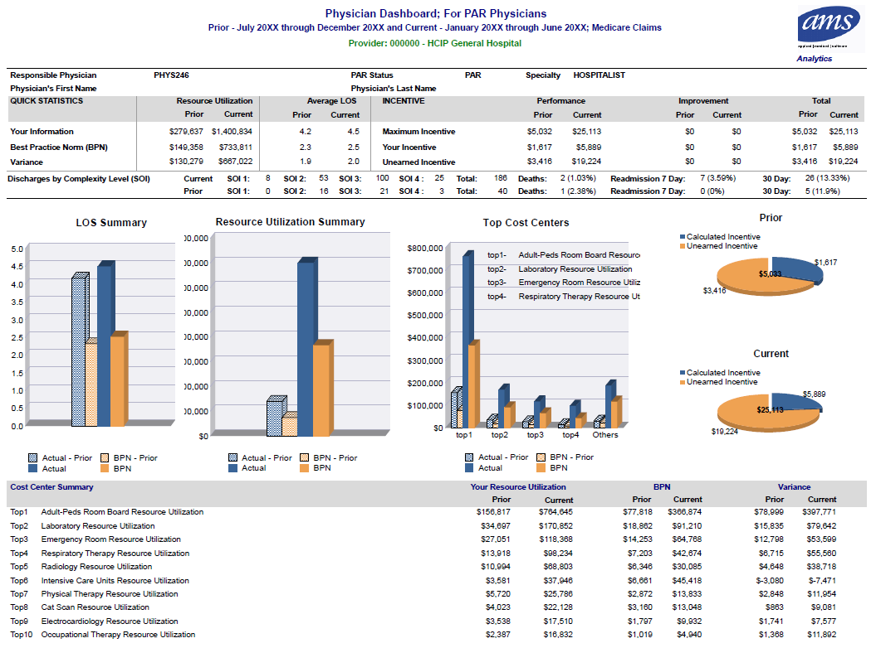

**FIGURE 2. SAMPLE PHYSICIAN REPORT**

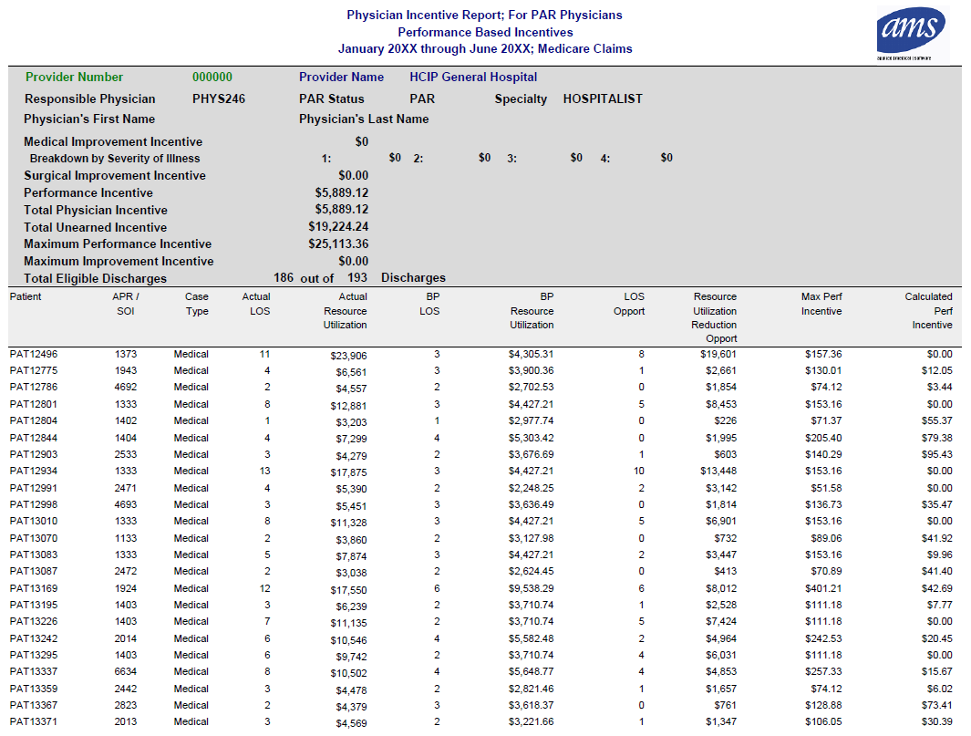

**Figure 3. SAMPLE QUALITY REPORT**

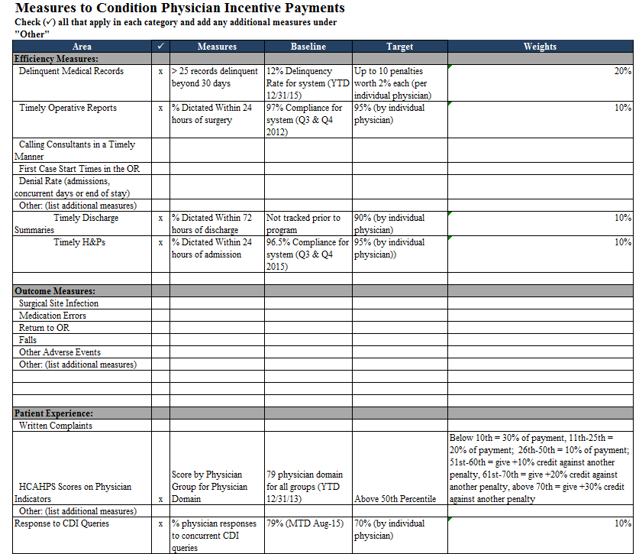

# Appendix B: Example of Methodology for Calculating Care Partner Incentive Payments

An illustrative example of calculating care partner incentive payments for APR DRG 165 – Coronary Bypass with Cardiac Cath or Percutaneous Cardiac Procedure (SOI Level 3) can be found in Appendix B.

**Overview of Hospital PAU Savings and Physician Opportunities**



**FIGURE 2. SAMPLE PHYSICIAN REPORT**



**Figure 3. SAMPLE QUALITY REPORT**



1. Because an individual physician or surgeon is unlikely to treat patients with the identical case-mix and levels of severity in the Prior Year and in the Current Year, the adjustments made to facilitate the comparison are a physician-specific case-mix/SOI index for the Prior Year and the Current Year.
2. Percentile will be set to eliminate the outlier effect caused by high-utilizing physicians.