RY2020 Medicare Performance Adjustment (MPA) Attribution FAQ

This guide is intended as a resource help explain the attribution used in the year 1 Medicare Performance Adjustment. It is not final and is subject to change. Additional questions or edits may be added as they are received.
Contents
Overview of Y1 MPA Attribution Algorithm 2
ACO-like attribution step walk-through 3
Step 1: Bene to ACO attribution 3
Step 2: ACO-like Bene to ACO provider 4
Step 3: ACO-like bene to hospital attribution 4
MDPCP-like attribution step walk-through 5
Step 1: Bene to PCP attribution 5
Step 2: PCP attribution to Hospitals. 5
Geographic Attribution (Primary Service Area-Plus) 6
Frequently asked attribution scenarios 7
What if the bene sees doctors in more than 1 ACO? 7
What if the bene also sees doctors not in an ACO? 7
What happens to benes attributed to a non-ACO group? 7
Other Frequently Asked Questions 8
Why are some providers in an ACO “missing”? 8
Which specialties are included in the ACO-like attribution? 9
Are the beneficiaries attributed under ACO-like the same ones as my ACO benes? 9
Can a doctor be assigned benes under both MDPCP-like and ACO-like? 9
Can a doctor be assigned benes to multiple hospitals? 9
Why are providers in the same practice assigned to different hospitals? 9

Overview of Y1 MPA Attribution Algorithm
Medicare attribution of Medicare Fee For Service beneficiaries with Part A and Part B is based on a hierarchy of Accountable Care Organization (ACO) –like, Maryland Primary Care Program (MDPCP)-like, and Primary Service Area (PSA)-plus. All beneficiaries are eventually included in the attribution. See Figure 1.

- ACO-like: Beneficiaries are attributed based on primary care use of clinicians in hospital-based Accountable Care Organization (ACO). The beneficiary is then linked to Maryland hospitals in that ACO.

- MDPCP-like: Benes not attributed in the ACO-like approach are attributed to PCPs based on primary care use, and then PCPs are linked to hospitals.

- PSA-plus: Any beneficiaries not attributed through the ACO-like or MDPCP-like components are attributed using the primary service areas listed in each hospital’s global budget revenue agreement, and as well as additional zip codes not claimed in any hospital’s PSA based on plurality of hospital utilization and drive time.

Bene
ACO PCP
Hospital
ACO-like component
PSA Plus component
MDPCP-like component
PCP stands for primary care provider. A PCP for this purpose includes traditional PCPs but also physicians from other selected specialties if used by beneficiary rather than a traditional PCP.
1
2
3
Beneficiaries attributed to an ACO
Beneficiaries attributed to PCP
All remaining beneficiaries attributed
Remaining unattributed benes
Figure 1. Overview of MPA Attribution Algorithm
Remaining unattributed benes

ACO-like attribution step walk-through
Under ACO-like attribution, benes are attributed to a hospital through three steps: bene to ACO, bene to provider, and provider or ACO to hospital. Under the ACO-like approach, each of the fourteen Maryland hospital-based ACOs are considered their own collection of providers, and any providers not in those collections are considered a “non-ACO” collection. Non-hospital based ACOs are considered non-ACOs for the purposes of the MPA Algorithm.

Step 1: Bene to ACO attribution
Each beneficiary is attributed under ACO-like based on the plurality of allowed primary care services charges among doctors in each ACO collection (or no ACO). If the plurality of primary care service charges is with a specific ACO’s collection of ACO NPIs (with eligible specialties), the beneficiary is attributed to that ACO under ACO-like. If the plurality of charges is with the non-ACO NPI collection, the beneficiary is not attributed under ACO-like, even if there are some services with ACO providers. If attributed to a non-ACO collection, the beneficiary moves to the MDPCP-like part of the algorithm. The algorithm checks first for primary care services with Traditional PCPs, then checks for specialist PCPs.

Bene has at least 1 visit/any PC services with Traditional PCPs?
Are the Plurality of PC services are with ACO PCP(s)?
No
No
Beneficiary moves to test attribution under MDPCP-like
Bene attributed to corresponding ACO
Figure 2. Bene to ACO-like diagram
Bene has any PC services with Other PCPs?
Yes
Yes
No
Yes

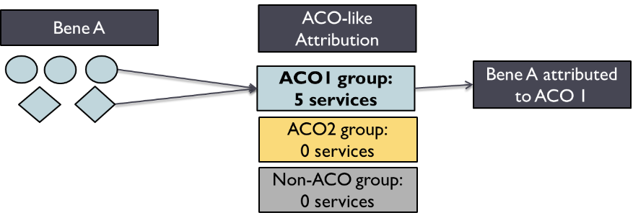
EXAMPLE: BENE TO ACO ATTRIBUTION
Beneficiary A had 5 primary care services with Dr. Circle and 5 with Dr. Diamond. Both Dr. Circle and Dr. Diamond are participating with ACO 1.

Attribution: Under the ACO-like attribution, the bene had 10 services with ACO1, and the bene is attributed to ACO1.

Step 2: ACO-like Bene to ACO provider
Once benes are attributed under ACO-like, benes are attributed to PCPs based on plurality of visits among the ACO providers. Even if a beneficiary was attributed to an ACO based on their use of ten different PCPs, the beneficiary will only be listed under one ACO provider. Again, this specific beneficiary-to-provider link does NOT determine whether the beneficiary is attributed to the ACO.
EXAMPLE: ACO-LIKE BENE TO ACO PROVIDER
Bene A was attributed to ACO 1, but had 3 services with Dr. Circle compared to 2 with Dr. Diamond.
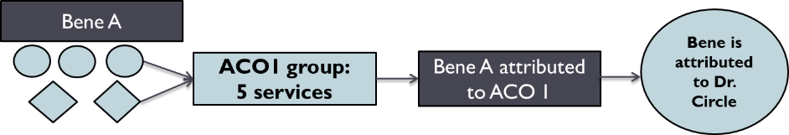

Attribution: Bene A is attributed to Dr. Circle.

Step 3: ACO-like bene to hospital attribution
ACO-like benes and TCOC can be directly attributed to hospitals in that ACO based on hospital market share OR ACOs can select which PCPs are linked with which hospitals in the ACO.

For ACOs with a single hospital participant: all beneficiaries attributed under ACO-like are attributed to that 1 hospital. For ACOs with only one hospital, all ACO-like benes are attributed to that hospital. The data by NPI is provided for informational purposes only and does not impact how the hospital is assigned beneficiaries

For ACOs with multiple hospital participants: there is an additional step to attribute the beneficiaries and TCOC to hospitals
- Under the default approach, beneficiaries’ TCOC is divided among ACO hospitals based on market share. (Bene-to-PCP link is presented for informational purposes only)
- Under the optional approach, ACOs designated specific ACO PCPs to specific ACO hospitals. The calculated bene-PCP link and ACO provided PCP-hospital link is used to assign the bene to hospital

MDPCP-like attribution step walk-through
Only beneficiaries not attributed under ACO-like are eligible for MDPCP-like attribution

Step 1: Bene to PCP attribution
If the bene has any office visits with a traditional PCP, the bene is attributed to the PCP with the plurality of that bene’s visits.If the bene doesn’t have any visits with a traditional PCP, the attribution checks for any visits with a specialist PCP. If neither of those is met, the bene moves to the PSA+ geography approach.
Any office visits with a Traditional PCP?
Any office visits with a Specialist PCP?
No
Bene moves to PSA+
Attributed to PCP with plurality of visits
(if tie, attributed to PCP with highest cost)
PCP linked to hospital with most IP and OP visits by all PCP’s attributed benes (if tie, hospital with greatest cost)
All PCP Benes* attributed to hospital
Yes
No
Yes
*all the Benes attributed to that PCP under MDPCP-like (ACO-like benes may be attributed to a different hospital).
Figure 3. MDPCP-Like Attribution

Step 2: PCP attribution to Hospitals.
Once beneficiaries are attributed to PCPs, all of the IP and OP visits by that PCP’s attributed beneficiaries are summed. Whichever hospital represents the greatest count of IP and OP visits by all those beneficiaries is attributed all of the PCP’s beneficiaries attributed under MDPCP-like.
EXAMPLE: PCP BENE TO HOSPITAL ATTRIBUTION
Two doctors have 100 beneficiaries attributed to them and neither is in an ACO. Both hospitals have a count of 10 visits to hospital A for all of their beneficiaries, but Dr. Triangle’s beneficiaries also have 20 visits to Hospital B.
ACO | Doctor | # of benes | Hospital A | Hospital B | Attribution to:
Non-ACO | Dr. Rectangle | 100 benes | 10 visits | 0 visits | All 100 benes attributed to Hospital A
Non-ACO | Dr. Triangle | 100 benes | 10 visits | 20 visits | All 100 benes attributed to Hospital B
Attribution: All 100 of Dr. Rectangle’s patients are attributed to Hospital A, and all 100 of Dr. Triangle’s patients are attributed to Hospital B

Geographic Attribution (Primary Service Area-Plus)
If benes are not attributed through the ACO-like or MDPCP-like approaches, benes and TCOC are attributed through the geographic approach. The benes and costs not attributed through ACO-like or MDPCP like are grouped into the bene zip codes of residence. If the zip code is in only one hospital’s primary service area (PSA) as indicated in their Global budget agreements, all the remaining patients are attributed to that hospital. If the zip code is in more than 1 hospital’s PSA, costs will be allocated according to utilization share in that zip code. If the zip code is not in any hospital’s PSA, it falls into the plus part of the PSA plus component. The zip code is assigned to hospitals based on share of Medicare ECMADs and drive time.

Benes residing in Zip Code
Benes on multiple hospital lists but costs allocated according to ECMAD in that Zip Code
Zip Code in one hospital’s PSA
Attributed to Hospital
Zip code not in any hospital’s PSA
Zip Code in more than one hospital’s PSA
Those Zip Codes assigned to hospitals (PSA-Plus) based on ECMADs and drive time (<30 minutes)
ECMAD stands for equivalent case-mix adjusted discharge. It is the number of (a) inpatient discharges and (b) outpatient visits scaled to reflect utilization similar to inpatient discharges.
Figure 4. PSA Plus Attribution

Frequently asked attribution scenarios

What if the bene sees doctors in more than 1 ACO?
Answer: Beneficiary is attributed to the ACO with the plurality of services

EXAMPLE: MORE THAN 1 ACO
Beneficiary B sees Dr. Circle for 3 visits and Dr. Diamond for 2 visits, but also sees Dr. Star for 4 services. Dr. Circle and Diamond participate with ACO1. Dr. Star participates with ACO2.
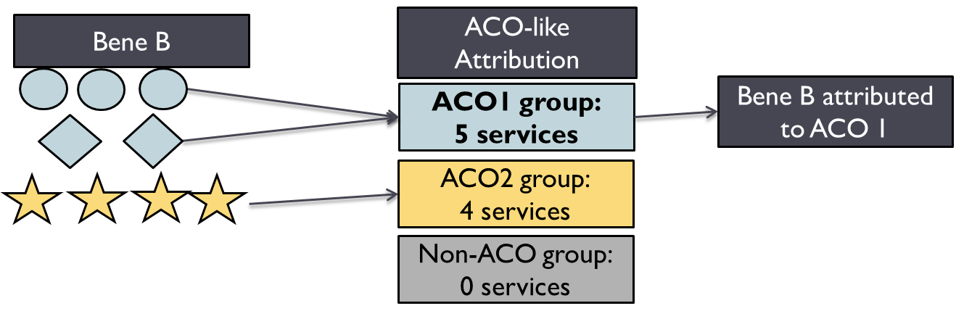
Attribution: Even though the largest number of services at a single provider was 4 from Dr. Star, the plurality of services is 5, from ACO1, so the bene is attributed to ACO1.

What if the bene also sees doctors not in an ACO?
Answer: Providers not in an ACO are grouped together as a Non-ACO collection, which is distinct from the other ACO groupings. The bene is attributed to the group with the plurality of services

What happens to benes attributed to a non-ACO group?
EXAMPLE
Beneficiary C sees Dr. Circle for 3 visits, Dr. Diamond for 2 visits, and Dr. Star for 4 services, but also sees Dr. Rectangle (no ACO) for 2 visits.
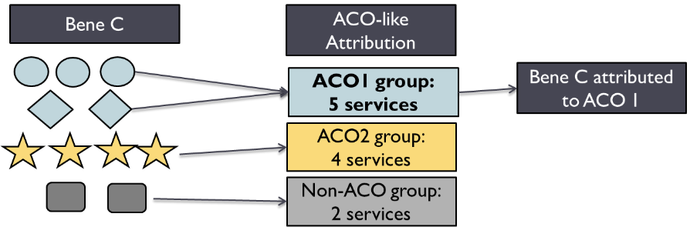
Attribution: The plurality of the services is still 5 at ACO1, so the bene is attributed to ACO 1
Answer: If the plurality of services is with Non-ACO providers, the bene will be not be attributed under the ACO-like attribution and will move on to the MDPCP-like part of the attribution.

Example Scenario: Bene D has 4 services with Dr. Star, 3 with Dr Rectangle and 2 with Dr. Triangle. Dr. Rectangle and Triangle are not with an ACO.
ACO-like Attribution: For Bene D, although the most from a single provider was 4 from Dr. Star, the plurality of services are with non-ACO providers, so Bene D is not attributed to any ACO. Bene D was not attributed to an ACO and moved to MDPCP-like.

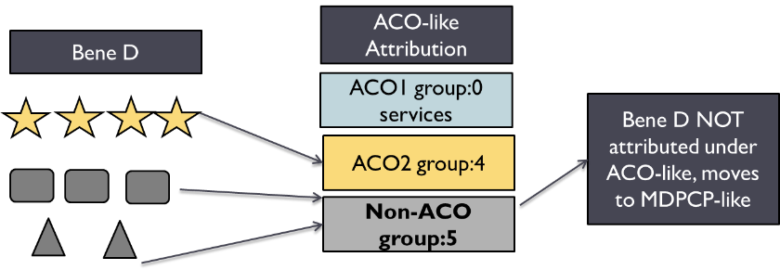

MDPCP-like Attribution: Because the plurality of services were with Dr. Star, bene D is attributed to Dr. Star under MDPCP-like. Because MDPCP-like is done on the individual provider, not on a collection of ACO providers, the doctor with the plurality of visits is attributed the bene.
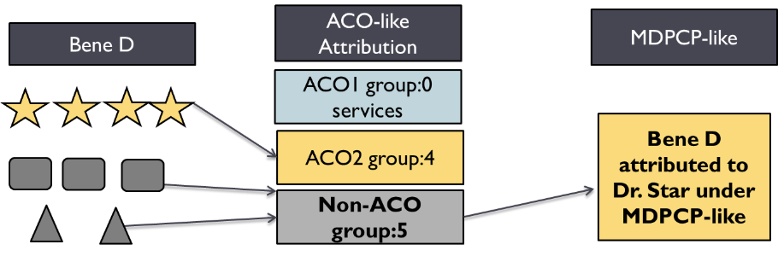

Other Frequently Asked Questions

Why are some providers in an ACO “missing”?
The ACO-like attribution uses collections of NPIs to determine beneficiary attribution. The ACO provider listed only represents the PCP that an ACO beneficiary sees most. This does not mean that the other PCPs were excluded from the ACO-like attribution, it only means that this is the PCP seen most.

Not all ACO providers are eligible for the ACO-like Attribution. While HSCRC requested the full list of ACO providers from ACOs, only providers with eligible specialties are considered in determining the ACO-like attribution . Most other types of providers or specialties will not contribute to the collections of NPIs that help determine the ACO (for example, podiatry, anesthesiology, clinical social worker, emergency medicine, etc.)

If a beneficiary is not attributed to an ACO based on the plurality of visits, the beneficiary is not assigned to the ACO Provider under the ACO-like list. For example, if a beneficiary sees ACO Doctor for 5 visits, and two non-ACO Doctors for 3 visits each, the beneficiary would be attributed to the non-ACO collection of providers because the plurality of services is with the non-ACO provider.If this happens for all of a provider’s beneficiaries, the provider would not show up on the ACO-like list, but would likely show up on the MDPCP-list.

Which specialties are included in the ACO-like attribution?
The ACO-like attribution uses the same specialties as the ACO algorithm. “Traditional” PCPs: primary care physicians specified as physicians, nurse practitioners, clinical nurse specialists, and physician assistants with specialties of internal medicine, general practice, family practice, geriatric medicine, or pediatric medicine. Other PCPs: (1)Cardiology, (2) Osteopathic manipulative medicine, (3) Neurology, (4) Obstetrics/gynecology, (5) Sports medicine, (6) Physical medicine and rehabilitation, (7) Psychiatry, (8) Geriatric psychiatry, (9) Pulmonary disease, (10) Nephrology, (11) Endocrinology, (12) Multispecialty clinic or group practice, (13) Addiction medicine, (14) Hematology, (15) Hematology/oncology, (16) Preventive medicine, (17) Neuro-psychiatry, (18) Medical oncology, (19) Gynecology/oncology.

Are the beneficiaries attributed under ACO-like the same ones as my ACO benes?
Benes attributed under ACO-like may not necessarily be the same ones as attributed under the CMS ACO program. See table below for the main differences between the two algorithms
 | CMS ACO Program | MPA ACO-like
Type of attribution | Retrospective: assigns benes to last year based on last year’s experience | Prospective: assigns benes to this year based on last year’s experience
Years of claims data | 1 federal fiscal year | 2 federal fiscal years

Can a doctor be assigned benes under both MDPCP-like and ACO-like?
Doctors can be assigned benes under both approaches. if the provider sees benes who do not see ACO-like PCPs for the plurality of their care, those benes will not be attributed to the ACO under ACO-like. When those non-ACO-like attributed benes are attributed under MDPCP-like, that provider may have the plurality of services. See What happens to benes attributed to a non-ACO group?

Can a doctor be assigned benes to multiple hospitals?
Most providers are only linked with one hospital, but a subset are linked with multiple hospitals.
This can happen under the following scenarios:
- if a doctor is aligned with more than one ACO (very small number of doctors)
- If a doctor is aligned with a hospital under ACO-like, but remaining benes are attributed under MDPCP-like and the plurality of IP and OP visits for those benes are with a different hospital than the doctor is linked to under ACO-like.

Why are providers in the same practice assigned to different hospitals?
The MPA algorithm is based on NPIs, which are individual doctors, rather than practice groups. This is because of the availability of data and the overlap of NPIs between groups. For Year 2, HSCRC is exploring ways to incorporate group information into the algorithm.

Using Equivalent Case-mix adjusted discharges (ECMADs)

