Final Recommendations for Updating
the Quality-Based Reimbursement Program for
Rate Year 2022
December 11, 2019
Health Services Cost Review Commission
4160 Patterson Avenue
Baltimore, Maryland 21215
(410) 764-2605
FAX: (410) 358-6217

This document contains the final staff recommendations for updating the Quality Based Reimbursement Program for RY 2022.
Table of Contents

List of Abbreviations 3
Executive Summary 4
Final Recommendations for RY 2022 QBR Program 4
Introduction 5
Background 6
Assessment 8
Maryland Performance by QBR Domain 9
Person and Community Engagement Domain 9
Safety Domain 14
Clinical Care Domain 15
Revenue Adjustment Modeling 17
QBR Future Updates 18
Stakeholder Feedback and Staff Responses 19
Final Recommendations For RY 2022 QBR Program 22
Appendix I. CMS Notification of Quality Program Exemptions, FFY 2020 23
Appendix II. HSCRC QBR Program Background, Detailed Overview 26
Domain Weights and Revenue At-Risk 27
QBR Score Calculation 28
Proposed RY 2022 QBR Program Updates 29
Appendix III. RY 2020 HCAHPS Measure Results by Hospital 32
Appendix IV. RY 2020 QBR Performance Standards 33
Appendix V. Modeling of Scores by Domain: RY 2020 QBR data with RY 2022 Measure Updates 34
Appendix VI. Modeling of QBR Program Revenue Adjustments 36

List of Abbreviations
CDC Centers for Disease Control & Prevention
CAUTI Catheter-associated urinary tract infection
CDIFF Clostridium Difficile infection
CLABSI Central Line-Associated Blood Stream Infection
CMS Centers for Medicare &e Medicaid Services
DRG Diagnosis-Related Group
ED Emergency Department
FFY Federal Fiscal Year
HCAHPS Hospital Consumer Assessment of Healthcare Providers and Systems
HSCRC Health Services Cost Review Commission
IQR Inpatient Quality Reporting
MRSA Methicillin-Resistant Staphylococcus Aureus
NHSN National Health Safety Network
PQI Prevention Quality Indicators
QBR Quality-Based Reimbursement
RY Maryland HSCRC Rate Year (Coincides with State Fiscal Year (SFY) July-Jun; signifies the timeframe in which the rewards and/or penalties would be assessed)
SIR Standardized Infection Ratio
SSI Surgical Site Infection
THA/TKA Total Hip and Knee Arthroplasty Risk Standardized Complication Rate
VBP Value-Based Purchasing

Executive Summary
This document puts forth the RY 2022 Quality-Based Reimbursement (QBR) final policy recommendations that include maintaining the RY 2021 quality domains, scoring approach, and pre-set revenue adjustment scale. This final recommendation also proposes minimal changes to the program measures, as outlined below.

Final Recommendations for RY 2022 QBR Program
- Implement the following measure updates:
  - Remove the ED-2b measure commensurate with its removal from the CMS Inpatient Quality Reporting (IQR) program.
  - Through the work of the QBR Redesign Sub Group, consider options for re-adopting ED Wait Time measures into the program for the RY 2023 policy and beyond.
- Continue Domain Weighting as follows for determining hospitals’ overall performance scores: Person and Community Engagement - 50 percent, Safety (NHSN measures) - 35 percent, Clinical Care - 15 percent.
- Maintain the pre-set scale (0-80 percent with cut-point at 41 percent), and continue to hold 2 percent of inpatient revenue at-risk (rewards and penalties) for the QBR program.

Introduction
Since 2014, Maryland hospitals have been funded under Population-Based Revenue, a fixed annual revenue cap that is adjusted for inflation, quality performance, reductions in potentially avoidable utilization, market shifts, and demographic growth. Under the Population-Based Revenue system, hospitals are incentivized to transition services to the most appropriate setting within the continuum of care, and may keep savings that they achieve via improved quality of care (e.g., reduced avoidable utilization, readmissions, hospital-acquired infections). It is important that the Commission ensure that any incentives to constrain hospital expenditures do not result in declining quality of care. Thus, the Maryland Health Services Cost Review Commission’s (HSCRC’s or Commission’s) Quality programs reward quality improvements that reinforce the incentives of the Population-Based Revenue system, while guarding against unintended consequences and penalizing poor performance.
The HSCRC’s Quality Based Reimbursement (QBR) program is one of several pay-for-performance initiatives that provide incentives for hospitals to improve patient care and value over time. Under the current Total Cost of Care (TCOC) Model Agreement between Maryland and the Centers for Medicare & Medicaid Services (CMS), Maryland’s QBR program has no stated performance requirements. However, the Commission has prioritized aligning the QBR program with the federal Value Based Purchasing (VBP) program, and has attempted to encourage improvement in areas where Maryland has exhibited poor performance relative to the nation.
Under the TCOC Model, the State must request exemptions from the CMS Hospital Acquired Conditions (HAC) program, Hospital Readmission Reduction program (HRRP), and Hospital Value-Based Purchasing (HVBP) program based on annual reports to CMS that demonstrate that Maryland’s program results continue to be aggressive and progressive, i.e. meeting or surpassing those of the nation. HSCRC submitted a report this year with its exemption request and received notification from CMS on August 29, 2019 that the exemptions were granted for Federal Fiscal Year 2020. With Maryland’s continued exemption from the federal VBP program, the State (via the HSCRC) can continue to generate autonomous, quality-based measurement and payment initiatives that set consistent all-payer quality incentives. .
The QBR program measures and domains are similar to those of the VBP program, but there are a few differences. Most notably, QBR does not include an Efficiency domain, as efficiency is more directly measured in other HSCRC methodologies, including, the Potentially Avoidable Utilization program, the Medicare Performance Adjustment, and the Integrated Efficiency policy. Another key difference is that the HSCRC has put higher weight on the Person and Community Engagement and Safety domains to encourage improvement on measures of patient experience.
Generally though the HSCRC tries to align the QBR program to measures of national import, and where feasible the Commission incorporates more comprehensive measurement relative to the VBP program, most notably an all-cause, inpatient Maryland mortality measure versus VBP’s condition-specific 30-day mortality measures.
Finally, it is important to note that Maryland has begun the work to update performance standards and targets in HSCRC’s portfolio of quality and value-based payment programs with the onset of the Total Cost of Care (TCOC) Model Agreement with CMS. Per directives from HSCRC Commissioners, staff worked with stakeholders last year to revise two of the Commission’s Quality programs, the Maryland Hospital Acquired Conditions program and the Potentially Avoidable Utilization program. This year, staff is working with stakeholders to redesign the Readmissions Reduction Incentive Program for RY 2022 (Performance Period - CY 2020). The QBR program will include minor updates this year, but will largely remain similar to prior iterations of the policy, as it is slated for redesign for next year. For more information on suggested areas of analysis for the future QBR redesign, please see “QBR Future Updates” or follow along with our work over the coming calendar year.
This report provides final recommendations for updates to Maryland’s QBR program for Rate Year (RY) 2022, with minimal updates from RY 2021.

Background
The Affordable Care Act established the hospital Medicare Value-Based Purchasing (VBP) program, which requires CMS to reward hospitals with incentive payments for the quality of care provided to Medicare beneficiaries. Figure 1 below compares the RY 2021 QBR measures--with changes noted from RY 2020— and domain weights to those used in the CMS VBP program.

Figure 1. RY 2021 QBR Measures with Changes from RY 2020, Domain Weights
Compared with CMS VBP Program
 | Maryland QBR Domain Weights and Measures | CMS VBP Domain Weights and Measures
Clinical Care | 15 percent -2 measures: all cause inpatient Mortality,  THA/TKA complications measure (newly adopted RY 2021) | 25 percent -5 measures: 4 condition-specific Mortality,  THA/TKA complications measure
Person and Community Engagement | 50 percent- 9 measures: 8 HCAHPS measures; ED-2b wait time measure  (ED-1b removed after RY 2020) | 25 percent- 8 HCAHPS measures  (no ED Wait Time measures)
Safety | 35 percent -5 measures: CDC NHSN HAI | 25 percent 5 measures: CDC NHSN HAI
Efficiency | N/A | 25 percent-Medicare Spending Per Beneficiary measure

With the selected measures from above, the QBR program assesses hospital performance on an all-payer basis. Performance standards are based on the national average (threshold) and the top performance values (benchmark) for all measures, with the exception of HSCRC calculated in-hospital mortality rate, which uses State data to calculate performance standards. Thus, a score of 0 percent means that performance on all measures is below the national average or not improved, while a score of 100 percent means performance on all measures is at or better than the top 5 percent best performing hospitals. This scoring methodology is the same as the national VBP program. However, unlike the VBP program that then relatively ranks all hospitals, the QBR program uses a preset scale to determine each hospitals revenue adjustment.
In the RY 2019 QBR recommendation, the Commission approved using a preset scale based on national performance to ensure that QBR revenue adjustments are linked to Maryland hospital performance relative to the nation. Prior to RY 2019, Maryland hospitals were evaluated by national thresholds and benchmarks, but their scores were then scaled in accordance with Maryland performance, resulting in Maryland hospitals receiving financial rewards despite falling behind the nation in performance. Consequently, the scale is now 0 to 80 percent regardless of the score of the highest performing hospital in the State, and the cut-point at which a hospital earns rewards in RY 2021 is 41 percent. This reward and penalty cut-point was based on an analysis of FFY16-FFY18 National Value-Based Purchasing scores, which indicated the average national score using Maryland domain weights (i.e., without the Efficiency domain) was around 41 percent (range 39.9 to 42.7).
As a recap, the methodology for calculating hospital QBR scores and associated inpatient revenue adjustments has remained essentially unchanged since RY 2019, and involves:
- assessing performance on each measure in the domain;
- standardizing measure scores relative to performance standards;
- calculating the total points a hospital earned divided by the total possible points for each domain;
- finalizing the total hospital QBR score (0-100 percent) by weighting the domains based on the overall percentage or importance the Commission has placed on each domain; and
- converting the total hospital QBR scores into revenue adjustments using the preset scale that ranges from 0 to 80 percent.
The methodology is illustrated in Figure 2 below.
Figure 2. Process for Calculating RY 2021 QBR Scores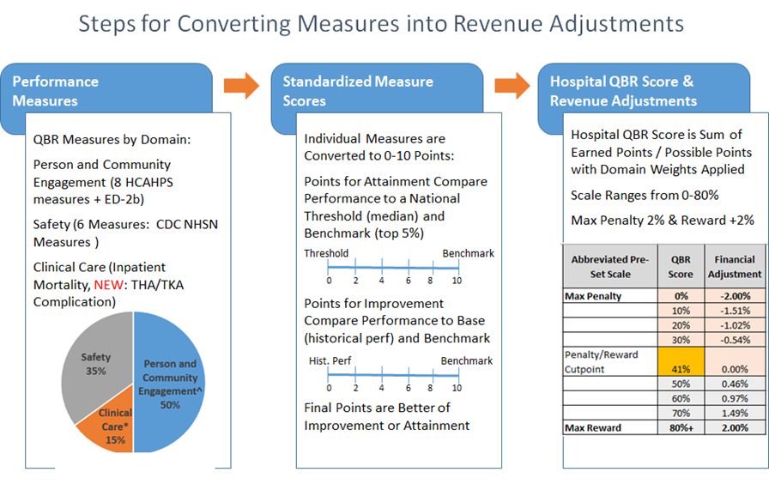 Appendix II contains further background and technical details about the QBR and VBP programs.

Assessment
The purpose of this section is to present an assessment, using the most current data available, of Maryland’s performance on measures used in QBR as well as other measures where national comparisons are available. The assessment, together with the deliberations of the Performance Measurement Workgroup (PMWG), serve as the basis for the recommendations for the RY 2022 QBR program. In addition, staff has modeled the QBR revenue adjustments with the recommended changes.

Maryland Performance by QBR Domain

Person and Community Engagement Domain
During RY 2020, the Person and Community Engagement domain measured performance using the HCAHPS patient survey, as well as two emergency department wait time measures for admitted patients. The addition of the emergency department wait time measures was an example of Maryland’s quality programs differing from the nation to target an area of concern.

Hospital Consumer Assessment of Healthcare Providers and Systems (HCAHPS)
Figure 3 below provides a graphic representation of the HCAHPS measure results for the RY 2020 base and performance periods for Maryland compared to the Nation, revealing that Maryland continues to lag behind the Nation, but both the Nation and Maryland are improving at similar rates overall.
Figure 3. HCAHPS Results: Maryland Compared to the Nation for RY 2020 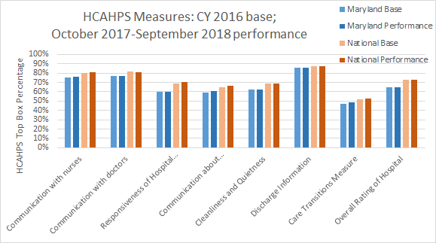
For each HCAHPS measure, the changes over time from the base to the performance period for Maryland and the Nation, and the gaps in performance between Maryland and the Nation, are provided below.
- Communication with nurses- Maryland and the Nation both improved by 1 percent, and the gap remained the same with Maryland -5 percent below (worse than) the Nation.
- Communication with doctors- Maryland remained the same, while the Nation decreased by 1 percent, and the gap lessened for Maryland from -5 percent to -4 percent below the Nation.
- Responsiveness of hospital staff- Maryland remained the same while the Nation improved by 1 percent, and the gap widened for Maryland from -9 percent to -10 percent below the Nation.
- Communication about medicine Maryland improved by 1 percent and the Nation remained the same, and the gap decreased for Maryland from -6 percent to -5 percent below the Nation.
- Cleanliness and quietness- Maryland and the Nation remained the same, and the gap remained the same for Maryland at -6 percent below the Nation.
- Discharge information- Maryland and the Nation remained the same, and the gap remained the same for Maryland at -1 percent below the Nation.
- Care transition measure- Maryland improved by 2 percent and the Nation improved by 1 percent, and the gap decreased for Maryland from -5 percent to -4 percent below the Nation.
- Overall rating of hospital- Maryland and the Nation remained the same, and the gap remained the same for Maryland at -8 percent below the Nation.

While the statewide data suggests that Maryland continues to lag behind the Nation on HCAHPS measures, there is variability in performance across individual hospitals, with some performing better than the national average on each measure. Furthermore, while the statewide improvements were modest, there were individual hospitals with significant improvements on each measure (Appendix III). Nevertheless, staff remains concerned about overall statewide performance relative to the Nation and will continue to consider additional incentive structures to improve performance as part of the QBR redesign.

An additional concern raised by hospitals is the potential impact of the HCAHPS patient mix adjustment changes between the base and performance periods at the federal level This adjustment, which accounts for the probability of a patient’s positive response on a survey relative to other sets of patients, e.g. 55-64 year olds versus individuals over 85, should ideally be consistent in the base and performance periods. However, CMS has advised staff that these changes occur on an ongoing basis and are not considered materially significant for the VBP program. Further, staff believes that the changes in any given year may slightly benefit or disadvantage each hospital on their respective QBR scores, but recognizes that the use of the prospective preset scale may make this issue more of a concern in Maryland. Therefore, staff proposes again to work with QBR redesign subgroup to be convened in CY 2020 and the PMWG to evaluate the impact, if any, of the patient mix adjustment changes for RYs 2019 through 2021, but does not believe retrospective revenue adjustments are warranted at this time. Staff may re-visit this position with the Commission should analysis determine the patient mix adjustment changes are materially significant.

Emergency Department Wait Times

Emergency Department wait time measures have been publicly reported nationally on Hospital Compare since 2012 for patients admitted (ED-1b and ED-2b), and since 2014 for patients treated and released (OP-18b). The measure definitions are provided below in Figure 4. Based upon Maryland’s sustained poor performance on these ED throughput measures, the Commission voted to include the two ED Wait Time measures for admitted patients as part of the QBR program for RY 2020. As CMS has discontinued mandatory data collection for ED-1b after CY 2018, this measure was removed from QBR for the RY 2021 policy; further, the ED-2b measure will be removed from CMS mandatory data submission requirements after CY 2019, necessitating its removal from the RY 2022 QBR program.

Figure 4. CMS ED Wait Time Measures
Measure ID | Measure Title
ED-1b | Median time from emergency department arrival to emergency department departure for admitted emergency department patients
ED-2b | Admit decision time to emergency department departure time for admitted patient
OP-18b* | Emergency department arrival time to departure time for discharged patients.
*OP-18 was not included in the RY 2021 Program. OP-18b strata includes non-psychiatric patients and OP-18c strata includes psychiatric patients.

Staff notes that the data trends to date do not reveal any positive impact since adding the measures to the QBR program. Based upon analysis of the RY 2020 QBR performance period (October 2017 through September 2018), Maryland continues to perform poorly on the ED Wait Time measures compared to the nation, as illustrated in Figure 5 below. At the hospital level, the most recent data show approximately 86 percent of Maryland hospitals perform worse than the national median in ED Wait Times, as compared to 85.7 percent of hospitals performing worse on ED-1b and 78.6 percent performing worse on ED-2b when these measures were first put in pay for performance programs two years ago.

Figure 5. Maryland Statewide ED Wait Time Trends for Admitted Patients
Compared to the Nation, Q2 2012 to Q32018.
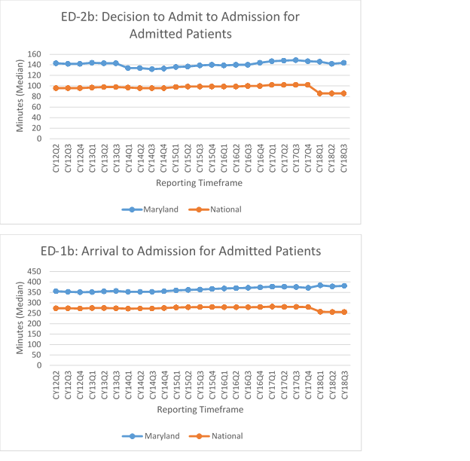
As staff notes above, for the RY 2022 QBR program, since CMS has discontinued mandatory reporting of the ED-2b measure after CY 2019, this measure will no longer be available on Hospital Compare for use. With the redesign of the QBR program for RY 2023, staff proposes to consider alternative data source options for re-adoption of ED Wait Time measures for admitted patients, such as the data submitted by hospitals to CMS specified as Electronic Clinical Quality Measures (eCQM).
With stakeholder interest continuing this year to retain ED Wait Time measures, particularly payer and consumer stakeholders, staff and the PMWG reconsidered whether to propose inclusion of OP-18b (non-admitted patients) for RY 2022. Maryland has performed poorly compared to the nation on the wait time for non-admitted/discharged patients as illustrated in Figure 6. While some stakeholders voiced support for inclusion of the OP-18b measure last year, others suggested the measure is at odds with hospitals’ efforts to reduce inpatient admissions and the time needed for care coordination in the ED.
Figure 6. Maryland Performance Compared to the Nation on OP-18b,
CY 2014 Qtr 1-CY 2018 Qtr 3
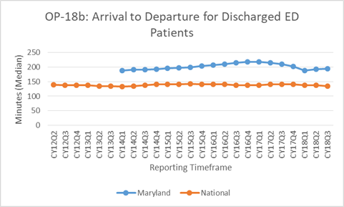
Last year, staff noted its intent to monitor performance on the OP-18b measure over the coming program year. Staff noted it would reconsider inclusion of OP-18b in the future if “spillover” improvements from implementing the wait time measures for admitted patients were not seen in outpatient/non-admitted ED Wait Times, particularly in light of the fact that Maryland’s higher wait times are paired with declining statewide ED visits. Conversely, staff acknowledged that a factor impacting the measure is related to difficulties with the behavioral health system in the State, such as the need for improvement in the behavioral health system infrastructure and labor shortages, which exacerbate emergency department throughput problems; however these issues are not unique to Maryland. Staff, therefore, proposed to reconsider adoption of the OP-18b measure as part of the process to redesign the QBR program during CY 2020 and to continue to monitor performance on this measure. With the data lag time, this will allow for two years of data to be analyzed where at least one ED Wait Time measure for admitted patients was included in the program. Staff has received stakeholder feedback on the draft policy which is summarized in the Stakeholder Feedback and Staff Response section below; staff does not at this time recommend adopting the OP-18b measure for RY 2022.
Finally, staff notes that, in the FFY 2020 notification of exemption from CMS quality programs, CMS acknowledged the challenges around improving patient experience, and were supportive of “...maintaining the highest weight for the person and community engagement component along with the one emergency department wait time measure (ED-2b) if publicly reported.”
Based on the analysis of the Person and Community Engagement domain as well as stakeholder feedback, HSCRC staff recommends continuing to weight this domain at 50 percent of the QBR score, with the HCAHPS measures remaining in the domain. Staff proposes to consider ED Wait Time measure options as part of the QBR redesign during CY 2020 with potential re-adoption of measures for RY 2023 and beyond.

Safety Domain
The Safety domain consists of five CDC National Health Safety Network (NHSN) healthcare associated infection (HAI) measures. As illustrated in Figure 7 below, Maryland's performance on the NHSN measures has been mixed (lower scores are better). Average hospital standardized infection ratios (SIRs) for five of the six HAI categories declined (improved) both nationally and for Maryland in the performance period compared to the base. Maryland’s improvement from the base was better than that of the nation for three of the six infection categories (Central Line Associated Blood Stream Infection-CLABSI, Catheter Associated Urinary Tract Infection-CAUTI, Methicillin Resistant Staph aureus- MRSA) and on par with the nation for two measures (Clostridium difficile-CDIFF, Surgical Sight Infection Colon- SSI Colon). Additionally, in the performance period, Maryland’s infection rates were better (lower) for CAUTI; slightly worse (higher) for CLABSI, SSI colon, MRSA, and CDIFF; and, markedly worse for Surgical Sight Infection hysterectomy.
Figure 7. Maryland vs. National Median Hospital SIRs on NHSN HAI Safety Measures (Base period Calendar Year 2016, Performance period October 1, 2017 to September 30, 2018)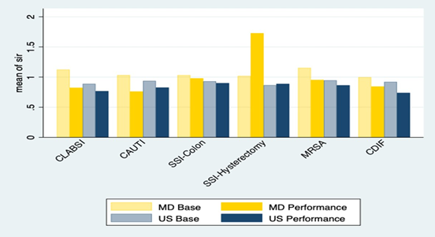

Staff recommends continuing to weight the Safety domain at 35 percent of the total QBR score (10 percent greater than the 25 percent in CMS VBP).

Clinical Care Domain

The QBR Clinical Care domain consists of one all-payer, all-cause, all-condition inpatient mortality measure, while the Medicare VBP program includes four 30-day condition-specific mortality measures (Heart Attack, Heart Failure, Pneumonia, and COPD). Medicare also monitors two additional 30-day mortality measures for Coronary Artery Bypass Graft and Stroke, but does not include these measures in VBP. Both QBR and VBP include the Total Hip and Knee Arthroplasty (THA/TKA) complication measure on Medicare patients with elective primary procedures.

Based on the analysis of the weighted average rates for Maryland versus the nation for the condition specific mortality measures provided by Health Quality Innovators, Maryland performs similarly to the nation for all condition-specific measures of 30-day mortality (Figure 8).

Figure 8. Maryland Hospital Performance Compared with the nation on CMS Condition-Specific Mortality Measure Rates
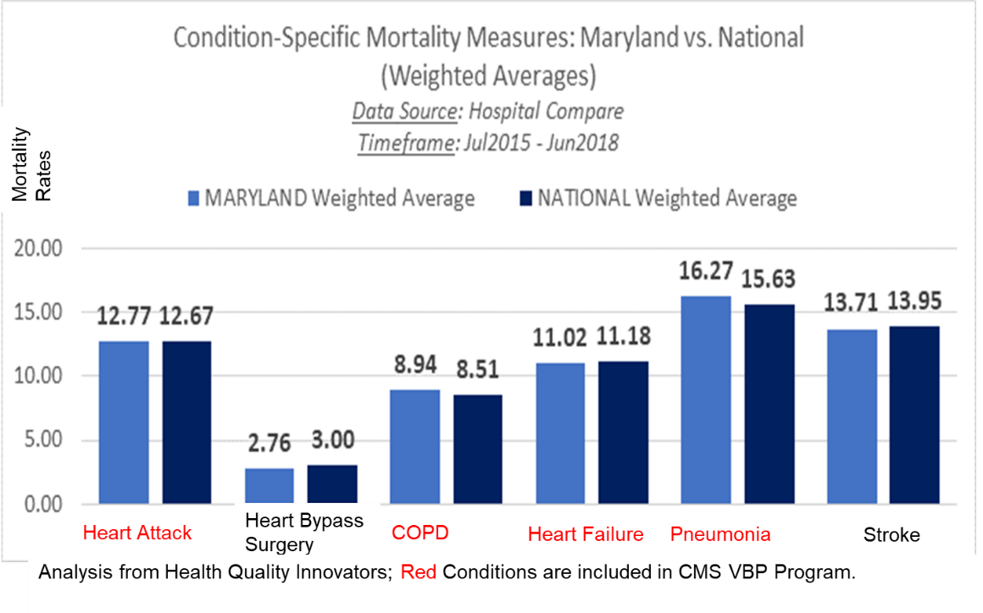
For the QBR all-payer inpatient mortality measure for RY 2020, statewide survival rate increased (improved) from 0.9553 in the base period to 0.9617 in the performance period. As illustrated in Figure 9 below, all but three hospitals earned points for either attainment or improvement on the mortality measure; 33 hospitals performed better than the statewide benchmark (50th percentile) as they earned at least one attainment point.
Figure 9. Maryland Hospital Performance, FY 2020 QBR
Inpatient All Condition, All Payer Mortality Measure
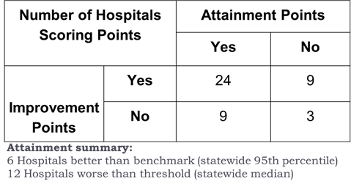

For RY 2022, staff is not proposing any significant methodology changes to the inpatient mortality measure. However, Johns Hopkins and University of Maryland have brought to our attention two technical adjustments that the staff will implement - these are minor adjustments to align the measure with the original intent of the 80 percent DRG inclusion, and to update the exclusions to accommodate recent ICD-10 updates. Other stakeholder comments on the inpatient measure will be considered during the QBR redesign, and as part of the development of the 30-day all-payer, all-condition mortality measure. Staff have been working with contractor support to develop the new mortality measure and will vet the measure with the QBR redesign subgroup and the PMWG during the course of the coming year, with potential plans for inclusion of the measure in the RY 2023 QBR program.

For the hip and knee complication rate measure for RY 2020, Figure 10 illustrates that, based on analysis of the weighted average rates for Maryland and the nation, Maryland performed on par with the nation.

Figure 10. Maryland THA/TKA Measure Performance
Compared to the Nation
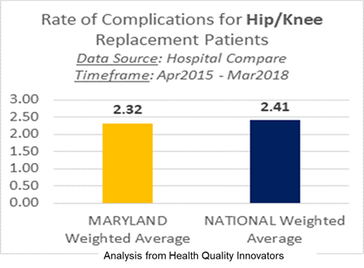
Since this measure is calculated by Hospital Compare using Medicare claims data and includes only Medicare patients, payer stakeholders of the PMWG have voiced support for expanding this measure to the commercial population and other payers if feasible. In addition, staff notes that this measure is applicable only to patients in the inpatient setting. With the removal of hip and knee replacement procedures from the Medicare “inpatient only” list--procedures for which Medicare will reimburse only if performed in the inpatient setting--, and the shift of these procedures to the outpatient setting, staff believes the QBR re-design subgroup should consider both payer and care setting applicability options for measure expansion.

Staff recommends continuing to include the inpatient mortality measure and hip and knee replacement complication measure in the Clinical Care domain consistent with the VBP program, and continuing to weight the Clinical Care domain at 15 percent.
Appendix IV details the available published performance standards (for VBP measures) for each measure by domain for RY2022; staff will calculate and disseminate the inpatient mortality standards when Version 37 of the 3M APR DRG grouper is implemented.

Revenue Adjustment Modeling
HSCRC staff modeled hospital QBR scores and revenue adjustments using the methodology approved for RY 2021. This includes maintaining the reward/penalty cut-point at 41 percent, which is consistent with updated analyses showing that the FFY19 national average score using QBR weights is 41 percent. The only changes in calculating the modeled QBR scores were the removal of the ED Wait Time measure and technical updates to the inpatient mortality measure.
Hospital-specific domain scores and total QBR scores are included in Appendix V. Statewide, the average hospital score is 35 percent; with a range from 13 to 59 percent. The modeled hospital-specific and statewide revenue impacts are found in Appendix VI. Figure 11 provides the estimated statewide revenue adjustments and counts of hospitals receiving a reward and penalty and compares to the final RY 2020 QBR revenue adjustments. Overall, the estimated revenue adjustments are significantly less than the net RY 2020 due to the lower cut-point (RY 2020 cut-point was 45 percent) and measure changes (ED Wait Time removal, addition of hip and knee measure).
Figure 11. Maryland THA/TKA Measure Performance
Compared to the Nation
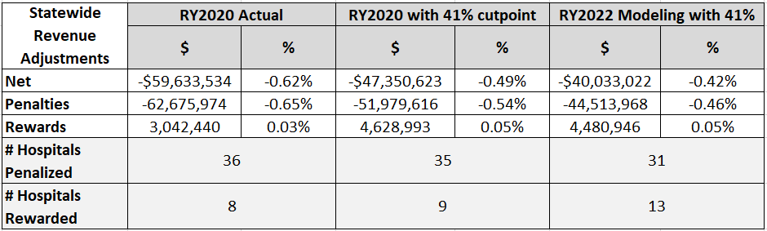

QBR Future Updates
As previously mentioned, staff intends to convene a sub-group of the Performance Measurement Work Group, comprised of key stakeholders and subject-matter experts, to consider an overhaul of the QBR program in CY 2020. This group will review the existing QBR policy and goals of the TCOC model, and develop recommendations to modify the QBR program for the RY 2023 QBR Policy and beyond. Because the QBR policy assesses multiple domains of hospital quality (as opposed to the complications or readmissions program), this program is particularly well suited for expanding into new areas that are relevant under the TCOC model. To accomplish this redesign, which will necessitate consideration of measures and domains outside of those in the current program, the sub-group will consider 1) measurement selection, which will include evaluating the feasibility of including other CMS inpatient and outpatient measures, as well as retaining measures currently used, or adopting other measures that cover important all-payer clinical areas that may not be addressed by CMS measurement and reporting; and 2) methodological concerns, which will include appropriate risk adjustment, scoring, and scaling, and establishing reasonable performance targets.
Among the topics the sub-group may consider are the following:
- Strengthen the current incentives to improve patient experience, safety, and clinical outcomes.
- Consider re-adoption of ED Wait Time measures.
- Explore potential new QBR measures from those already in the CMS inpatient hospital reporting pipeline but not currently used in pay for performance, such as the Severe Sepsis and Septic Shock: Management Bundle measure (SEP-1).
- Explore other available measures using measure catalogues such as the CMS’s Measure Inventory Tool and the National Quality Forum’s Quality Positioning System.
- Evaluate additional data sources needed for performance measurement under the TCOC model.
- Evaluate new opportunities for performance measurement as care is moved from the inpatient setting to other settings of care (e.g., outpatient hospital measures). Ensure that financial incentives under the population-based revenue system are aligned.
- Identify or develop holistic and patient-centered measures.
- Develop hospital pay-for-performance programs that foster accountability for broader care transformation and population health initiatives; specifically, the QBR program could be utilized to support goals developed for the State Integrated Health Improvement Strategy (SIHIS) that do not fit under other quality programs.
Staff acknowledges that this redesign will require substantial work in concert with industry and a broad array of other stakeholders, including consumers, payers, cross-continuum providers, quality measurement experts, and government agencies (local, state, and federal). Staff welcomes additional topics for consideration related to the QBR sub-group, and encourages those interested in participating in the sub-group to contact the Quality team at hscrc.quality@maryland.gov.

Stakeholder Feedback and Staff Responses
Staff received comment letters on the draft QBR recommendation from Maryland Citizens’ Health Initiative Education Fund (MCHI), CareFirst, the Maryland Chapter of the American College of Emergency Physicians (ACEP), Luminis Health (an integrated system comprised of Anne Arundel Medical Center and Doctors Community Hospital), the Maryland Hospital Association (MHA), Johns Hopkins, and Maryland Institute for Emergency Medical Services Systems (MIEMSS).
The comments received with staff responses are summarized below.
Program Methodology
Several stakeholders registered support for maintaining the current methodology for scoring cut-point, scaling, and revenue adjustments (MHA and CareFirst).
Staff Response: Staff is not recommending alterations to the scoring, scaling or revenue adjustment methodologies for the RY 2022 policy. However, staff does propose that alternative options for these parts of the methodology be considered during the process to reconstitute the QBR program next year.

Concerns about Maryland’s Long ED Wait Times
All commenters expressed concern about the sustained trends of extended ED Wait Times in Maryland. Stakeholders argued both for and against the inclusion of the OP-18b measure into the RY 2022 QBR program. This feedback was generated in response to staff’s suggestion to include the OP-18b measure following the removal of both ED-1b and ED-2b measures from CMS Hospital Compare.
Arguments For OP-18b Measure Inclusion:
- OP-18b represents the experience of the majority of patients who visit the Emergency Department, “since the majority of ED visits result in no admission” (Luminis, CareFirst).
- “Longer ED wait times erode patient confidence in the hospital system and are perceived by many as an indicator of poor quality care provision” (MCHI).
Arguments Against OP-18b Measure Inclusion:
- Hospitals have undertaken significant efforts to reduce avoidable admissions, which include additional care coordination and treatment in the Emergency Department. These additional efforts will increase the OP-18b wait time but are indicative of proper care under the global budget model (ACEP, MHA, Johns Hopkins Medicine).
- Trends in Emergency Department utilization suggest that, while overall visits are declining, the relative complexity of patients is increasing. Additionally, behavioral health ED visits are trending upwards (MHA).

Other Suggestions to Address the ED Throughput Issue:
- Ask hospitals to directly report ED-2b, a better metric of the “boarding” of patients who should be admitted; hospitals should begin direct reporting to HSCRC for CY 2020 so there is not a gap in measurement and in accountability through the QBR program (ACEP, CareFirst, MIEMSS).
- Concurrent with including ED-2b in QBR through direct reporting to HSCRC, “…placing value on this measure [OP-18b] will help our understanding and management of complex systems issues” (MIEMSS)
- Consider including time on ED diversion status, as well as a measure of hospital capacity, to better understand the challenges to addressing ED throughput (Luminis)
- Consider options for adjusting ED Wait Time measures for bed capacity and socioeconomic status, but pending the completion of this work, it is of paramount importance that we continue to track and incentivize hospitals’ efforts to reduce ED wait times (CareFirst).
- Score hospitals on ED Wait Times on both improvement and attainment (Luminis).
- Given multiple factors contributing to ED Throughput concerns (both within and outside of hospital control), delay inclusion of any ED Wait Time measures in QBR program pending further review through QBR Re-design (Johns Hopkins Medicine).
Staff Response: Staff agrees that Emergency Department throughput remains an area of concern and acknowledges stakeholder feedback that the ED-2b measure should continue to be collected, as the preferred measure of "boarding" and of overall hospital throughput efficiency. HSCRC clarifies that the source of information regarding ED Wait Times is CMS Hospital Compare, and without this source data, staff is at present unable to easily collect ED Wait time data. HSCRC would need to establish data collection, reporting and auditing parameters, and infrastructure in order to collect the ED Wait Time measures for patients who are admitted. Staff views this proposal as not feasible at this time. Fortunately, CMS has created an electronic clinical quality measure of ED-2b, which staff can incorporate into mandatory collection and reporting during the QBR re-design. Staff will explore how to receive validated ED wait time data (potentially as a mandated eCQM) over the coming year with the QBR re-design group. Staff does not recommend including OP-18b but as with the ED-2b measure staff agrees that this should be considered for inclusion in the future along with other measures of hospital throughput and efficiency. Finally, staff notes that Maryland does not have an accurate and comprehensive measure of ED diversion or capacity at this time, and would need to work with stakeholders before using such metrics to adjust measures of ED throughput.
Feedback Regarding HCAHPS:
- Engage consumers to improve HCAHPS scores (MCHI).
- Consider implementing focus groups to highlight hospitals with particular opportunity to improve upon HCAHPS scores (CareFirst).
- Target HCAHPS hospital outliers for updating how incentives are used in QBR.

Staff Response: Staff appreciates these additional suggestions regarding our persistently low HCAHPS scores. Staff will consider this feedback for engaging consumers to improve HCAHPS, and for updating the QBR methodology and incentive structure for HCAHPS outliers, as part of the QBR re-design in the coming year.
Feedback Regarding Hip-Knee Complication (THA-TKA) Measure
- Consider expanding the existing THA-TKA measure to include payers other than Medicare FFS (CareFirst).

Staff Response: Staff acknowledges that, where possible, all-payer metrics are preferable over payer-specific metrics. However, staff is not proposing any changes to the THA-TKA measure population for RY 2022, but will consider this suggestion in terms of the feasibility, validity, and reliability of applying the CMS Medicare measure specifications to the all-payer population as part of the QBR re-design in the coming year.

Final Recommendations For RY 2022 QBR Program
- Implement the following measure updates:
  - Remove the ED-2b measure commensurate with its removal from the CMS Inpatient Quality Reporting (IQR) program.
  - Through the work of the QBR Redesign Sub Group, consider options for re-adopting ED Wait Time measures into the program for the RY 2023 policy and beyond.
- Continue Domain Weighting as follows for determining hospitals’ overall performance scores: Person and Community Engagement - 50 percent, Safety (NHSN measures) - 35 percent, Clinical Care - 15 percent.
- Maintain the pre-set scale (0-80 percent with cut-point at 41 percent), and continue to hold 2 percent of inpatient revenue at-risk (rewards and penalties) for the QBR program.

Appendix I. CMS Notification of Quality Program Exemptions, FFY 2020

Appendix II. HSCRC QBR Program Background, Detailed Overview
The Affordable Care Act established the hospital Medicare Value-Based Purchasing (VBP) program, which requires CMS to reward hospitals with incentive payments for the quality of care provided to Medicare beneficiaries. The program assesses hospital performance on a set of measures in Clinical Care, Person and Community Engagement, Safety, and Efficiency domains. The incentive payments are funded by reducing the base operating diagnosis-related group (DRG) amounts that determine the Medicare payment for each hospital inpatient discharge. The Affordable Care Act set the maximum penalty and reward at 2 percent for federal fiscal year (FFY) 2017 and beyond.
Maryland’s Quality-Based Reimbursement (QBR) program, in place since July 2009, employs measures that are similar to those in the federal Medicare VBP program, under which all other states have operated since October 2012. Similar to the VBP program, the QBR program currently measures performance in Clinical Care, Safety, and Person and Community Engagement domains, which comprise 15 percent, 35 percent, and 50 percent of a hospital’s total QBR score, respectively. For the Safety and Person and Community Engagement domains, which constitute the largest share of a hospital’s overall QBR score (85 percent), performance standards are the same as those established in the national VBP program. The Clinical Care Domain, in contrast, uses a Maryland-specific mortality measure and benchmarks. In effect, Maryland’s QBR program, despite not having a prescribed national goal, reflects Maryland’s rankings relative to the nation by using national VBP benchmarks for the majority of the overall QBR score.
In addition to structuring two of the three domains of the QBR program to correspond to the federal VBP program, the Commission has increasingly emphasized performance relative to the nation through benchmarking, domain weighting, and scaling decisions. For example, beginning in RY 2015, the QBR program began utilizing national benchmarks to assess performance for the Person and Community Engagement and Safety domains. Subsequently, the RY 2017 QBR policy increased the weighting of the Person and Community Engagement domain, which was measured by the national Hospital Consumer Assessment of Healthcare Providers and Systems (HCAHPS) survey instrument to 50 percent. The weighting was increased in order to raise incentives for HCAHPS improvement, as Maryland has consistently scored in the lowest decile nationally on these measures. In RY 2020, ED-1b, and ED-2b wait time measures for admitted patients were added to this domain with the domain weight remaining at 50 percent; in RY 2021, the domain weight remained constant but the ED-1b measure was removed from the program.
While the QBR program has many similarities to the federal Medicare VBP program, it does differ because Maryland’s unique Model Agreements and autonomous position allow the State to be innovative and progressive. Figure 12 below compares the RY 2021 QBR measures and domain weights to those used in the CMS VBP program.

Figure 12. RY 2021 QBR Measures and Domain Weights Compared with CMS VBP Program
 | Maryland QBR Domains and Measures | CMS VBP Domain Weights and Measure Differences
Clinical Care | 15 percent  (2 measures: all cause inpatient Mortality; THA/TKA Complication) | 25 percent  (5 measures: 4 condition-specific Mortality, THA/TKA Complication)
Person and Community Engagement | 50 percent  (8 HCAHPS measures,  ED-2b wait time measure) | 25 percent  Same HCAHPS measures, no ED Wait Time measures
Safety | 35 percent  (5 measures: CDC NHSN)* | 25 percent  (5 measures: CDC NHSN)*
Efficiency | N/A | 25 percent (Medicare Spending Per Beneficiary measure)
*While there are six Healthcare Associated Infection categories, the two SSI colon and hysterectomy categories are combined resulting in five Safety domain measures.
The methodology for calculating hospital QBR scores and associated inpatient revenue adjustments has remained essentially unchanged since RY 2019, and involves: 1) assessing performance on each measure in the domain; 2) standardizing measure scores relative to performance standards; 3) calculating the total points a hospital earned divided by the total possible points for each domain; 4) finalizing the total hospital QBR score (0-100 percent) by weighting the domains based on the overall percentage or importance the Commission has placed on each domain; and 5) converting the total hospital QBR scores into revenue adjustments using the preset scale that ranges from 0 to 80 percent.

Domain Weights and Revenue At-Risk
As illustrated in the body of the report, for the RY 2021 QBR program, the policy weighted the clinical care domain at 15 percent of the final score, the Safety domain at 35 percent, and the Person and Community Engagement domain at 50 percent.
The HSCRC sets aside a percentage of hospital inpatient revenue to be held “at-risk” based on each hospital’s QBR program performance. Hospital performance scores are translated into rewards and penalties in a process that is referred to as scaling. Rewards (positive scaled amounts) or penalties (negative scaled amounts) are then applied to each hospital’s update factor for the rate year. The rewards or penalties are applied on a one-time basis and are not considered permanent revenue. The Commission previously approved scaling a maximum reward of 2 percent and a penalty of 2 percent of total approved base inpatient revenue across all hospitals.
HSCRC staff has worked with stakeholders over the last several years to align the QBR measures, thresholds, benchmark values, time lag periods, and amount of revenue at risk with those used by the CMS VBP program where feasible, allowing the HSCRC to use data submitted directly to CMS. As mentioned above, Maryland implemented an efficiency measure in relation to population based revenue budgets based on potentially avoidable utilization outside of the QBR program. The potentially avoidable utilization (PAU) savings adjustment to hospital rates is based on costs related to potentially avoidable admissions, as measured by the Agency for Healthcare Research and Quality Prevention Quality Indicators (PQIs) and avoidable readmissions. HSCRC staff will continue to work with key stakeholders to complete development of an efficiency measure that incorporates population-based cost outcomes.

QBR Score Calculation
QBR Scores are evaluated by comparing a hospital’s performance rate to its base period rate, as well as the threshold (which is the median, or 50th percentile, of all hospitals’ performance during the baseline period), and the benchmark, (which is the mean of the top decile, or approximately the 95th percentile, during the baseline period).
Attainment Points: During the performance period, attainment points are awarded by comparing an individual hospital’s rates with the threshold and the benchmark. With the exception of the MD Mortality measure and ED Wait Time measures, the benchmarks and thresholds are the same as those used by CMS for the VBP program measures. For each measure, a hospital that has a rate at or above benchmark receives 10 attainment points. A hospital that has a rate below the attainment threshold receives 0 attainment points. A hospital that has a rate at or above the attainment threshold and below the benchmark receives 1-9 attainment points
Improvement Points: The improvement points are awarded by comparing a hospital’s rates during the performance period to the hospital’s rates from the baseline period. A hospital that has a rate at or above the attainment benchmark receives 9 improvement points. A hospital that has a rate at or below baseline period rate receives 0 improvement points. A hospital that has a rate between the baseline period rate and the attainment benchmark receives 0-9 improvement points.
Consistency Points: The consistency points relate only to the experience of care domain. The purpose of these points is to reward hospitals that have scores above the national 50th percentile in all of the eight HCAHPS dimensions. If they do, they receive the full 20 points. If they do not, the dimension for which the hospital received the lowest score is compared to the range between the national 0 percentile (floor) and the 50th percentile (threshold) and is awarded points proportionately.
Domain Denominator Adjustments: In particular instances, QBR measures will be excluded from the QBR program for individual hospitals. In the Person and Community Engagement domain, ED Wait Time measures (if included in the RY 2020 program) will be excluded for protected hospitals. As described in the body of the report, a hospital may exclude the ED-2b measure if it has earned at least one improvement point and if its improvement score would reduce its overall QBR score. If this measure is excluded, the Person and Community Engagement domain will reduce from 110 total points to 100 points.
Similarly, hospitals are exempt from measurement for any of the NHSN Safety measures for which there is less than 1 predicted case in the performance period. If a hospital is exempt from an NHSN measure, its Safety domain score denominator reduces from 50 to 40 points. If it is exempt from two measures, the Safety domain score denominator would be 30 total possible points. Hospitals must have at least 2 of 5 Safety measures in order to be included in the Safety domain.
Domain Scores: The better of attainment and improvement for each measure is used to determine the measure points for each measure, which are then summed and divided by the total possible points in each domain and multiplied by 100.
Total Performance Score: The total Performance Score is computed by multiplying the domain scores by their specified weights, then adding those totals The Total Performance Score is then translated into a reward/ penalty that is applied to hospital revenue.

Proposed RY 2022 QBR Program Updates
For RY 2022, no fundamental changes to the methodology or measures are proposed. Figure 13 below depicts the steps for converting the measure scores to standardized scores for each measure, and then to rewards and penalties based upon total scores earned, with the proposed updates for RY 2022.
Figure 13. Proposed RY 2022 Process for Calculating QBR Scores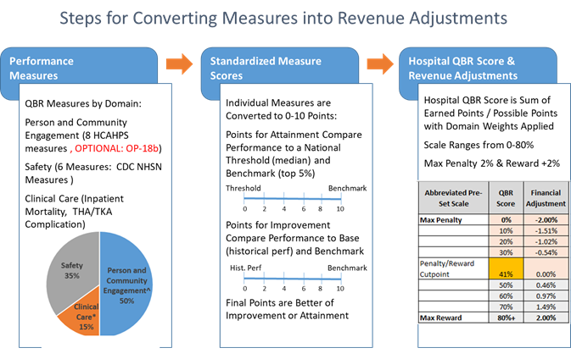
Similarly with the scoring and incentive methodology, there are no fundamental changes proposed for the measures and domain weighting for RY 2022, as illustrated in Figure 14 below.
Figure 14. Proposed RY 2022 QBR Domains, Measures and Data Sources
 | Clinical Care | Person and Community Engagement | Safety
Proposed QBR RY 2022 | 15 percent  2 measures  - Inpatient Mortality (HSCRC case mix data)  - THA TKA (CMS Hospital Compare, Medicare claims data) | 50 percent  8 measures  - 8 HCAHPS domains (CMS Hospital Compare patient survey) | 35 percent  5 measures  - 6 CDC NHSN HAI categories (CMS Hospital Compare chart abstracted)
Figure 15 illustrates the base and performance period timeline for the RY 2022 QBR program

Figure 15. RY 2022 Proposed Timeline (Base and Performance Periods; Financial Impact)
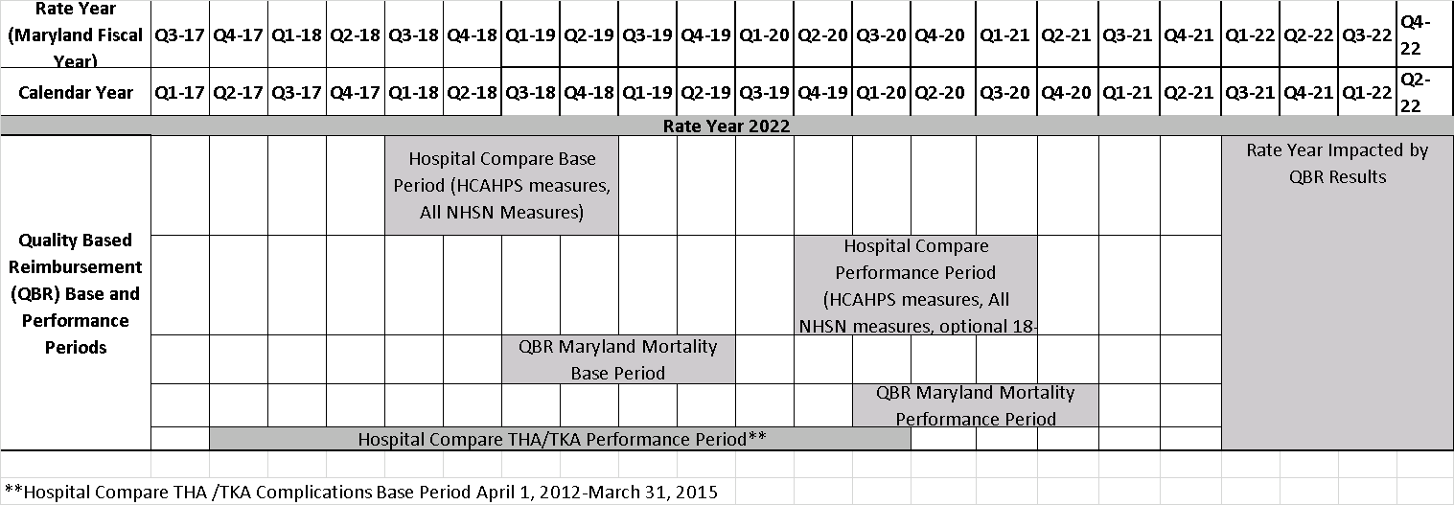

Appendix III. RY 2020 HCAHPS Measure Results by Hospital

Appendix IV. RY 2021 QBR Performance Standards
Person and Community Engagement Domain*
Dimension | Benchmark | Achievement Threshold  (50th percentile) | Floor  (Minimum)
Communication with Nurses | 87.53 percent | 79.18 percent | 15.73 percent
Communication with Doctors | 87.85 percent | 79.72 percent | 19.03 percent
Responsiveness of Hospital Staff | 81.29 percent | 65.95 percent | 25.71 percent
Communication about Medicines | 74.31 percent | 63.59 percent | 10.62 percent
Cleanliness and Quietness of Hospital Environment | 79.41 percent | 65.46 percent | 5.89 percent
Discharge Information | 91.95 percent | 87.12 percent | 66.78 percent
3-Item Care Transition | 63.11 percent | 51.69 percent | 6.84 percent
Overall Rating of Hospital | 85.18 percent | 71.37 percent | 19.09 percent
*The Person and Community Engagement performance standards displayed in this table were calculated using four quarters of calendar year 2018 data, and published in the CMS Inpatient Prospective Payment System FFY 20 Final Rule.
Safety Domain*
Measure Short ID | Measure Description | Benchmark | Achievement Threshold
CAUTI | Catheter-Associated Urinary Tract Infection | 0.00 | 0.727
CDI | Clostridium difficile Infection | 0.047 | 0.646
CLABSI | Central Line-Associated Blood Stream Infection | 0.00 | 0.633
MRSA | Methicillin-Resistant Staphylococcus aureus | 0.00 | 0.748
SSI | SSI - Abdominal Hysterectomy | 0.00 | 0.727
SSI | SSI - Colon Surgery | 0.00 | 0.749
*The Safety Domain performance standards were published in the CMS Inpatient Prospective Payment System FFY 20 Final Rule.
Clinical Care Domain
Measure Short ID | Measure Description | Benchmark | Achievement Threshold
Mortality | All Condition Inpatient Mortality | TBD* | TBD*
THA/TKA RSCR** | Total Hip/Knee Arthroplasty Risk Standardized Complication Rate | 0.021493 | 0.029833
*Mortality standards will be calculated by HSCRC staff and disseminated with implementation of v. 37 of the APR DRG grouper.
**THA/TKA standards were published in the CMS Inpatient Prospective Payment System FFY 20 Final Rule.

Appendix V. Modeling of Scores by Domain: RY 2020 QBR data with RY 2022 Measure Updates
This appendix includes modeled QBR scores with ED Wait Times removed, THA-TKA measure included, and technical changes to the mortality measure.
Hospital ID | Hospital Name | HCAHPS Score | Mortality Score | THA-TKA Score | Safety Score | Total Score
Hospital ID | Hospital Name | 50% | 10% | 5% | 35% | Total Score
210001 | Meritus | 23% | 10% | 60% | 33% | 27.17%
210002 | UMMC | 19% | 0% | 100% | 32% | 25.58%
210003 | UM-PGHC | 8% | 20% |  | 17% | 12.83%
210004 | Holy Cross | 15% | 40% | 0% | 18% | 17.92%
210005 | Frederick | 20% | 100% | 0% | 35% | 32.25%
210006 | UM-Harford | 33% | 50% | 70% | 70% | 49.50%
210008 | Mercy | 39% | 60% | 90% | 23% | 38.17%
210009 | Johns Hopkins | 43% | 30% |  | 23% | 34.17%
210010 | UM-Dorchester | 27% | 50% | 90% | 45% | 38.75%
210011 | St. Agnes | 19% | 40% | 90% | 35% | 30.25%
210012 | Sinai | 15% | 20% | 100% | 33% | 26.17%
210013 | Bon Secours | 36% | 50% |  | 23% | 33.67%
210015 | MedStar Fr Square | 33% | 70% | 100% | 62% | 50.08%
210016 | Washington Adventist | 21% | 40% | 90% | 60% | 40.00%
210017 | Garrett | 47% | 10% | 90% |  | 44.89%
210018 | MedStar Montgomery | 15% | 30% | 70% | 60% | 35.00%
210019 | Peninsula | 30% | 70% | 100% | 27% | 36.33%
210022 | Suburban | 21% | 20% | 100% | 18% | 23.80%
210023 | Anne Arundel | 36% | 40% | 100% | 42% | 41.58%
210024 | MedStar Union Mem | 23% | 30% | 100% | 8% | 22.13%
210027 | Western Maryland | 24% | 20% | 10% | 38% | 27.92%
210028 | MedStar St. Mary's | 26% | 90% | 100% | 17% | 32.83%
210029 | JH Bayview | 22% | 30% | 100% | 28% | 28.92%
210030 | UM-Chestertown | 47% | 100% | 100% |  | 59.19%
210032 | Union of Cecil | 14% | 40% | 50% | 58% | 33.63%
210033 | Carroll | 24% | 100% | 100% | 42% | 41.58%
210034 | MedStar Harbor | 18% | 90% | 10% | 23% | 26.67%
210035 | UM-Charles Regional | 28% | 80% | 100% | 48% | 43.92%
210037 | UM-Easton | 27% | 40% | 90% | 45% | 37.75%
210038 | UMMC Midtown | 18% | 100% | 80% | 30% | 33.50%
210039 | Calvert | 24% | 100% | 100% | 80% | 55.00%
210040 | Northwest | 17% | 90% | 70% | 20% | 28.00%
210043 | UM-BWMC | 31% | 80% | 0% | 32% | 34.58%
210044 | GBMC | 24% | 90% | 40% | 43% | 38.17%
210048 | Howard County | 27% | 70% | 50% | 53% | 41.67%
210049 | UM-Upper Chesapeake | 31% | 60% | 100% | 57% | 46.33%
210051 | Doctors | 16% | 40% | 60% | 82% | 43.70%
210056 | MedStar Good Sam | 18% | 70% | 20% | 38% | 30.30%
210057 | Shady Grove | 18% | 10% | 70% | 45% | 29.25%
210060 | Ft. Washington | 15% | 60% | 40% |  | 23.75%
210061 | Atlantic General | 35% | 70% | 10% | 60% | 46.00%
210062 | MedStar Southern MD | 19% | 20% | 100% | 45% | 32.25%
210063 | UM-St. Joe | 31% | 90% |  | 63% | 51.17%
210065 | HC-Germantown | 14% | 80% |  | 10% | 22.50%

Appendix VI. Modeling of QBR Program Revenue Adjustments
HOSPID | HOSPITAL NAME | RY19 Permanent Inpatient Revenue | RY 2022 Modeled QBR Points | % Revenue Impact | $ Revenue Impact
210001 | MERITUS | $219,551,750 | 27.17% | -0.67% | -$1,470,997
210002 | UNIVERSITY OF MARYLAND | $1,203,673,856 | 25.58% | -0.75% | -$9,027,554
210003 | PRINCE GEORGE | $282,929,188 | 12.83% | -1.37% | -$3,876,130
210004 | HOLY CROSS | $355,608,692 | 17.92% | -1.13% | -$4,018,378
210005 | FREDERICK MEMORIAL | $232,665,827 | 32.25% | -0.43% | -$1,000,463
210006 | HARFORD | $54,181,186 | 49.50% | 0.44% | $238,397
210008 | MERCY | $226,492,002 | 38.17% | -0.14% | -$317,089
210009 | JOHNS HOPKINS | $1,456,687,424 | 34.17% | -0.33% | -$4,807,068
210010 | DORCHESTER | $22,653,845 | 38.75% | -0.11% | -$24,919
210011 | ST. AGNES | $238,757,730 | 30.25% | -0.52% | -$1,241,540
210012 | SINAI | $399,817,673 | 26.17% | -0.72% | -$2,878,687
210013 | BON SECOURS | $64,363,349 | 33.67% | -0.36% | -$231,708
210015 | FRANKLIN SQUARE | $306,898,504 | 50.08% | 0.47% | $1,442,423
210016 | WASHINGTON ADVENTIST | $164,197,283 | 40.00% | -0.05% | -$82,099
210017 | GARRETT COUNTY | $23,714,400 | 44.89% | 0.20% | $47,429
210018 | MONTGOMERY GENERAL | $84,721,645 | 35.00% | -0.29% | -$245,693
210019 | PENINSULA REGIONAL | $249,228,264 | 36.33% | -0.23% | -$573,225
210022 | SUBURBAN | $208,954,270 | 23.80% | -0.84% | -$1,755,216
210023 | ANNE ARUNDEL | $294,544,506 | 41.58% | 0.03% | $88,363
210024 | UNION MEMORIAL | $243,156,679 | 22.13% | -0.92% | -$2,237,041
210027 | WESTERN MARYLAND | $169,462,000 | 27.92% | -0.64% | -$1,084,557
210028 | ST. MARY | $79,141,046 | 32.83% | -0.40% | -$316,564
210029 | HOPKINS BAYVIEW MED CTR | $366,607,627 | 28.92% | -0.59% | -$2,162,985
210030 | CHESTERTOWN | $17,859,942 | 59.19% | 0.93% | $166,097
210032 | UNION HOSPITAL OF CECIL | $65,426,887 | 33.63% | -0.36% | -$235,537
210033 | CARROLL COUNTY | $140,291,849 | 41.58% | 0.03% | $42,088
210034 | HARBOR | $110,392,040 | 26.67% | -0.70% | -$772,744
210035 | CHARLES REGIONAL | $76,930,098 | 43.92% | 0.15% | $115,395
210037 | EASTON | $103,481,053 | 37.75% | -0.16% | -$165,570
210038 | UMMC MIDTOWN | $111,141,002 | 33.50% | -0.37% | -$411,222
210039 | CALVERT | $67,111,996 | 55.00% | 0.72% | $483,206
210040 | NORTHWEST | $138,719,920 | 28.00% | -0.63% | -$873,935
210043 | BALTIMORE WASHINGTON | $250,217,336 | 34.58% | -0.31% | -$775,674
210044 | G.B.M.C. | $237,787,317 | 38.17% | -0.14% | -$332,902
210048 | HOWARD COUNTY | $182,870,977 | 41.67% | 0.03% | $54,861
210049 | UPPER CHESAPEAKE HEALTH | $128,686,091 | 46.33% | 0.27% | $347,452
210051 | DOCTORS COMMUNITY | $141,094,311 | 43.70% | 0.14% | $197,532
210056 | GOOD SAMARITAN | $146,901,579 | 30.30% | -0.52% | -$763,888
210057 | SHADY GROVE | $251,748,234 | 29.25% | -0.57% | -$1,434,965
210060 | FT. WASHINGTON | $19,890,383 | 23.75% | -0.84% | -$167,079
210061 | ATLANTIC GENERAL | $36,931,910 | 46.00% | 0.26% | $96,023
210062 | SOUTHERN MARYLAND | $162,087,856 | 32.25% | -0.43% | -$696,978
210063 | UM ST. JOSEPH | $223,399,907 | 51.17% | 0.52% | $1,161,680
210065 | HC-GERMANTOWN | $59,062,315 | 22.50% | -0.90% | -$531,561
 | Statewide Total | $9,620,041,749 |  |  | -$40,033,022
 |  | Average |  |  | -0.42%
 | Scaling Components | Values |  | Total Penalties | -44,513,968
 | QBR Lowest Score | 0 |  | % Inpatient Revenue | -0.46%
 | QBR Max Penalty | -2% |  | Total rewards | 4,480,946
 | QBR Highest Score | 80% |  | % Inpatient revenue | 0.05%
 | QBR Max Reward | 2%
 | QBR Threshold | 41%

The notification of exemption may be found in Appendix I
For more information on the VBP Exemption (granted annually by CMMI), please see Appendix I.
For more information on the VBP program, see https://www.cms.gov/Medicare/Quality-Initiatives-Patient-Assessment-Instruments/Value-Based-Programs/HVBP/Hospital-Value-Based-Purchasing.html, last accessed 10/28/19.
During the coming year, staff will work with contractor support to continue developing an all-cause, all-condition 30-day mortality measure applicable to all payers, expanding further the QBR mortality measure’s potential to incentivize better outcomes outside the hospital walls.
In the fall of 2017, HSCRC Commissioners and staff support conducted several strategic planning sessions to outline priorities and guiding principles for the upcoming Total Cost of Care Model. Based on these sessions, the HSCRC developed a Critical Action Plan that delineates timelines for review and possible reform of financial and quality methodologies, as well as other staff operations.
Maryland has implemented an efficiency measure in the Population-Based Revenue system, based on a calculation of potentially avoidable utilization (PAU), but it has not made efficiency part of its core quality programs as a domain because the revenue system itself incentivizes improved efficiency. PAU is currently defined as the costs of readmissions and a subset of admissions defined by the Agency for Healthcare Research and Quality Prevention Quality Indicators (PQIs).
Details of CMS VBP measures may be found at: https://www.cms.gov/Medicare/Quality-Initiatives-Patient-Assessment-Instruments/HospitalQualityInits/Measure-Methodology.html.
The Patient-Mix Adjustment document for the July 2019 Public Report period can be found at: : https://hcahpsonline.org/globalassets/hcahps/mode-patient-mix-adjustment/july_2019_mode--patient-mix-adj_pma.pdf. The HCAHPS PMA model was updated to add Question 28, patient’s self-reported overall mental or emotional health, beginning with July 1, 2018 discharges. The new PMA variable is called Self-Rated Mental Health. In addition, the label for overall health has been changed to “Self-Rated Overall Health.” Self-Rated Mental Health follows the same linear parameterization as Self-Rated Overall Health: patient responses are coded as 1 (“Excellent”) through 5 (“Poor”). The patient-mix adjustment model will thus include both Self-Rated Overall Health and Self-Rated Mental Health.
91 percent of Maryland hospitals perform worse than the nation in ED-1b, 77 percent perform worse than the nation in ED-2b, and 91 percent perform worse on OB-18b. The median wait times are adjusted based upon ED volume. These results are similar to the 85 percent average reported in RY2021 policy.
While there are six Healthcare Associated Infection categories, the two SSI colon and hysterectomy categories are combined resulting in five Safety domain measures.
Two technical changes to the mortality measure are: 1. adding the procedure code for removing ECMO patients previously identified only by DRG (under ICD-10 ECMO patients are now in multiple DRGs); 2. adjusting the process for selecting the included DRGs to ensure all DRGs with same number of observed deaths at the cut-point are included.
42 USC § 1395ww(o)(7).
42 USC § 1395ww(o)(7)(C).
The HCAHPS increase reduced the Clinical Care domain from 20 percent to 15 percent.
Details of CMS VBP measures may be found at: https://www.cms.gov/Medicare/Quality-Initiatives-Patient-Assessment-Instruments/HospitalQualityInits/Measure-Methodology.html ; last accessed 10./28/19.
Scaling refers to the differential allocation of a pre-determined portion of base-regulated hospital inpatient revenue based on assessment of the quality of hospital performance.
VBP measure specifications may be found at: www.cms.gov/Medicare/Quality-Initiatives-Patient-Assessment-Instruments/HospitalQualityInits/Measure-Methodology.html
As an exception, for the ED wait time measures, attainment points are not calculated; instead full 10 points are awarded to hospitals at or below (more efficient) than the national medians for their respective volume categories in the performance period.

